OMB Control No.: 0536-xxxx

Exp. Date: mm/dd/yyyy

Dear [STATE] Resident:

We recently sent you a letter for an internet survey about farm management in [STATE]. If you have completed the survey, **thank you!**

**If not**, please take a few minutes to share your thoughts. Your confidential input is essential to ensure the accuracy of the survey. As a thank you, we will send you **$30** when you complete the survey.

To start, please use the web address and ID code ***printed on the other side*** of this card. The website needs to be entered into the address bar of your web browser.* Or you can e-mail your ID code to me, and I will send you a link you can click on.

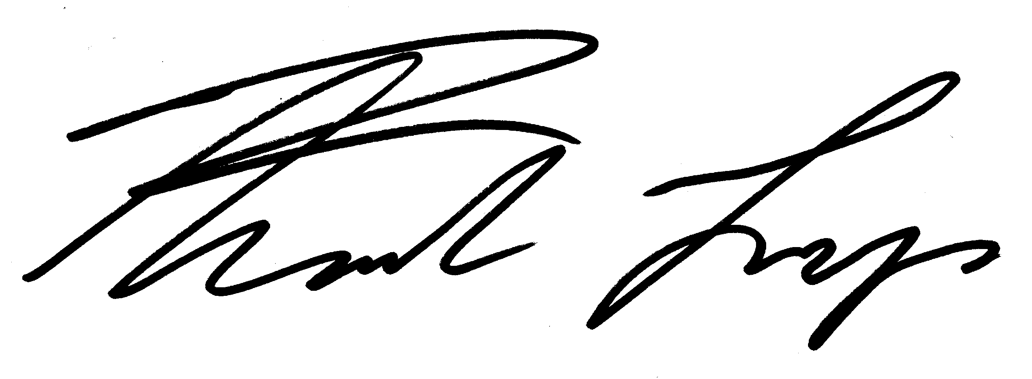Thank you,

Prof. Frank Lupi, *CropSurvey@usda.gov* 517-432-3883

* The address bar is usually at the top of the web browser and is not the same as search. To find the address bar you can also press “control+L” in Windows or “command+L” on a Mac.



*Corn and Soybean Grower Survey*

*c/o Prof. Frank Lupi*

*307 Morrill Hall*

Michigan State University

East Lansing, MI 48824

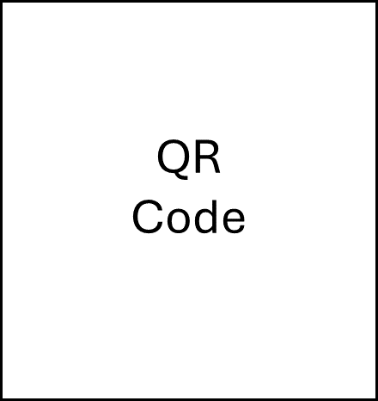<NAME>

<ADDRESS>

<CITY>, <ST> <ZIP5>-<ZIP4>

**Web address:** <LINK> **ID code:** <PASSCODE>