
OMB Control No.: 0536-xxxx
Exp. Date: mm/dd/yyyy
Dear [STATE] Resident:
We need your help with an important internet survey. If you have completed the survey, thank you! If not, please take a few minutes to share your thoughts. Your confidential input is essential to ensure the accuracy of the survey. When you complete the survey, we will send you $30 as a thank you.
Please use the web address and ID code printed on the other side of this card. The website needs to be entered into the address bar of your web browser.*
Or you can e-mail your ID code to me at CropSurvey@usda.gov, and I will send you a link you can click on.
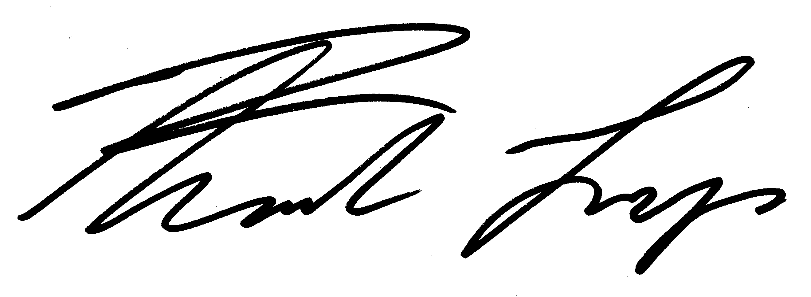
Thank you,

Prof. Frank Lupi, CropSurvey@usda.gov 517-432-3883
* The address bar is usually at the top of the web browser and is not the same as search. To find the address bar you can also press “control+L” in Windows or “command+L” on a Mac.

Corn and Soybean Grower Survey
c/o Prof. Frank Lupi
307 Morrill Hall
Michigan State University
East Lansing, MI 48824

<NAME>
<ADDRESS>
<CITY>, <ST> <ZIP5>-<ZIP4>

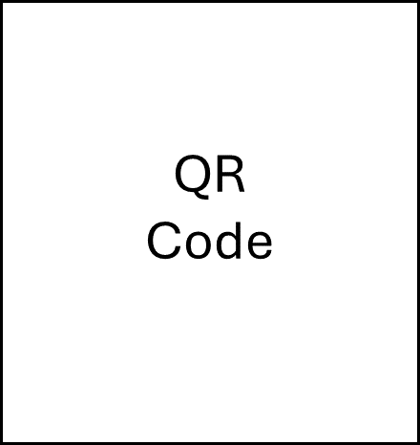

Web address: <LINK> ID code: <PASSCODE>

