**APPENDIX B.1a**

**CENSUS SURVEY INSTRUMENT SAMPLE SCREENSHOTS**

**APPENDIX F**

**NASS Comments and Fns response**

2027 Farm to School Census Survey Instrument

Sample Screenshots of Web Survey

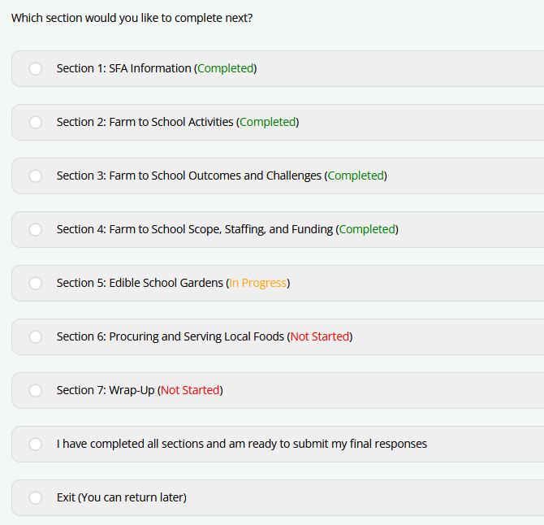

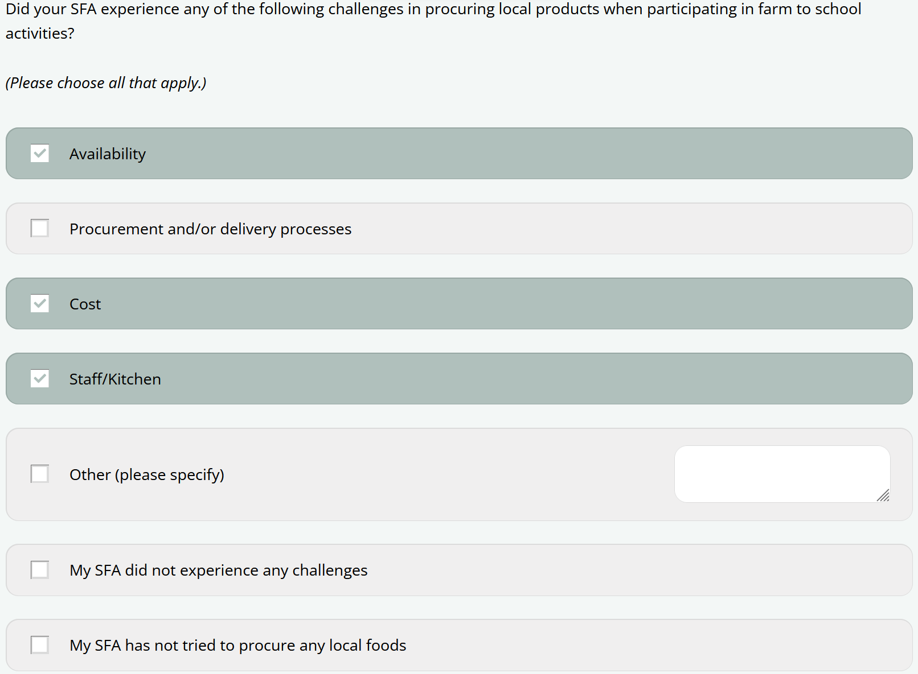

This image is a screenshot of a question in the 2023 Farm to School Census. It says "This section asks about activities that take place in your SFA and schools. We are interested in any of these activities that occur in your SFA, including at the SFA-level, at one school, or at many schools. For each activity below, please indicate if your SFA or schools in your SFA have never done the listed activity, did the activity before SY 2022-23, did the activity last year (SY 2022-23), are doing the activity this year (SY 2023-24), and/or plan to do the activity in the future. For each row, please choose all that apply. If you're taking the Census on a mobile phone, please rotate your phone horizontally for landscape mode to scroll through the grid. Remember, we are counting it as participation even if only one school in your SFA does or has done an activity."

The question then has a grid of activities and response options with check boxes. Along the top of the grid says "Choose all that apply: My SFA/schools in my SFA..." and has the five response options: Have never done, Did before SY 2022-23, Did in SY 2022-23 (last year), Doing in SY 2023-24 (this year), Plan to do in the future. There are corresponding check boxes for each of the response options. Within the grid there are several activities that respondents will use the check boxes to respond to. Those shown include: Use local foods of any type and in any form in the National School Lunch program (NSLP) (Reminder: You defined "local" as "Produced within a 50 mile radius"); Use local foods of any type and in any form in the School Breakfast Program (SBP); Use local foods of any type and in any form in summer meals (i.e., meals in the Summer Food Service Program (SFSP) or through the Seamless Summer Option (SSO), when operated during the summer); Serve local food in any other way (e.g., in the classroom, sold a la carte, as fundraisers).

This image is a screenshot of a question in the 2023 Farm to School Census.  It asks "In SY 2022-23, what percent of your local purchasing (based on dollars spent) came from each of the sources you selected? Your best estimate is fine)."

The question then lists all of the sources selected on the left, and on the right, a box in which respondents can enter the percentage of local purchasing for each source.

This example shows the following sources and percentages: Directly from an individual food producer (i.e., farmer, rancher, fisher), including but not limited to a farmers' market or CSA model = 20 percent; Directly from a cooperative of producers (i.e., farmers, ranchers, or fishers) = 15 percent; Directly from a local food processer = 10 percent; Food hub = 55 percent. Underneath the sources it says "Please make sure that your responses total to 100%" and the box to the right automatically sums up all of the percentages that the respondent listed. In this example, the total is 100%.

This information is being collected to assist the Food and Nutrition Service in understanding and tracking farm to school engagement. This is a mandatory collection and FNS will use the information to set priorities for USDA outreach and technical support. This collection does not request any personally identifiable information under the Privacy Act of 1974. According to the Paperwork Reduction Act of 1995, an agency may not conduct or sponsor, and a person is not required to respond to, a collection of information unless it displays a valid OMB control number. The valid OMB control number for this information collection is 0584-0646. The time required to complete this information collection is estimated to average 0.5 hours per response, including the time for reviewing instructions, searching existing data sources, gathering and maintaining the data needed, and completing and reviewing the collection of information. Send comments regarding this burden estimate or any other aspect of this collection of information, including suggestions for reducing this burden, to: U.S. Department of Agriculture, Food and Nutrition Service, Office of Policy Support, 1320 Braddock Place, 5th Floor, Alexandria, VA 22706 ATTN: PRA (0584-0646). Do not return the completed form to this address.