APPENDIX D6. AND D07. HOUSEHOLD BROCHURE - ENGLISH/SPANISH (GROUP 2A/2B)

This information is being collected to assist the Food and Nutrition Service in understanding school food purchasing practices, the nutritional quality of school meals and snacks, the cost to produce school meals, and student participation and dietary intakes. This is a voluntary collection and FNS will use the information to monitor program operations. This collection does not request any personally identifiable information under the Privacy Act of 1974. According to the Paperwork Reduction Act of 1995, an agency may not conduct or sponsor, and a person is not required to respond to, a collection of information unless it displays a valid OMB control number. The valid OMB control number for this information collection is 0584-0698. The time required to complete this information collection is estimated to average 0.13 hours per response, including the time for reviewing instructions, searching existing data sources, gathering and maintaining the data needed, and completing and reviewing the collection of information. Send comments regarding this burden estimate or any other aspect of this collection of information, including suggestions for reducing this burden, to: U.S. Department of Agriculture, Food and Nutrition Service, Office of Policy Support, 1320 Braddock Place, 5th Floor, Alexandria, VA 22314 ATTN: PRA (0584-0698). Do not return the completed form to this address.

OMB Number: 0584-0698 Expiration Date: 06/30/2027

# Who is conducting the study?

Mathematica is doing this study for the

U.S. Department of Agriculture's Food and Nutrition Service (FNS). Mathematica has more than 30 years of experience studying school nutrition programs.

**Am I required to participate?** Participation is voluntary but encouraged by your school district and school. This critical study helps FNS understand school nutrition and school meals to better serve your community.

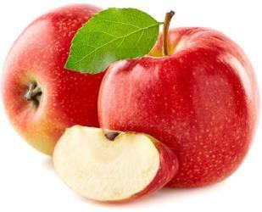As a thank you for participating, students will receive **[$5/$15]** [and parents will receive **[$25/$15]**]. The study complies with the Family Educational Rights and Privacy Act (FERPA).

# For further information contact:

**Alice Ann Gola**

Schools and Families Working Together to Understand the School Food Environment

Funded by the

USDA Food and Nutrition Service

**2024–2025 National School Foods Study**

**P.O. Box 2393**

**Princeton, NJ 08543-2393 Phone: [FILL]**

**Email: [FILL] Fax: 609-799-0005**

**Visit our website:** [**www.mathematica.org**](http://www.mathematica.org/)

**Why is this study being done?** Schools are working to follow updated meal requirements aimed at giving healthier foods to children. Schools are also trying to promote healthy eating and exercise habits. FNS is sponsoring this study to learn how these federally sponsored school food programs are working.

2024–2025 NATIONAL SCHOOL FOODS STUDY

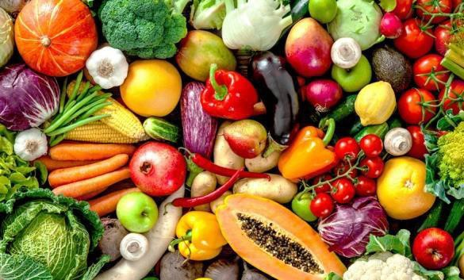

# How will the study work?

We will interview students [and their parents]. We will ask about what students eat, their activities, and their opinions about school meals. The study will represent all public school students across the country. The information you and your child share will help FNS learn about the school food program and how it can better serve your community. Your experiences and opinions matter!

# My child does not eat the school breakfast or lunch. Should I still participate?

Yes! This study is about all students. It is important that we interview students who eat school meals and those who do not. Even if your child has never eaten a meal or snack provided by the school, we need your help. We want to understand why some families do not participate in the school food program.

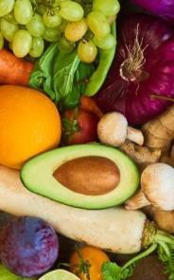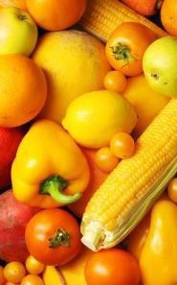

**Will my answers be kept private?** All information gathered for the study will be kept private to the fullest extent allowed by law. No information on individual students or families will be shared or reported. No students or parents will be named or identified in any way. Your participation will not affect any benefits you may receive now or in the future.

# What will I be asked?

The person who interviews you may ask about:

* How often your child eats school foods
* What your child usually eats, and what they ate on a specific day
* General student characteristics, such as exercise habits
* Satisfaction with school meals and snack program

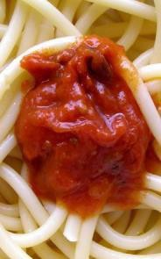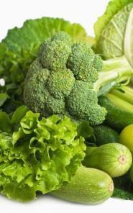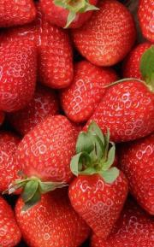

**How long will the interview take?** The student interview will take place in school. It will last about [60/30] minutes. [The parent interview will take place [by web/phone/in person] and will last about 25 minutes].

**What do I get for participating?** As a thank you for participating, students will receive **[$5/$15]** [and parents will receive **[$25/$15]** after completing an interview].