APPENDIX C07. SFA DIRECTOR Sample NOTIFICATION EMAIL FROM
STATE CN DIRECTOR (GROUPs 1A, 1B, 2A, 2B, & 3)

OMB Number: 0584-0698
Expiration Date: 06/30/2027

This information is being collected to assist the Food and Nutrition Service in understanding school food purchasing practices, the nutritional quality of school meals and snacks, the cost to produce school meals, and student participation and dietary intakes. This is a mandatory collection and FNS will use the information to monitor program operations. This collection does not request any personally identifiable information under the Privacy Act of 1974. According to the Paperwork Reduction Act of 1995, an agency may not conduct or sponsor, and a person is not required to respond to, a collection of information unless it displays a valid OMB control number. The valid OMB control number for this information collection is 0584-0698. The time required to complete this information collection is estimated to average 0.03 hours per response, including the time for reviewing instructions, searching existing data sources, gathering and maintaining the data needed, and completing and reviewing the collection of information. Send comments regarding this burden estimate or any other aspect of this collection of information, including suggestions for reducing this burden, to: U.S. Department of Agriculture, Food and Nutrition Service, Office of Policy Support, 1320 Braddock Place, 5th Floor, Alexandria, VA 22314 ATTN: PRA (0584-0698). Do not return the completed form to this address.
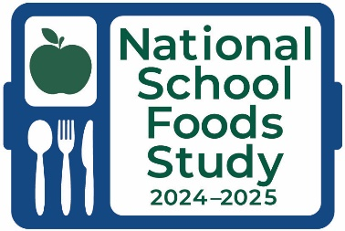

Dear SFA Director:
Our State is working with Mathematica, Decision Information Resources, and ProTeam to conduct the 2024–2025 National School Foods Study on behalf of FNS.
With better data comes better policy; we seek to collect data to fully understand the school food environment.
All information gathered for this study is for research purposes only and will not affect meal reimbursements to participating schools or school meal program benefits of participating households.
Study representatives will be contacting you in the coming weeks to introduce the National School Foods Study and schedule a week for data collection to take place.
Thank you in advance for your cooperation and participation in this very important study.
Sincerely,
[State CN Director]

