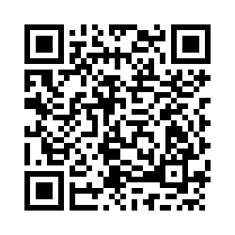
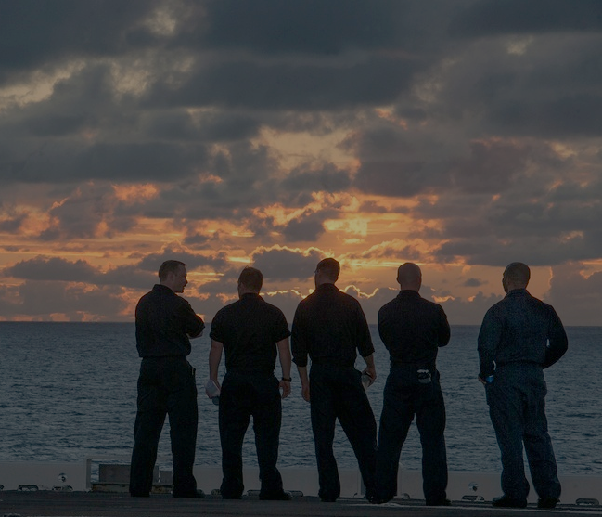
THE NAVAL HEALTH RESEARCH CENTER IS CONDUCTING A STUDY ON MEN’S HELP-SEEKING EXPERIENCES DURING MILITARY SERVICE

If you are a male active duty sailor or recent Navy Veteran, you may be eligible to participate!

Participation involves completing a confidential
60-minute phone interview.

Volunteers will receive a $40
Amazon gift card for their time.

If you have questions or would like to learn more about this research,
please reach us at mosaicstudy@health.mil

Study Coordinator: lauren.m.hurtado2.ctr@health.mil Study Principal Investigator: kristen.h.walter.civ@health.mil
Please use this QR code to see if you are eligible and to sign up for the study!
LOOKING FOR RESEARCH PARTICIPANTS

