Attachment C: Demographic Survey
Demographic Survey
- What is your age? ________________________
- What is your dominant hand?
Left | Right
- Are you: (Mark all that apply.)
 Male
 Female

- What is your race and/or ethnicity? Select all that apply.
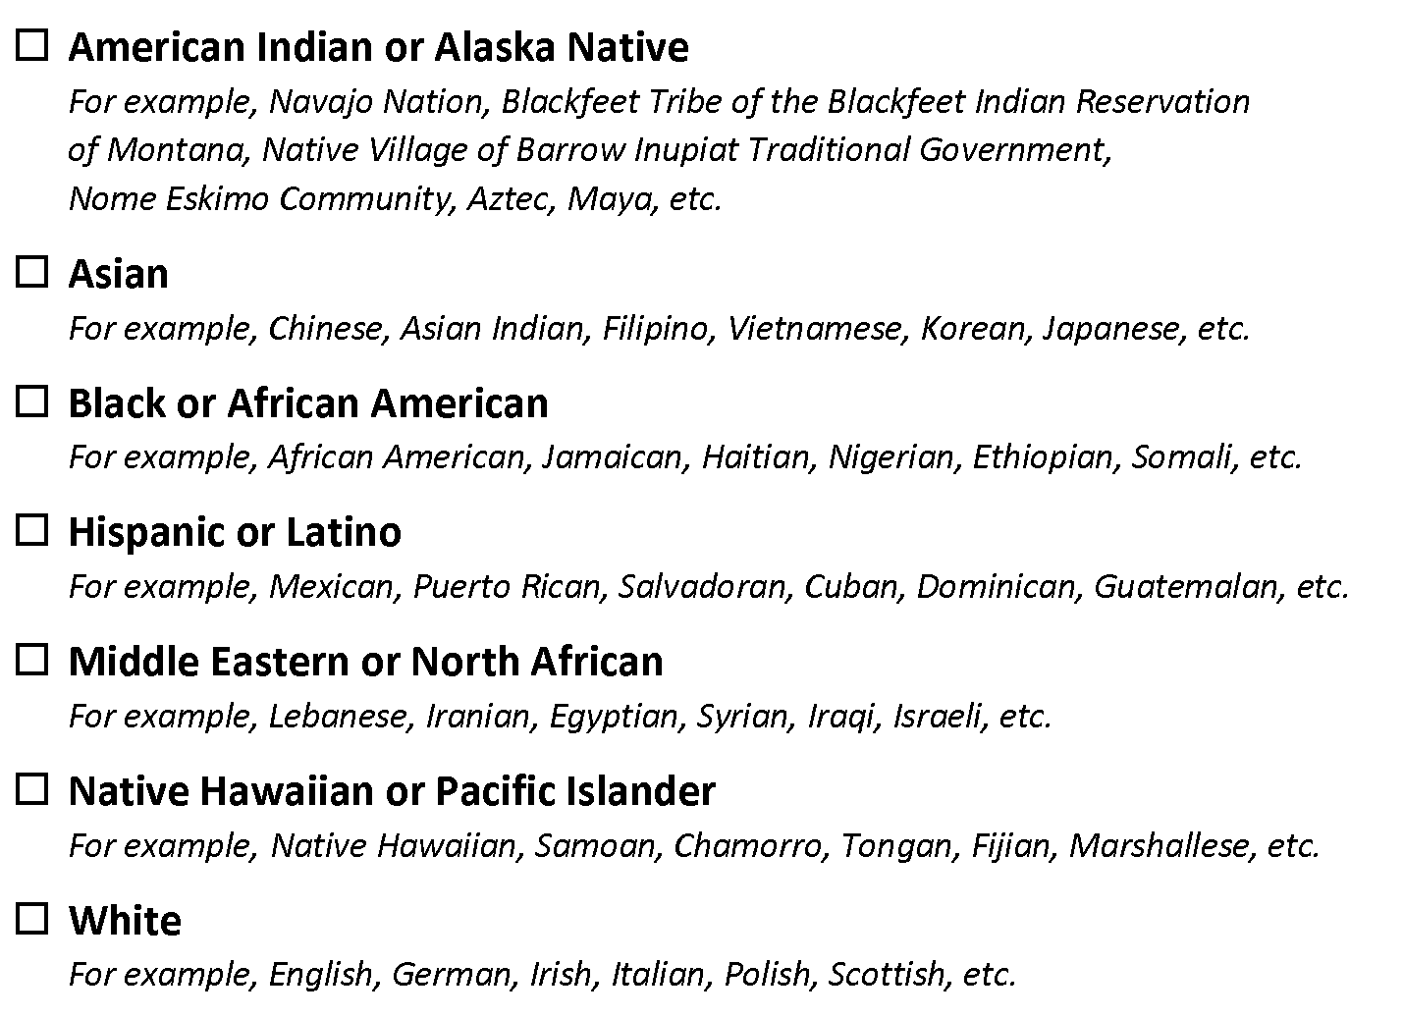
- Job experience
  - Currently employed in manufacturing/warehousing or similar industry? YES | NO

  - Years of experience: _______ years

