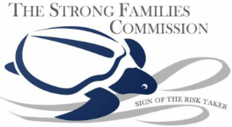

**Participant Release Form**

**LISTENING SESSION CONSENT**

As part of my participation in the ***Listening Session with LGBTQIA+ individuals Living in Georgia Urban and Rural Communities***, I understand participation is **voluntary**, and that I may cease participation at any time. I may also skip questions that I do not want to answer. I acknowledge that my participation is private. Reports about the listening session will protect participant’s privacy by excluding names and personally identifiable information. I understand that there will be an audio recording to create a transcript and analyze the information provided by participants. I also understand that findings will be reported in a qualitative summary on the listening sessions, which ACF will publicly publish, and in a presentation for internal use by ACF program offices and managers. ACF intends to use the information to inform approaches to providing grants, services, and technical assistance to meet the needs of rural communities and to increase father involvement in ACF programs

I agree to participate in the listening session: Yes___ No___

**Print Name** _________________________________

**Signature** ___________________________________

**Date** _______________________________________