6. After you enter your data, click on the “Submit Data to BLS” button to finish, or the “Edit” button to return to the previous screen.

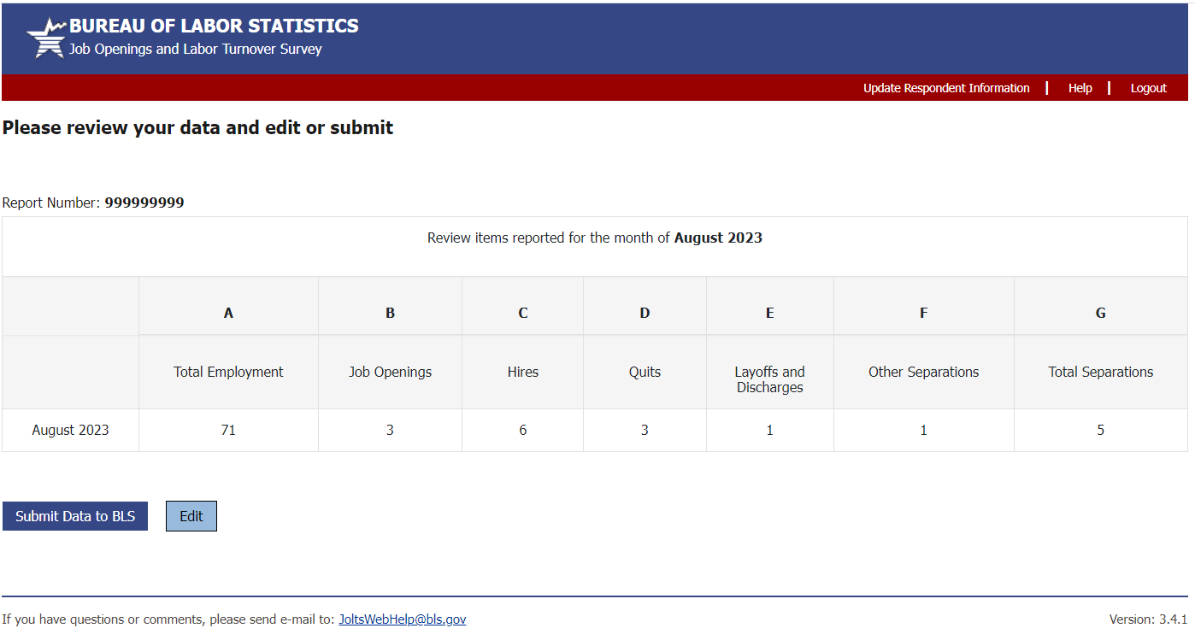

7. After submitting your data, you will be taken to a confirmation page. Here you can view the data you have submitted, print your data, and view your confirmation number. If you received a confirmation number, your data were submitted successfully. If not, a problem occurred so please re-enter your data.

8. If you need to enter data for another report number or a different month click the corresponding link in the bottom left corner of the screen. If you need to make corrections to already submitted data, log in and resubmit all the data items for that reference month. The newer data submission will be kept.

U.S. Department of Labor

Bureau of Labor Statistics
Job Openings and Labor Turnover Survey

JOLTSWebHelp@bls.gov
rev. 08/2023

If you have any questions, please call 1-833-985-9693

Reporting JOLTS Data

on the BLS Internet



U.S. Department of Labor

Bureau of Labor Statistics
Job Openings and Labor Turnover Survey

https://joltsdata.bls.gov
Reporting JOLTS Data on the BLS Internet

1. Link to https://joltsdata.bls.gov/JOLTS. Please note that the “s” in “https” is required.

If you experience any difficulties, send an e-mail to JOLTSWebHelp@bls.gov. This e-mail link is at the bottom of every page.

2. Enter your report number in the first box. Your report number will be printed in the subject line of the e-mail reminder you receive when it is time to report.

3. If you can read the numbers, enter them in the CAPTCHA field, then click on the “I accept” button. If you can't read the letters, you can click the ‘Speaker Icon’ to hear them sounded out or the ‘Refresh Icon’ to generate a new set of numbers.

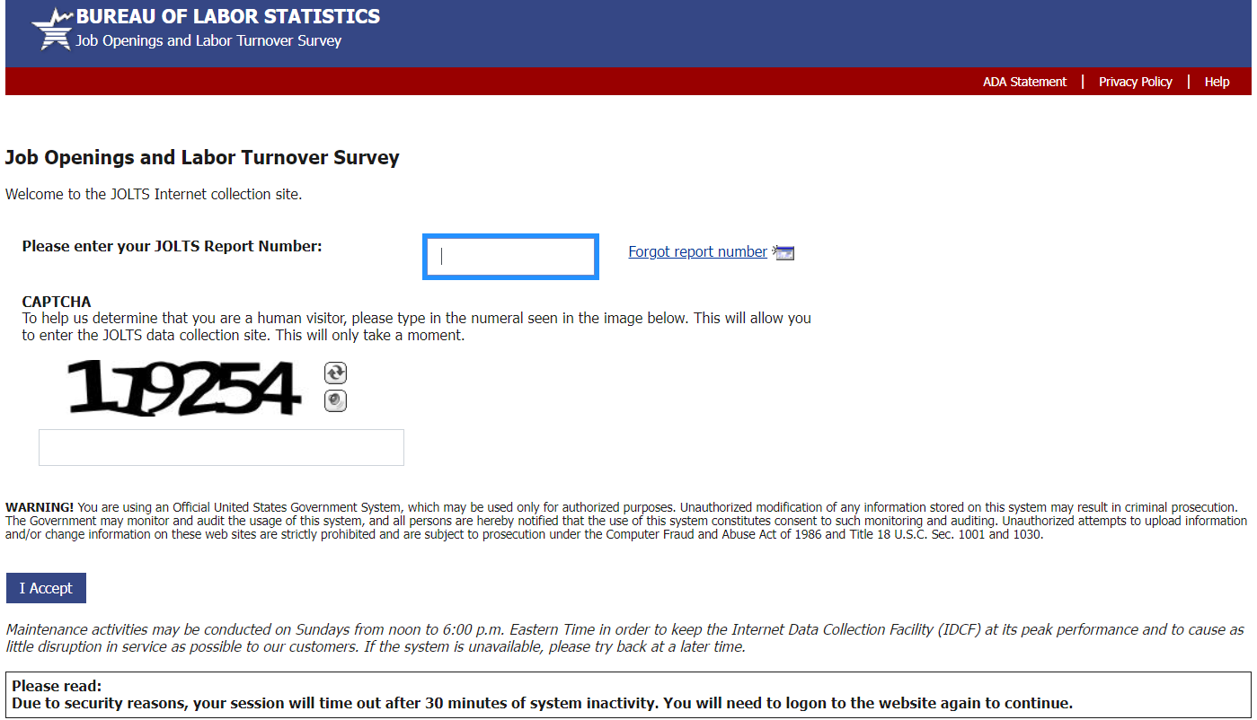

4. The welcome screen is next. Click on “Continue” when you are ready to enter your data.

5. Select the reference month and enter your data. Only the two most recent reference months are available to report. Be sure to enter a value in the box for each data item you can report. If any data item is not available, leave the box blank. Click “Continue” once you are finished entering your data.

