Attachment B: Recruiting Emails and Banner

In this attachment are samples for recruiting for the following methods:
- Emails to those who have previously volunteered to help
- Emails to BLS email lists
- Advertising through organizations supporting the relevant occupations (for teachers, counselors, and the media)
- Advertising in online marketplaces
- Emails to contacts of team members who work in these occupations

In addition to the emails, we will place banners on the Classroom site to invite volunteers.

For Previous Volunteers
Subject: Give us your feedback! Participate in an interview and earn $50!

Thank you for your previous interest in the Bureau of Labor Statistics (BLS) Classroom site (https://www.bls.gov/k12/). We are redesigning the site to improve the resources we offer to better meet the needs of those teaching and learning about BLS data and related concepts. Towards that goal, we would like to talk with you to get your input on the current site and your thoughts about what we could include in the redesigned site.

This study will take about an hour. We will conduct the sessions using Teams, and we would ask you to share your screen with us as you explore our site. With your permission, we would like to record the sessions. We are offering a $50 electronic gift card for participating in the study.

If you can help us with this important study, please reply to this email to let us know what classes and/or grades you teach, along with the state in which you live.

Thank you,
[Add name]

For BLS Email Lists

Subject: Give us your feedback! Participate in an interview and earn $50!

The Bureau of Labor Statistics (BLS) is redesigning our current Classroom page (https://www.bls.gov/k12/) to provide more resources to better meet the needs of those teaching and learning about BLS data and related concepts. We would like to get your input on the current site and your thoughts about what we could include in the redesigned site.

This study will take about an hour. We will conduct the sessions using Teams, and we would ask you to share your screen with us as you explore our site. With your permission, we would like to record the sessions. We are offering a $50 electronic gift card for participating in the study.

If you can help us with this important study, please reply to this email to let us know what classes and/or grades you teach, along with the state in which you live.

Thank you,
Jean Fox

For Professional Organizations (Education)
Subject: The Bureau of Labor Statistics seeks educators for feedback

Hello [Contact Name],

The Bureau of Labor Statistics is planning to redesign our current Classroom site, which provides resources for career planning and for teaching BLS-related topics to K–12 students. To help ensure that the redesign best meets the needs of our target audience, we would like to talk with [teachers/counselors] who might use our site. Our goal is to better understand the resources they use and to get their input for our new site.

We are asking for your help in finding [teachers/counselors] who would be willing to talk with us for about an hour sometime in the next few weeks. The discussions will be conducted via Teams videoconferencing, and participants will receive a $50 electronic gift card.

Would [Organization Name] be able to help us find candidates for this important effort?

Please email me at [Email Address] if you have questions or need additional information. Anyone who is interested can also email me at that address.

Sincerely,
[Add name]

For Professional Organizations (Media)
Subject: The Bureau of Labor Statistics seeks economic journalists for feedback

Hello [Contact Name],

The U.S. Bureau of Labor Statistics is working on new educational content to support journalists who are covering topics related to BLS. To help ensure that these resources are helpful, we would like to talk with journalists who report on these topics, especially those who are new to this work. Our goal is to better understand the resources that would be helpful and to get their input for our new content.

We are asking for your help in finding journalists who would be willing to talk with us for about an hour sometime in the next few weeks. The discussions will be conducted via Teams videoconferencing, and participants will receive a $50 electronic gift card.

Would [Organization Name] be able to help us find candidates for this important effort?

Please email me at [Email Address] if you have questions or need additional information. Anyone who is interested can also email me at that address.

Sincerely,
[Add name]

For Online Marketplaces
Posting title: Give us your feedback! Participate in an interview and earn $50!

Posting content:
The U.S. Bureau of Labor Statistics is looking for teachers and career counselors to share their input in research interviews. By participating in this research, you’ll help us improve the resources we provide on our Classroom site for [teachers/counselors] like you!

We will be conducting the interviews online using Teams. The sessions will last about an hour, and participants will receive a $50 electronic gift card.

If you are interested and fit the description below, please contact us at [email] with the subject line “Classroom Study.” Please include your name, email address, phone number, city and state in which you live, and how you meet the study criteria.

We’re looking for people currently in any of the following jobs:

- Career Counselors (middle school, high school, or college)
- Civics or Social Studies Teachers (middle school or high school)
- Math or Statistics Teachers (middle school or high school)
- Economics Teachers (high school or college)
- Elementary School teachers (grades K–5)

For more information about our office, please go to www.bls.gov/osmr/overview.htm.

For Team Contacts
The U.S. Bureau of Labor Statistics is looking for teachers and counselors to share their feedback in research interviews. By participating in this research, you’ll help us improve the resources we provide on our Classroom site for teachers and career counselors.

We will be conducting the interviews online using Teams. The sessions will last about an hour, and participants will receive a $50 electronic gift card.

If you are interested, please contact us at [email] with the subject line “Classroom Study.” Let us know what classes and/or grades you teach and what state you live in.

Banner
The banner will be similar to the banner currently on the Teacher’s page of the Classroom site as shown in Figure 1 below.

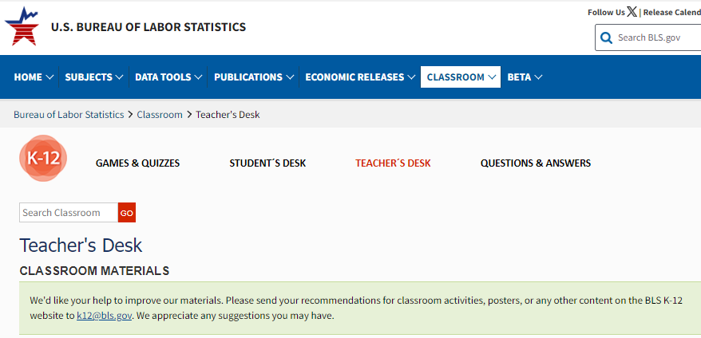
Figure 1. Sample Banner Invitation.

