**Attachment G: Advertisements and Screening Questions for Remote Cognitive Interviews**

Flyers

**Give us your feedback!**

**Earn $50**

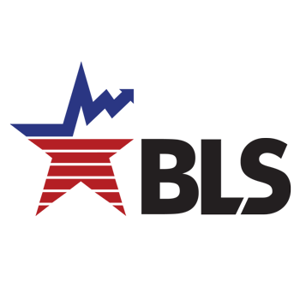

**Participate in an Online Interview**

with the

**U.S. Bureau of Labor Statistics**

We’re looking for parents and guardians with children between the ages of 11-17.

You and your child will provide feedback on survey materials.

* Interviews (conducted on video conference via Microsoft Teams) last up to 60 minutes (30 minutes with you, and 30 minutes with your child)
* Parents and guardians will be given an e-gift card, which can be spent online
* Your responses will help to improve our surveys
* More information about our office at www.bls.gov/osmr/overview.htm

Please contact us at [Research@bls.gov](mailto:Research@bls.gov) using the subject line “Youth Study.” Provide the following information:

* Your name
* Email address
* Phone number
* State in which you live
* The age and gender of your child who would be available to participate in the interview with you

*Online bulletin board posting/Emails to community listservs*

The U.S. Bureau of Labor Statistics is looking for parents and guardians in the community with children between the ages 11-17 to share their feedback in research interviews. You and your child must be available to participate in the interviews. By participating in this research, you’ll help us improve our survey.

Participation is online. Interview sessions will be conducted via video conference on Microsoft Teams and will last up to 60 minutes (30 minutes for you and 30 minutes for your child). Parents and guardians receive $50 by egift card, which can be spent online.

If you are interested and fit the description above, please contact us at [Research@bls.gov](mailto:Research@bls.gov) with the subject line “Youth Study.” Please include the following information:

* Your name
* Email address
* Phone number
* State in which you live
* Age and gender of your child who would participate in the interview with you

For more information about our office, please go to [www.bls.gov/osmr/overview.htm](http://www.bls.gov/osmr/overview.htm).

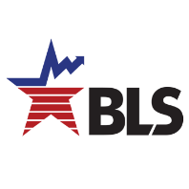

*Screening Questions*

(Ask if not apparent) Are you…

* Male
* Female
* Transgender, non-binary, or another gender?

What is your age? [open numeric entry]

What is the highest level of school you have completed or the highest degree you have received? [Less than a high school diploma; High school graduate, no college; Some college or associate degree; Bachelor’s degree or higher]

What kind of work do you do, that is what is your occupation? (if more than one, collect all) [open-ended]

Do you have a child who would be willing to participate in a 30 minute survey interview? (yes/no 🡪 screen out)

What is your child’s age? [open numeric entry]

What grade is your child in? [open numeric entry]

What is your child’s gender? [open text entry]

Do you and your child agree to use Microsoft Teams for the video interview and have your camera on? (Yes/No)

If you will be using a smartphone, you will need to download the Microsoft Teams app before the interview.

Do you have multiple devices available, so we can interview you and your child at the same time? (Yes/No)