Appendix A: Screenshots

All diary forms and instructions will be based on the current 2024 Diary, which is accessible on the BLS public website: <https://www.bls.gov/cex/research_papers/pdf/2024-ced-diary-form.pdf>

**Instructions**

There are three versions of the instructions. The full Instructions page is shown on the next page, and the differences between the versions are highlighted here:

Version 1 will be the current diary, with the first bullet as is:

Enter the name of the restaurant, vendor, or cafeteria where you made this purchase.

Version 2 will modify the first bullet:

Enter the name of the restaurant, vendor, or cafeteria where you made this purchase. If you used a third-party app or website to order or deliver the food, include the name of that service and the name of the restaurant.

Version 3 will modify the first bullet:

Enter the name of the restaurant, vendor, or cafeteria where you made this purchase. If you used a third-party service to order or deliver the food, include the name of the service and the name of the restaurant.

**Version 1: Version 2: Version 3:**



**Form**

There are three versions of the form. The full form section is shown below, and the differences between the versions are highlighted here:

Version 1 will be the current column label as is:

Name of Restaurant or Vendor

Version 2 will modify the label:

Name of the Restaurant or Vendor AND Name of App or Website, if used

Version 3 will modify the label:

Name of the Restaurant or Vendor AND Name of Third-Party Service, if used

All versions will have a modified example:

2nd example: DoorDash / Panera

**Version 1:**

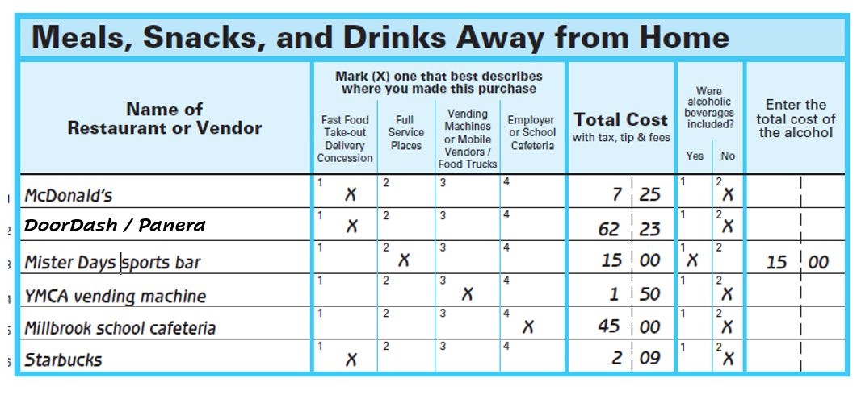



**Version 2:**



**Version 3:**

