# Appendix D: Advertisements for Cognitive Interviews

*Flyers for community bulletin boards*

**Research Participants Needed!**

**Earn $50**

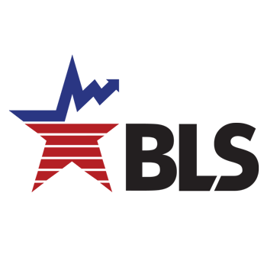

**Participate in an Interview**

with the

**U.S. Bureau of Labor Statistics**

Interviews will be conducted in-person at <LOCATION TBD>

Contact us at Research@bls.gov

* Interviews last up to 60 minutes
* Interviews will take place in-person at <LOCATION TBD>
* Payment by digital Visa gift card, which can be spent online
* Your responses will help to improve our surveys
* More information about our office at www.bls.gov/osmr/overview.htm

*Emails to community listservs*

The U.S. Bureau of Labor Statistics is looking for members of the community to share their feedback in research interviews. By participating in this research, you’ll help us improve our survey and how we measure what people do!

Participation is in-person at <LOCAION TBD>. Interview sessions last up to 60 minutes. Participants receive $50 by egift card, which can be spent online.

If you are interested, please contact us at [Research@bls.gov](mailto:Research@bls.gov)with the subject line “Time-Use Study.” Please include your name, email address, phone number, city and state in which you live.

For more information about our office, please go to [www.bls.gov/osmr/overview.htm](http://www.bls.gov/osmr/overview.htm).

*Snowball sampling text*

The U.S. Bureau of Labor Statistics is looking for members of the community to share their feedback in research interviews. By participating in this research, you’ll help us improve our survey and how we measure what people do!

Participation is online or by telephone. Interview sessions last up to 60 minutes. Participants receive $50 by egift card, which can be spent online.

If you are interested, please contact us at [Research@bls.gov](mailto:Research@bls.gov) with the subject line “Time-Use Study.” Please include your name, email address, phone number, city and state in which you live.

*Advertisements for online bulletin boards*

Posting title: Give us your feedback! Participate in an interview and earn $50

Posting content:

The U.S. Bureau of Labor Statistics is looking for members of the community to share their feedback in research interviews. By participating in this research, you’ll help us improve our survey and how we measure what people do!

Interviews will be conducted in-person at <LOCATION TBD>. Interview sessions last up to 60 minutes. Participants receive $50 by egift card, which can be spent online.

If you are interested, please contact us at [Research@bls.gov](mailto:Research@bls.gov) with the subject line “Time-Use Study.” Please include your name, email address, phone number, city and state in which you live.

For more information about our office, please go to [www.bls.gov/osmr/overview.htm](http://www.bls.gov/osmr/overview.htm).

