Appendix A: Screenshots
All diary forms and instructions will be based on the current 2024 Diary, which is accessible on the BLS public website: https://www.bls.gov/cex/research_papers/pdf/2024-ced-diary-form.pdf

Instructions
There are three versions of the instructions. The full Instructions page is shown on the next page, and the differences between the versions are highlighted here:
Version 1 will be the current diary, with the first bullet as is:
Enter the name of the restaurant, vendor, or cafeteria where you made this purchase.
Version 2 will modify the first bullet:
Enter the name of the restaurant, vendor, or cafeteria where you made this purchase. If you used a third-party app or website to order or deliver the food, include the name of that service and the name of the restaurant.
Version 3 will modify the first bullet:
Enter the name of the restaurant, vendor, or cafeteria where you made this purchase. If you used a third-party service to order or deliver the food, include the name of the service and the name of the restaurant.

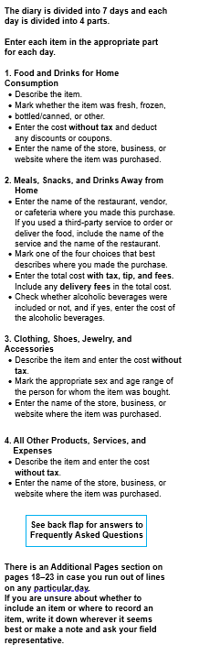
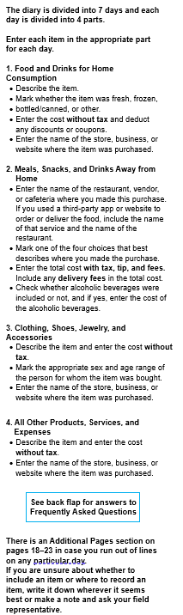
Version 1: Version 2: Version 3:
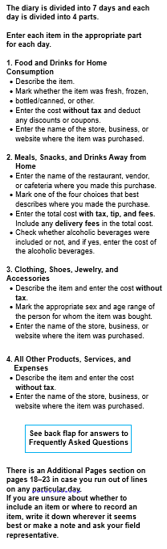

Form
There are three versions of the form. The full form section is shown below, and the differences between the versions are highlighted here:
Version 1 will be the current column label as is:
Name of Restaurant or Vendor
Version 2 will modify the label:
Name of the Restaurant or Vendor AND Name of App or Website, if used
Version 3 will modify the label:
Name of the Restaurant or Vendor AND Name of Third-Party Service, if used

All versions will have a modified example:
2nd example: DoorDash / Panera

Version 1:
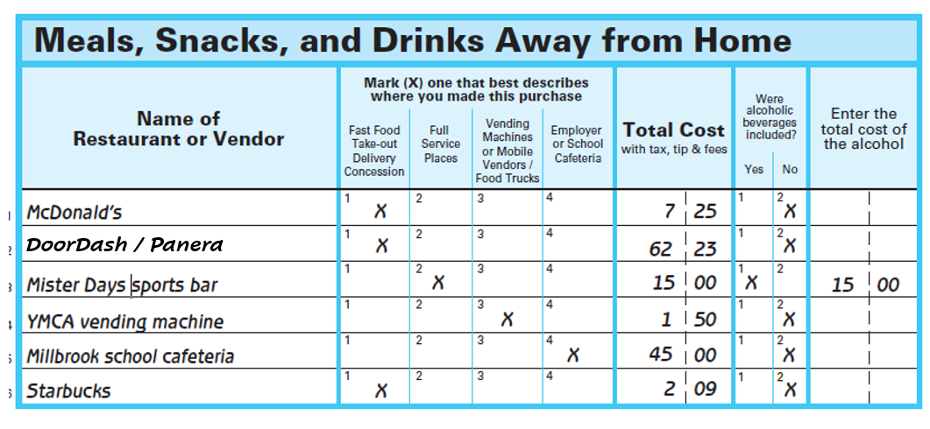
Version 2:
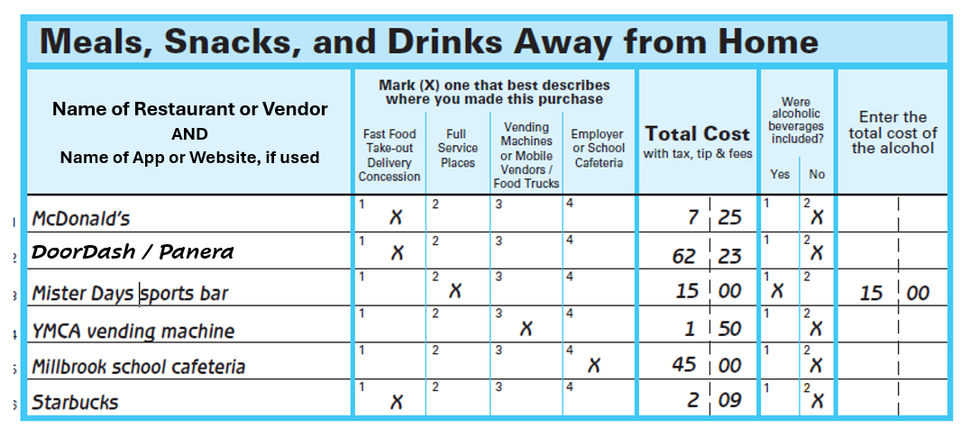
Version 3:
