Attachment C: Web Survey Instrument

Welcome! Thank you for your interest in our research to improve the National Longitudinal Survey of Youth, a survey that follows American youth to collect information on labor market behavior and educational experiences.

The study should take about 15 minutes. Please only start the study when you will be able to complete the whole study without interruption. Please do your best to respond to the questions accurately.

Please do not use your browser's back button.

This voluntary study is being collected by the Bureau of Labor Statistics under OMB No. 1220-0141 (Expiration Date: July 31, 2027). Without this currently approved number, we could not conduct this survey. This survey will take approximately 15 minutes to complete. If you have any comments regarding this estimate or any other aspect of this study, send them to BLS_PRA_Public@bls.gov. The BLS cannot guarantee the protection of survey responses and advises against the inclusion of sensitive personal information in any response. This survey is being administered by Qualtrics and resides on a server outside of the BLS Domain. Your participation is voluntary, and you have the right to stop at any time.

---page break---

What is your CloudResearch Connect ID?
[open entry]

For accuracy, please re-enter your CloudResearch Connect ID:
[open entry]

---page break---

What is your age?
[open numeric entry]

What is the highest level of school you have completed or the highest degree you have received?
- Less than a high school diploma
- High school graduate, no college
- Some college or associate degree
- Bachelor's degree or higher

What is your sex?
- Male
- Female

---page break---

We would like to talk to you about any work you have done in the past TWO YEARS, that is from [date] to [date]:

Please read the following information carefully:

- Work for pay: When answering these questions, please tell us about any work you did for pay, as well as any work you did for a family business, whether or not you were paid.
- Types of jobs: We are interested in all types of jobs, including those where you worked for an employer, such as being an employee of a supermarket or restaurant.
- Self-employment: We are also interested in any self-employment work you have done. Self-employment includes working as a freelancer, independent contractor, or independent consultant and working for yourself in your own business. It also includes informal work for pay, such as mowing a lawn or babysitting for a neighbor.
- Multiple jobs: Please do not count work for different clients or customers as different jobs if the line of work is the same.
  - For example, if you work as a painter and painted three homes, count house painting as one job, not three.
  - Or if you deliver food and get customers through two different apps, please count food delivery as one job, not two.

---page break---

[For calendar group: Please look at the calendars below, which include dates, along with holidays and other events. Think about all jobs you have held for the last TWO YEARS, and the dates you worked at them].

---page break---

Let’s start by making a list of all jobs you’ve held in the last TWO YEARS [fill dates].
Please include all jobs where you were working for a particular employer, including working in a family business, as well as jobs where you were self-employed, freelancing, or working informally for pay.

In the spaces below, please provide a brief description (for example, server, cashier, babysitter) for up to 5 jobs you have held in the last two years, starting with your CURRENT or MOST RECENT job. Note that each job must be unique (do not list the same job twice).

Job 1 (Current/Most recent job): ___________
Job 2: ___________
Job 3: ___________
Job 4: ___________
Job 5: ___________

---page break---

Loop through questions for each job provided

You said your most recent job was (fill Job 1). Are you currently working at this job?
- Yes
- No

---page break---

On what month, day, and year did you first start working as (fill Job X)?
<Calendar picker>

(If date is missing): These dates are very important for our survey. Please provide the date or your best guess.
On what month, day, and year did you first start working as (fill Job X)?
<Calendar picker>

---page break---

How did you come up with this date? (randomize all but last option)
- Recalled from memory
- Estimated
- Used a personal calendar
- Used personal records
- Looked up a timesheet or paystub
- Guessed
- Something else, specify: ____

You said that you started (fill job) on (fill month/day/year). How confident are you that started (fill job) during that month?
- Not at all confident
- Somewhat confident
- Moderately confident
- Very confident
- Completely confident

You said that you started (fill job) on (fill month/day/year). How confident are you that you started this job on that exact day?
- Not at all confident
- Somewhat confident
- Moderately confident
- Very confident
- Completely confident

(If not at all or somewhat confident) For what reasons are you not confident? ____

(If Very/Completely) For what reasons are you confident? ____

---page break---

(If not currently working at Job X) On what month, day, and year did you stop working as (fill Job X)?
<Calendar picker>

(If date is missing): These dates are very important for our survey. Please provide the date or your best guess. You can refer to the calendar above to help you determine the date.
On what month, day, and year did you last stop working as (fill Job X)?
<Calendar picker>

---page break---

How did you come up with this date? (randomize all but last option)
- Recalled from memory
- Estimated
- Used a personal calendar
- Used personal records
- Looked up a timesheet or paystub
- Guessed
- Something else, specify: ____

You said that you ended your job as (fill job) on (fill day). How confident are you that you started this job on this exact day?
- Not at all confident
- Somewhat confident
- Moderately confident
- Very confident
- Completely confident

(If not at all or somewhat confident) For what reasons are you not confident? ___

How confident are you that ended this job in (FILL MONTH)?
- Not at all confident
- Somewhat confident
- Moderately confident
- Very confident
- Completely confident

---page break---

On your job as (fill Job X), are you self-employed?
As a reminder, self-employment includes working as a freelancer, independent contractor, or independent consultant, working for yourself in your own business, and informal work for pay.
- Yes
- No
- Not sure, please explain: _______

In your daily life, what would you call this type of work in conversation with other people your age? (randomize all but last option)
- Self-employment
- Freelancer
- Independent contractor
- Independent consultant
- Your own business
- Gig work
- Side hustle
- Odd jobs
- Something else, specify: ____

---page break---

On this job, do you work for a temporary help or staffing agency or other company that provides you or your services to other organizations or clients under contract?

- Yes
- No
- Not sure, please explain: ____

---page break---

(If not sure)
- Some companies provide workers or their services to other companies under contract. Workers in these situations are paid by one company but spend much or all of their time working for a client, often at the client’s worksite.
  - For example, temporary help and other staffing agencies supply workers in a wide range of occupations to factories, offices, hospitals, among other organizations.
  - Other companies provide specialized services under contract to clients. A few examples of services that can be provided under contract include private security, landscaping, and IT services.

On this job, do you work for a temporary help or staffing agency or other company that provides you or your services to other organizations or clients under contract?

- Yes
- No
- Still not sure, please explain: _____

---page break---

Which of the following best describes your employment arrangement on (fill Job X)?
- Employee
- Self-employed/business owner
- Independent contractor, independent consultant, or freelancer
- Informal or cash basis
- Something else, specify: _____

(Ask all in first loop) In your own words, what does working on an “informal or cash basis” mean to you? ______

(If selected that they work on an informal or cash basis) How does this arrangement work? ______

---page break---

[For calendar group: Please look at the calendars below, which include dates, along with holidays and other events. Think about any periods of two full weeks or more where you were not working at your previous job(s).]

<Loop through questions for each job reported on roster>

For one reason or another, people often do not work for a couple of weeks, a month, or even longer. For example, strikes, layoffs, and extended illnesses can cause people to miss work.

Between [fill date] and [fill date], were there any periods of two full weeks or more during which you did not work at [fill Job X], not counting paid vacations or paid sick leave?

- Yes
- No
- Not sure (please explain): _____

(If no or not sure)

Thinking again about your job at [fill Job X], were there any periods of two full weeks or more during which you did not work at this job, not counting paid vacations or paid sick leave?
- Yes
- No

(If yes) How many periods of a full two weeks or more did you not work at [fill Job X], not counting paid vacations or paid sick leave?

- One
- Two
- Three
- Four or more

---page break---

<Loop through each gap per each job reported>

Please think about the [longest/second longest/third longest] period between [fill date] and [fill date] during which you didn't work at this job for a full two weeks or more.
When did this period begin? Please use the calendar to give your best estimate of the date (month, day, and year).
<calendar picker>

(If missing) These dates are very important for our survey. Please provide the date or your best guess of the month and year. You can refer to the calendar above to help you determine the date (month, day, and year).
<calendar picker>

---page break---

How did you come up with this date? (randomize all but last option)
- Recalled from memory
- Estimated
- Used a personal calendar
- Used personal records
- Looked up a timesheet or paystub
- Guessed
- Something else, specify: ____

You said that this period began on (fill day). How confident are you that this is the exact day?
- Not at all confident
- Somewhat confident
- Moderately confident
- Very confident
- Completely confident

(If not at all or somewhat confident) For what reasons are you not confident? ____

How confident are you that this period began (FILL MONTH)?
- Not at all confident
- Somewhat confident
- Moderately confident
- Very confident
- Completely confident

---page break---

Please think about the [longest/second longest/third longest period] between [fill date] and [fill date] during which you didn't work at this job for a full two weeks or more.
When did this period end? Please use the calendar to give your best estimate of the date.
<calendar picker>

(If missing) These dates are very important for our survey. Please provide the date or your best guess of the month and year. You can refer to the calendar above to help you determine the date.

---page break---

How did you come up with this date? (randomize all but last option)
- Recalled from memory
- Estimated
- Used a personal calendar
- Used personal records
- Looked up a timesheet or paystub
- Guessed
- Something else, specify: ____

You said that this period ended on (fill day). How confident are you that this is the exact day?
- Not at all confident
- Somewhat confident
- Moderately confident
- Very confident
- Completely confident

(If not at all or somewhat confident) For what reasons are you not confident? ___

How confident are you that this period ended (FILL MONTH)?
- Not at all confident
- Somewhat confident
- Moderately confident
- Very confident
- Completely confident

Which of the following best describes the MAIN reason why did you not work during this period of time?
- On strike
- On temporary layoff, expecting to be called back to work
- Quit job but returned to same employer
- Job ended for a period of time but began again
- Some other reason you went on unpaid vacation/leave, specify: ___

---page break---

Next, we’d like you to read some fictional scenarios about people’s work, and answer questions about them.

Ava has cared for 2 kids in the Smith family for the past three years. The first year, she provided childcare every few months. The second year, she provided childcare on the first Friday of every month. The third year, because of her school schedule, she only cared for the Smith kids during the summer.
Would you say that Ava has any job gaps? A job gap is a period of two full weeks or more during which someone does not work and is not paid.
- Yes
- No
- Not sure, please explain: ___
(If yes) How many job gaps did Ava have?
- 0
- 1
- 2
- 3 or more
---page break---

John mows lawns for 6 families in his neighborhood. Every year, from May to August, he mows 3 lawns on Friday and 3 on Saturday. In July, he goes on a 1-week vacation with his family and does not mow any lawns. At the end of August, he packs away his mowing equipment until the next year.
Would you say that John has any job gaps? A job gap is a period of two full weeks or more during which someone does not work and is not paid.
- Yes
- No
- Not sure, please explain: ___
(If yes) How many job gaps did John have?
- 0
- 1
- 2
- 3 or more
---page break---

Jennifer waits tables at a restaurant on the weekends. She has had the same weekend schedule at the restaurant for the last 6 months. During the week, she auditions for theater productions.
Would you say that Jennifer has any job gaps? A job gap is a period of two full weeks or more during which someone does not work and is not paid.
- Yes
- No
- Not sure, please explain: ___
(If yes) How many job gaps did Jennifer have?
- 0
- 1
- 2
- 3 or more
---page break---
Next, we have some questions about different types of employment.
The first is about self-employment versus working for an employer.
- Self-employment includes working as a freelancer, independent contractor, or independent consultant and working for yourself in your own business.
- It also includes informal work for pay, such as mowing a lawn or babysitting for a neighbor.
Which of the following jobs are considered self-employment, according to the definition above? (Select all that apply; presented in random order)
- Mowing a neighbor’s lawn
- Babysitting for a neighbor
- Freelance graphic designer
- Owning a social media marketing business
- Independent contractor at a tutoring company
- Cashier at a supermarket
- Server at a restaurant
- Lifeguard at a hotel pool
- Sales associate at a clothing store
- Attendant at an amusement park

From the list below, indicate whether each job is considered self-employment, according to the definition above. (Yes/No radio buttons; presented in random order)
Yes No
Mowing a neighbor’s lawn
Babysitting for a neighbor
Freelance graphic designer
Owning a social media marketing business
Independent contractor at a tutoring company
Cashier at a supermarket
Server at a restaurant
Lifeguard at a hotel pool
Sales associate at a clothing store
Attendant at an amusement park

---page break---
We have another question about having one job versus more than one job.
- Do not count work for different clients or customers as different jobs if the line of work is the same. For example:
  - If you are self-employed and you do the same type of tasks or projects for many different customers or organizations (sometimes finding customers through an app), this counts as ONE job or type of work.
  - If you work as a painter and painted three homes, count house painting as one job, not three.
  - If you deliver food and get customers through two different apps, count food deliver as one job, not two.
  - If you pet sit for two people, please include that as one job and not two.
Which of the following are considered to be ONE job, according to the definition above? (Select all that apply; presented in random order)
- Delivering food for customers through two different apps
- Pet sitting for two people
- Painting three different homes
- Babysitting for multiple families
- Mowing lawns for multiple homes
- Working as a lifeguard and a sales associate
- Tutoring and doing social media marketing
- Working as a cashier and a landscaper
- Working as a computer programmer and dog walker
- Working at a library and as a camp counselor
From the list below, indicate whether each job is considered self-employment, according to the definition above. (Yes/No radio buttons; presented in random order)
Yes No
Delivering food for customers through two different apps
Pet sitting for two people
Painting three different homes
Babysitting for multiple families
Mowing lawns for multiple homes
Working as a lifeguard and a sales associate
Tutoring and doing social media marketing
Working as a cashier and a landscaper
Working as a computer programmer and dog walker
Working at a library and as a camp counselor

---page break---

Thank you for answering these questions.

Your completion code is: 152130

Calendars:

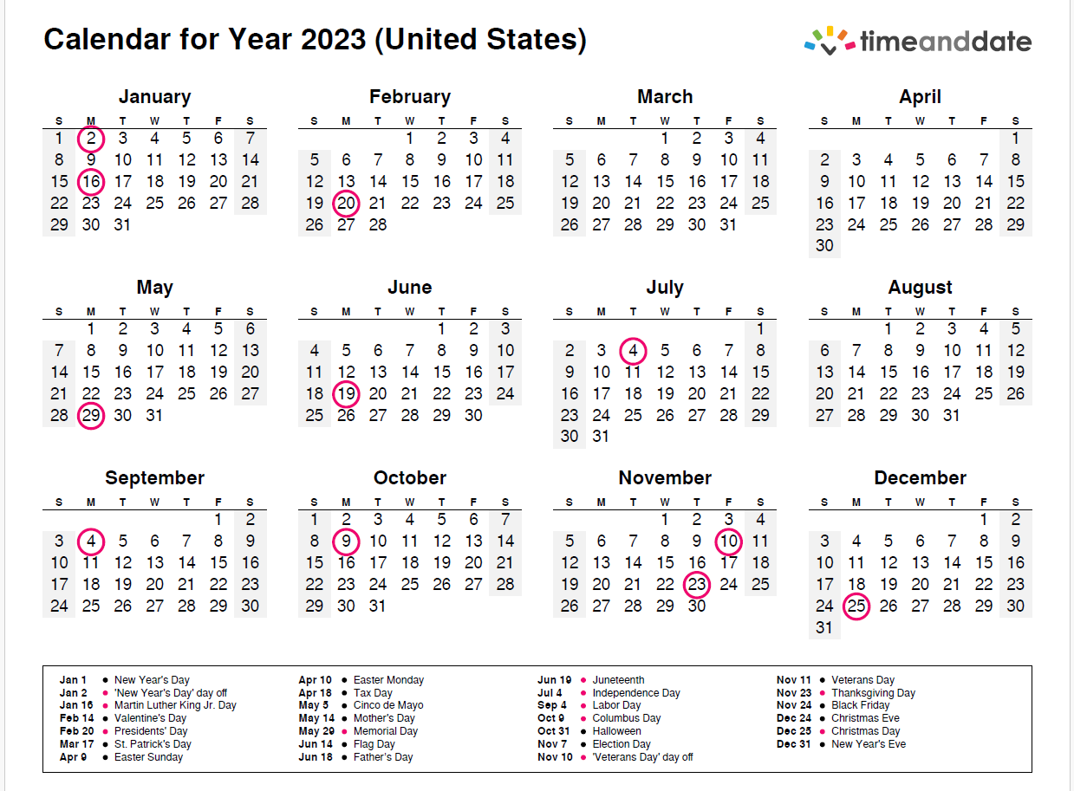
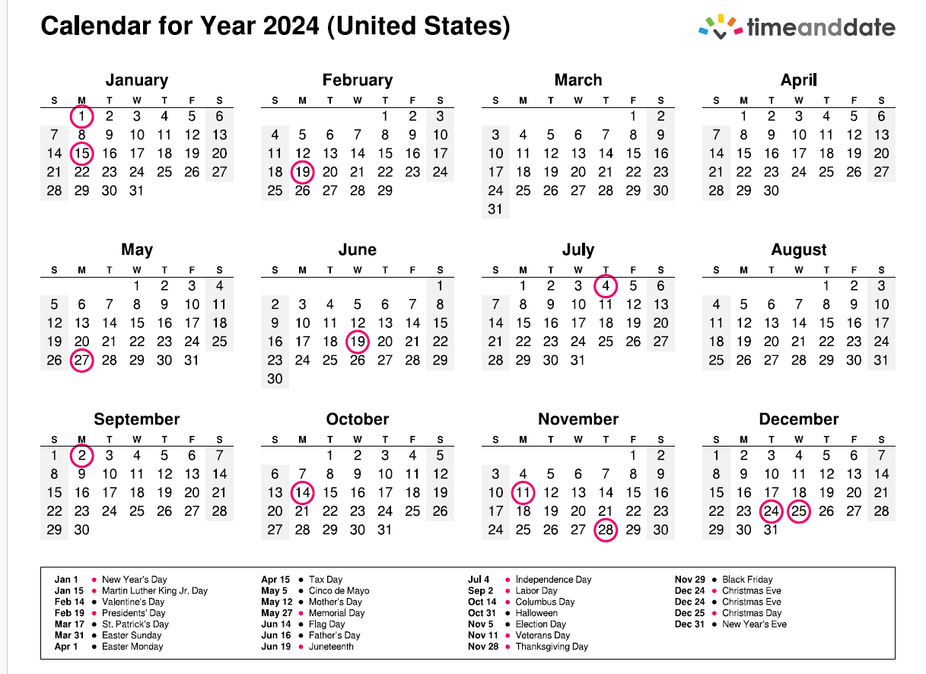

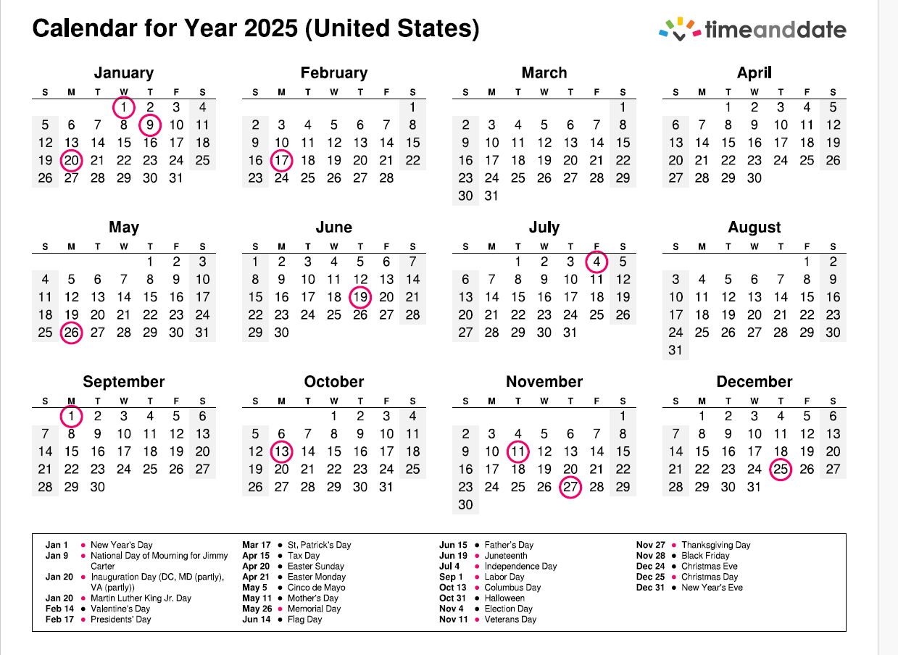

See the end of the protocol for the calendars

