ATTACHMENT B

Safer Choice Program: Product and Ingredient Submissions in the Safer Choice Community Cloud-based Salesforce System

OMB Control No. 2070-0221
Approval expires 5/31/2025

This collection of information is approved by OMB under the Paperwork Reduction Act, 44 U.S.C. 3501 et seq. (OMB Control No. 2070-0221). Responses to this collection of information are voluntary. An agency may not conduct or sponsor, and a person is not required to respond to, a collection of information unless it displays a currently valid OMB control number. The public reporting and recordkeeping burden for this collection of information is estimated to be 16 hours per response for formulators of cleaning and non-cleaning products establishing Partnership Agreements with Safer Choice, 11 hours per response for formulators undergoing partnership renewals and audits, and eight hours per response for partners wishing to add third-party partners and products, including the time for reviewing instructions, gathering information, and completing and reviewing the application. Send comments on the Agency’s need for this information, the accuracy of the provided burden estimates and any suggested methods for minimizing respondent burden to the Information Engagement Division Director, U.S. Environmental Protection Agency (2821T), 1200 Pennsylvania Ave., NW, Washington, D.C. 20460. Include the OMB control number in any correspondence. Do not send the completed form to this address.

Following are screenshots from the Product and Ingredient Submission forms in the Safer Choice Community cloud-based Salesforce data system. Please refer to Section 12b, IC #1 for a full list of data items collected. Note that the specific details of the screenshots may change over time as the Safer Choice program improves and/or modifies the system. However, the general and fundamental components of the Salesforce system will be similar to what is presented in the following screenshots.

Product Submissions

Quote or a Formal Review Page

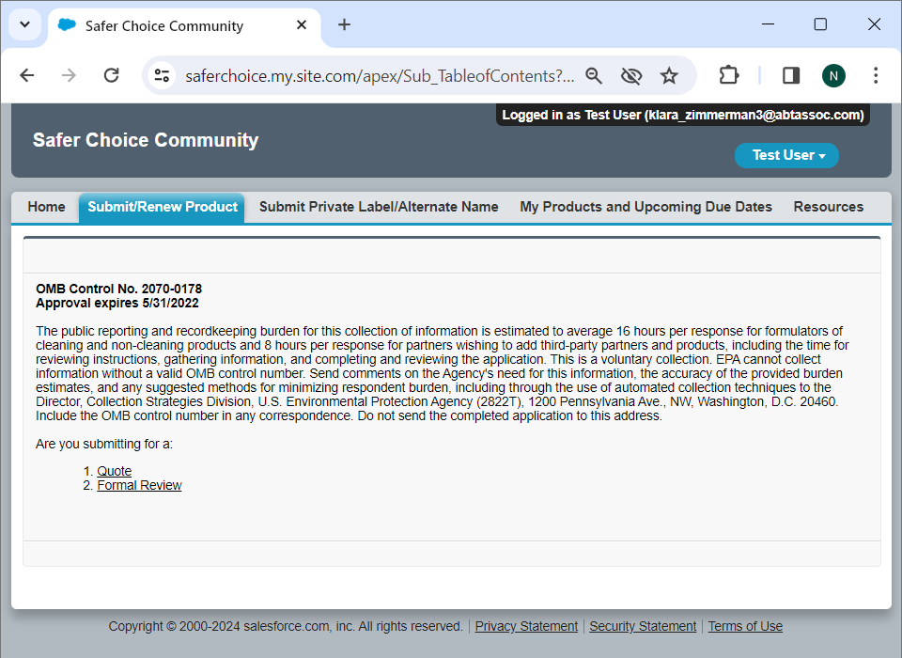

The respondent may choose to submit for a Quote or a Formal Review. The following screenshots show the Formal Review submission, which is the more comprehensive option and requires some information that the Quote submission does not.

Quick Tips and Table of Contents Page
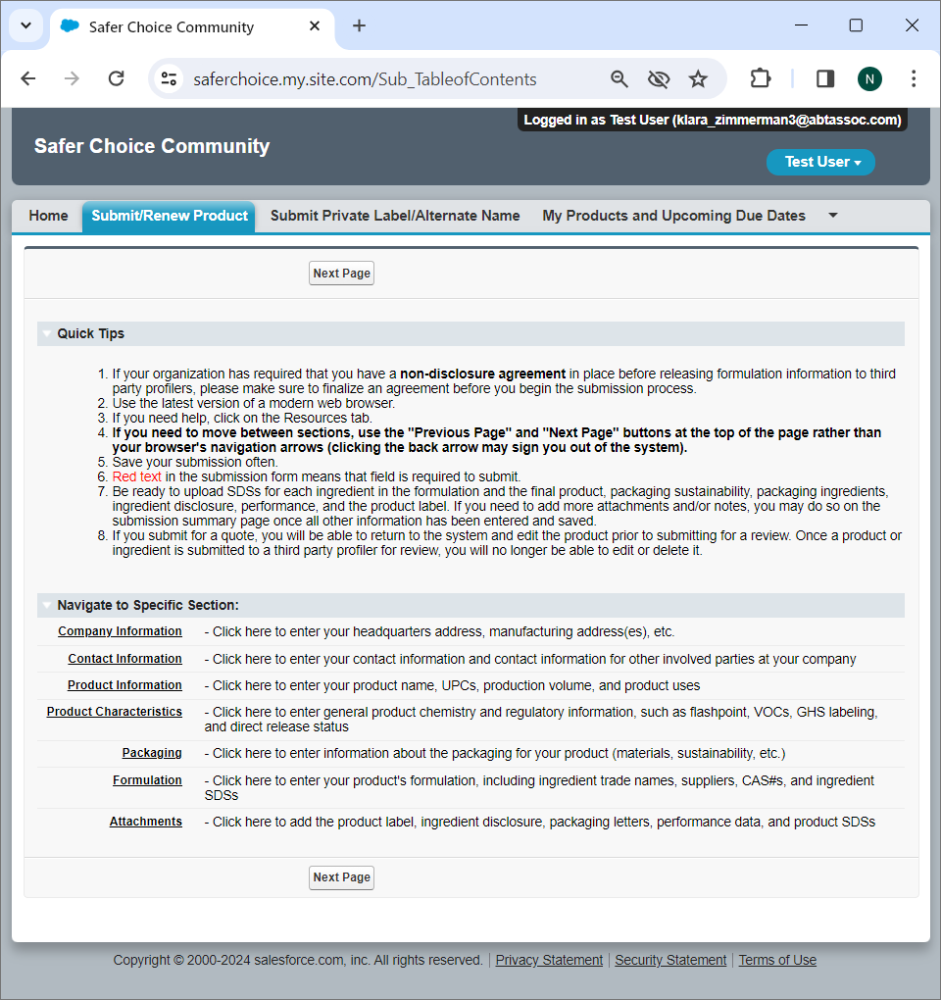

Company Information Page

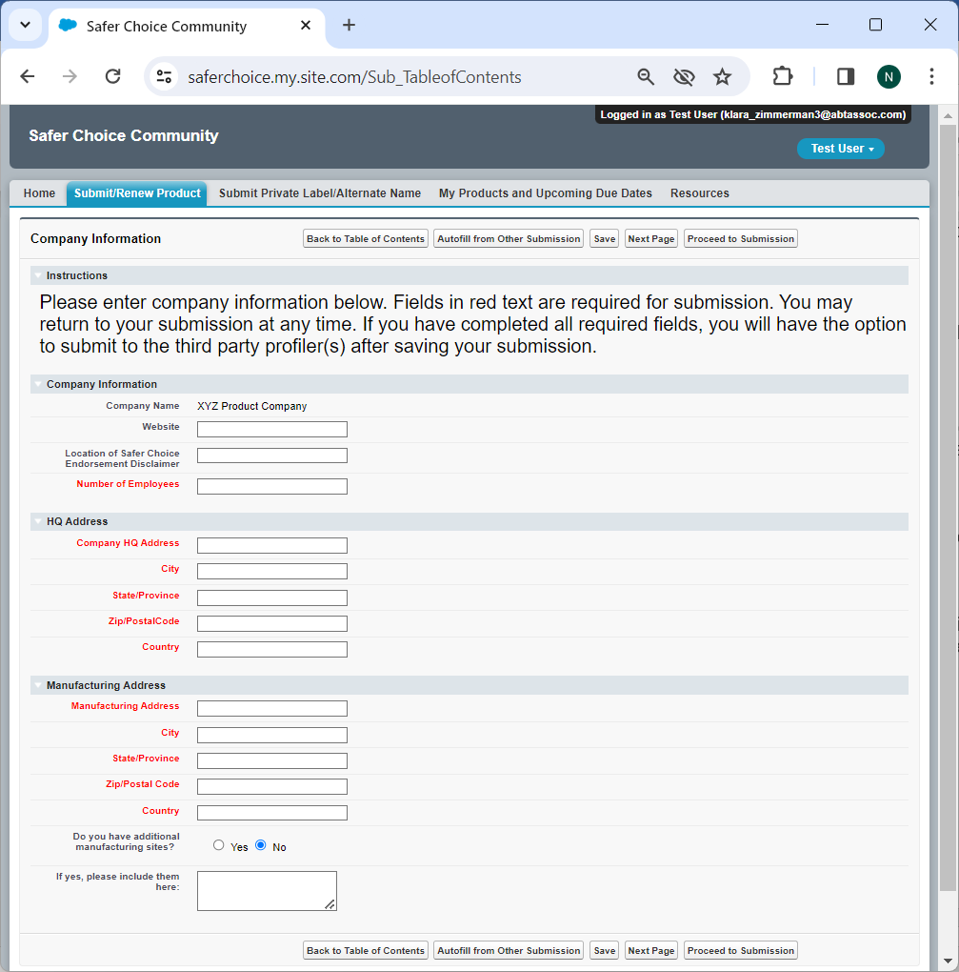

Clicking the Autofill from Other Submission button from any page within the submission opens a new page, shown on the next page, that allows the respondent to populate the fields on the current page using information from a previous submission.

Autofill from Existing Submission Page

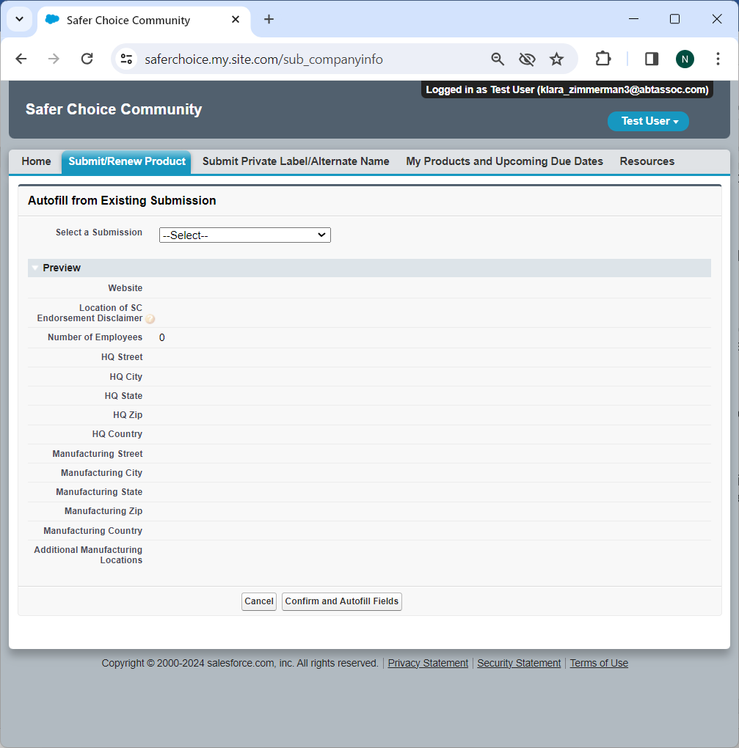

Select a Submission: Dropdown options include all of the respondent’s previous product submissions.

Contact Information Page

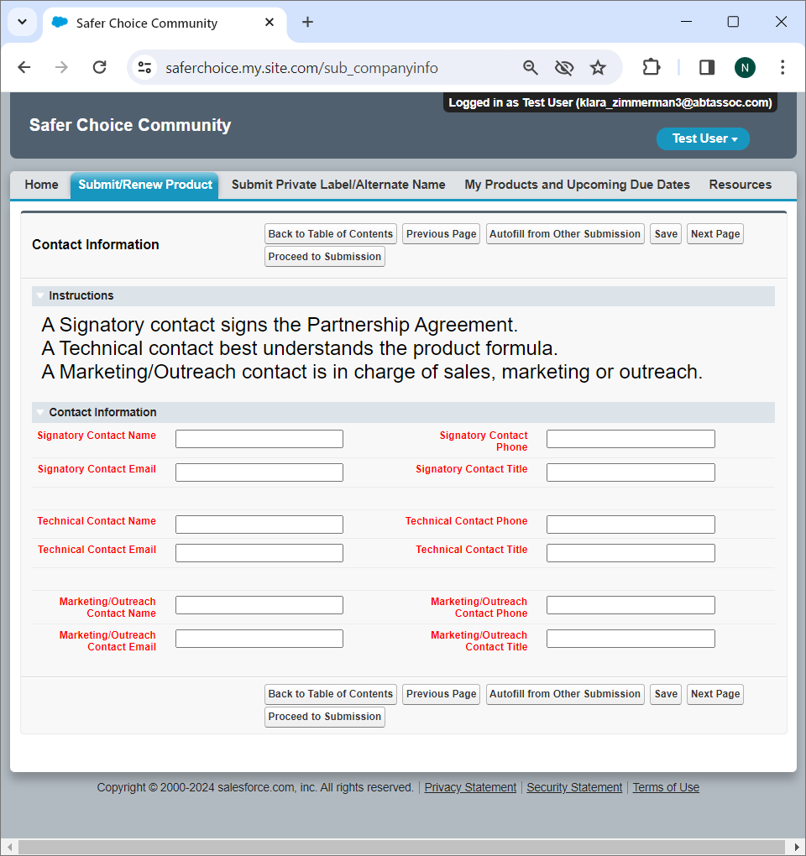

Product Information Page

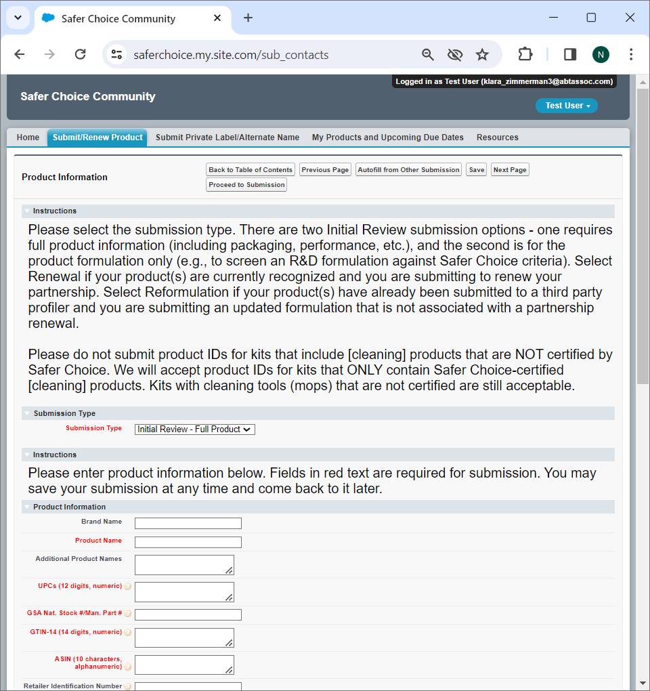

Submission Type: Dropdown options are Renewal, Reformulation, Initial Review – Full Product, Initial Review – Formulation

Product Information Page (cont.)

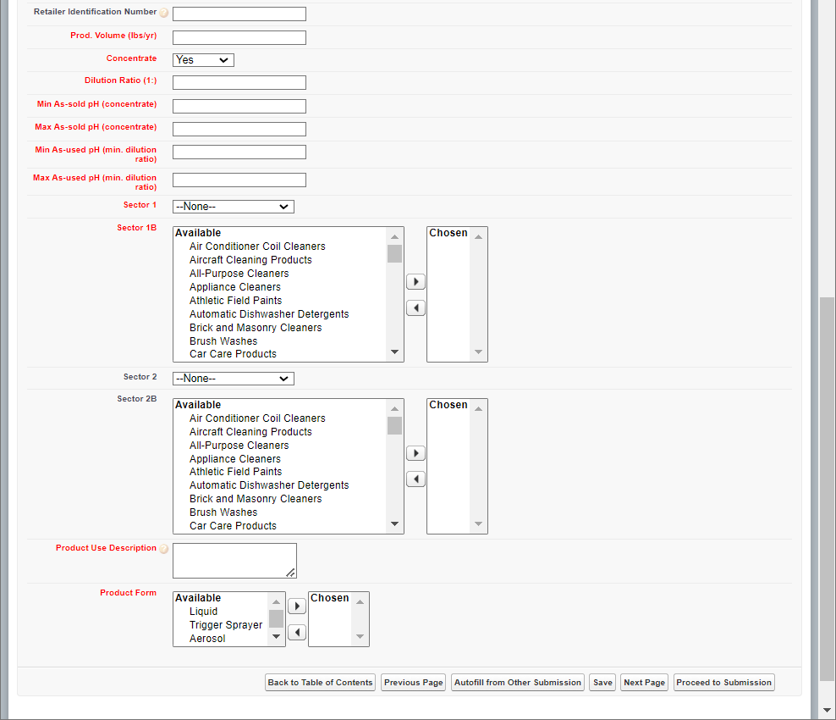

Concentrate: Dropdown options are Yes, No. If Yes, additional fields appear:

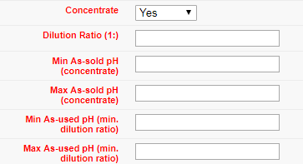

Product Information Page (cont.)

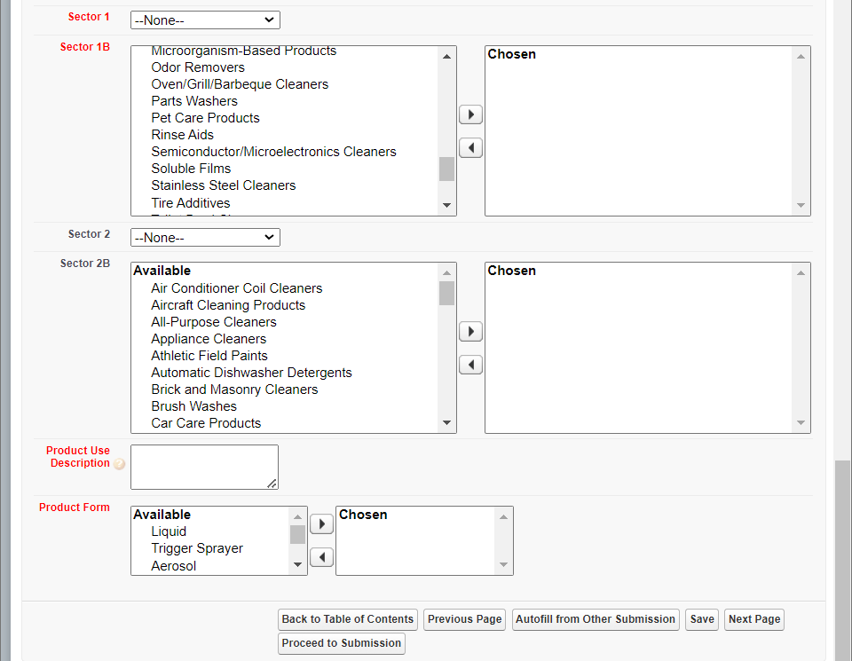

Sector 1 and Sector 2: Dropdown options are Consumer, Industrial/Institutional, Both, N/A

Sector 1B and Sector 2B: Pick list options are Air Conditioner Coil Cleaners; Aircraft Cleaning Products;-, All-Purpose Cleaners; Appliance Cleaners; Athletic Field Paints; Automatic Dishwasher Detergents; Brick and Masonry Cleaners; Brush Washes; Car Care Products; Carpet Care Products: Carpet Cleaners; Carpet Care Products: Spot Removers; Degreasers; Deicers; Descalers; Dish Soaps; Dry Erase Board Cleaners; Electronics; Fire Defense Products; Floor Care Products: Floor Cleaners; Floor Care Products: Floor Finishes; Floor Care Products: Floor Strippers; Graffiti Removers; Granite/Stone Cleaners; Hand Soaps; HVAC Maintenance; Industrial Coating: Conversion Coatings; Industrial Coating: Pavement Treatments; Inkjet Printing Products; Kitchen/Countertop Cleaners; Laundry Products: Boosters; Laundry Products: Dryer Sheets; Laundry Products: Fabric Softeners; Laundry Products: Laundry Detergents; Laundry Products: Pre-Treaters; Leather Cleaners; Marine/RV Cleaners; Medical Instrument Cleaners; Metal Cleaner/Polishes; Microorganism-Based Products; Odor Removers; Oven/Grill/Barbeque Cleaners; Parts Washers; Pet Care Products; Rinse Aids; Semiconductor/Microelectronics Cleaners; Soluble Films; Stainless Steel Cleaners; Tire Additives; Toilet Bowl Cleaners; Tub/Tile Cleaners; Upholstery Cleaners; Window/Glass Cleaners; Wood Cleaners; Other Industrial/Institutional Products; Other Consumer Products

Product Form: Pick list options are Liquid, Trigger Sprayer, Aerosol, Solid, Powder, Foaming Nozzle, Wipe, Other
Product Characteristics Page

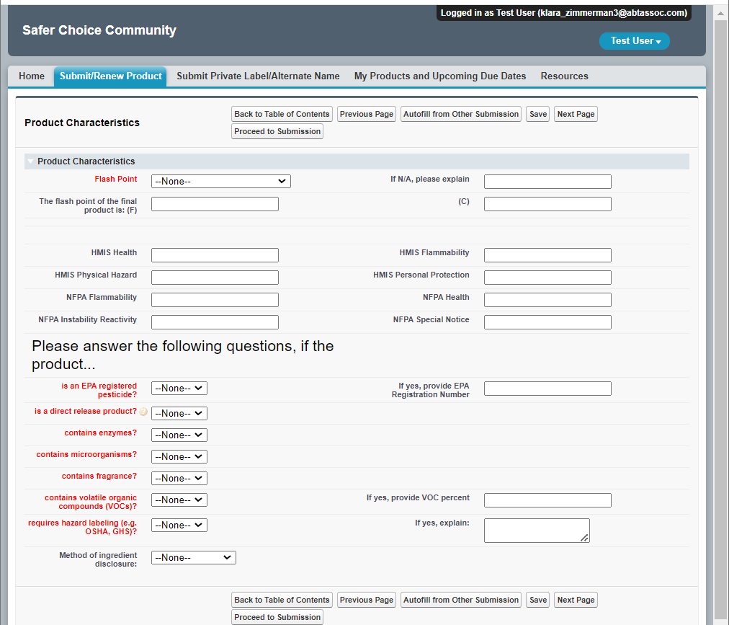

Flash Point: Dropdown options are N/A, <140 F, >140 F, HMIS Flammability Rating 0, HMIS Flammability Rating 1, HMIS Flammability Rating 2, HMIS Flammability Rating 3, HMIS Flammability Rating 4

Is an EPA Registered Pesticide: Dropdown options are Yes, No

Is direct release product: Dropdown options are Yes, No

Contains enzymes: Dropdown options are Yes, No

Contains microorganisms: Dropdown options are Yes, No

Contains fragrance: Dropdown options are Yes, No

Contains volatile organic compounds (VOCs): Dropdown options are Yes, No

Requires hazard labeling (e.g. OSHA, GHS): Dropdown options are Yes, No

Method of ingredient disclosure: Dropdown options are Product Label, Website, Phone Number, SDS, Other
Packaging Page

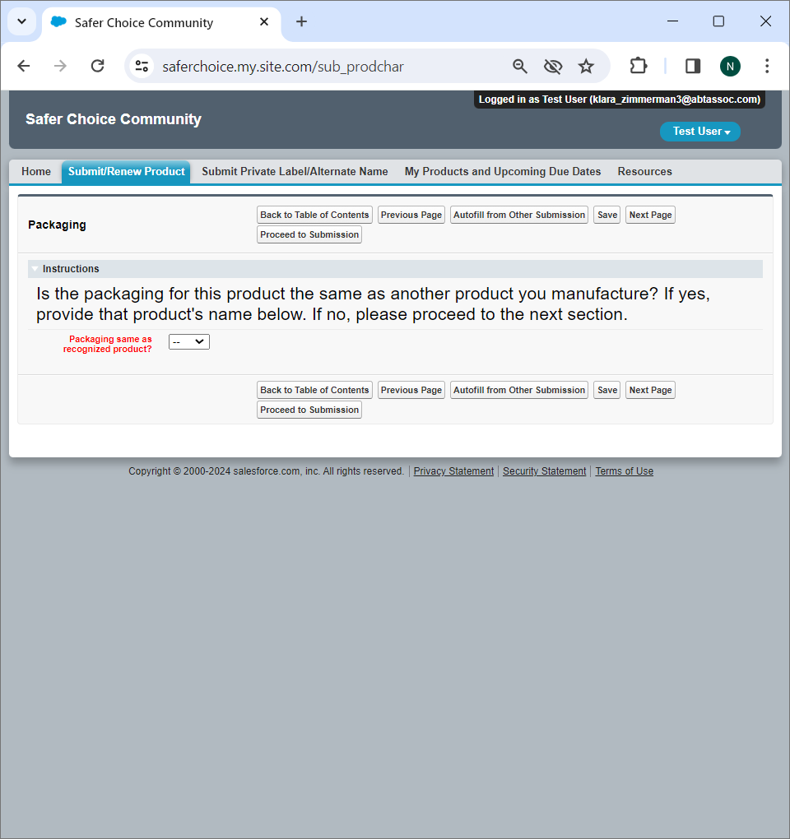

Packaging Page (cont.)

Packaging same as recognized product: Dropdown options are Yes, No. If no, additional instructions appear:

If yes:
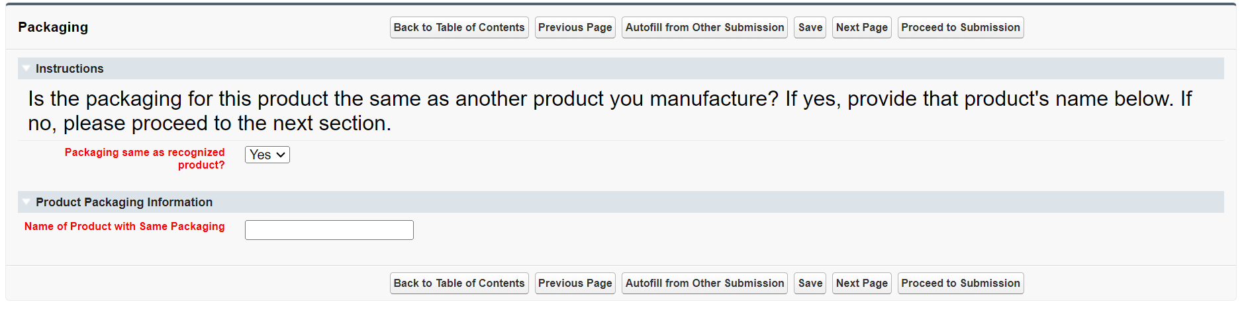
If no:
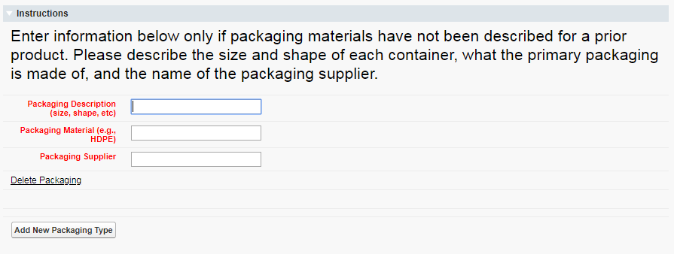

Formulation Page

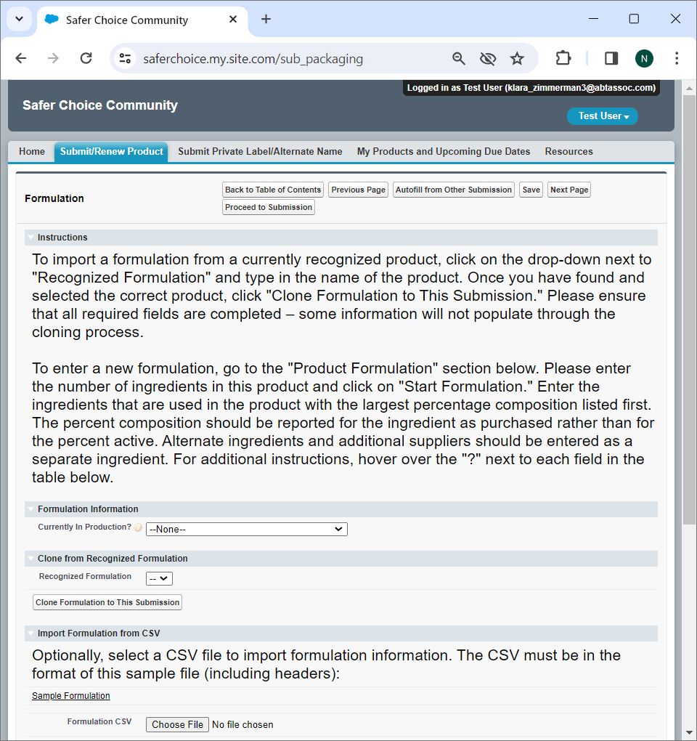

Currently in Production: Dropdown options are Yes, the formulation below is in production; No, this is a proposed formulation

Recognized Formulation: Dropdown options are the currently approved formulations on file with the Safer Choice program for the company

Formulation Page (cont.)

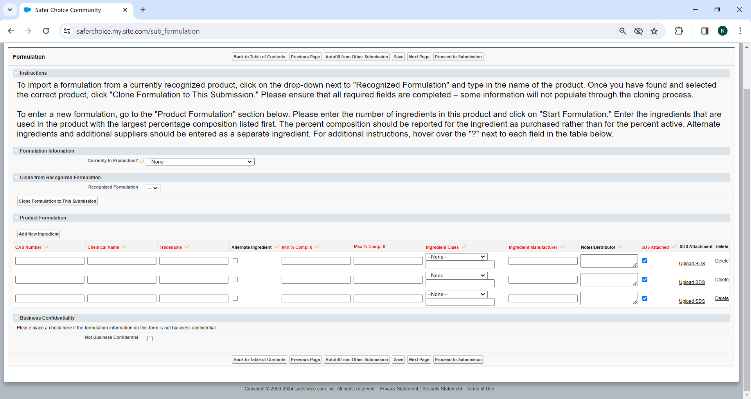
Ingredient Class: Dropdown options are Abrasive, Active, Antifoaming Agent, Antioxidant, Buffer, Builder, Chelant, Colorant, Corrosion Inhibitor, Deicer, Denaturant, Deodorant, Dispersant, Emollient, Enzyme, Fragrance, Hydrotrope, Impurity, Leveling Aid, Microorganism, Optical Brightener, Oxidant, pH Adjuster, Plasticizer, Polymer, Preservative, Propellant, Residual, Sequestrant, Solvent, Stabilizer, Surfactant, Thickener, Wax, Wetting, Other (please specify)

Attachments Page

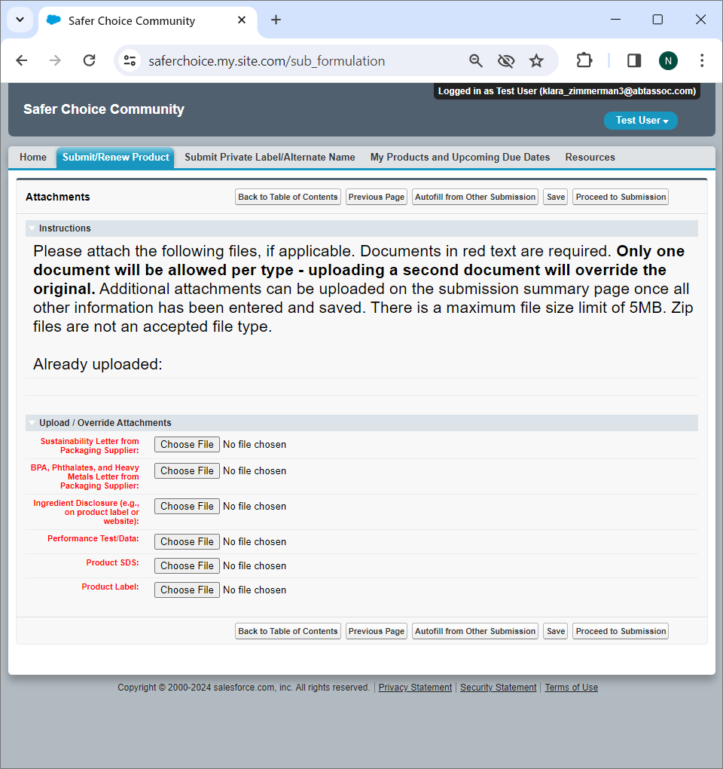
Ingredient Submissions
CleanGredients

CleanGredients Submission Page

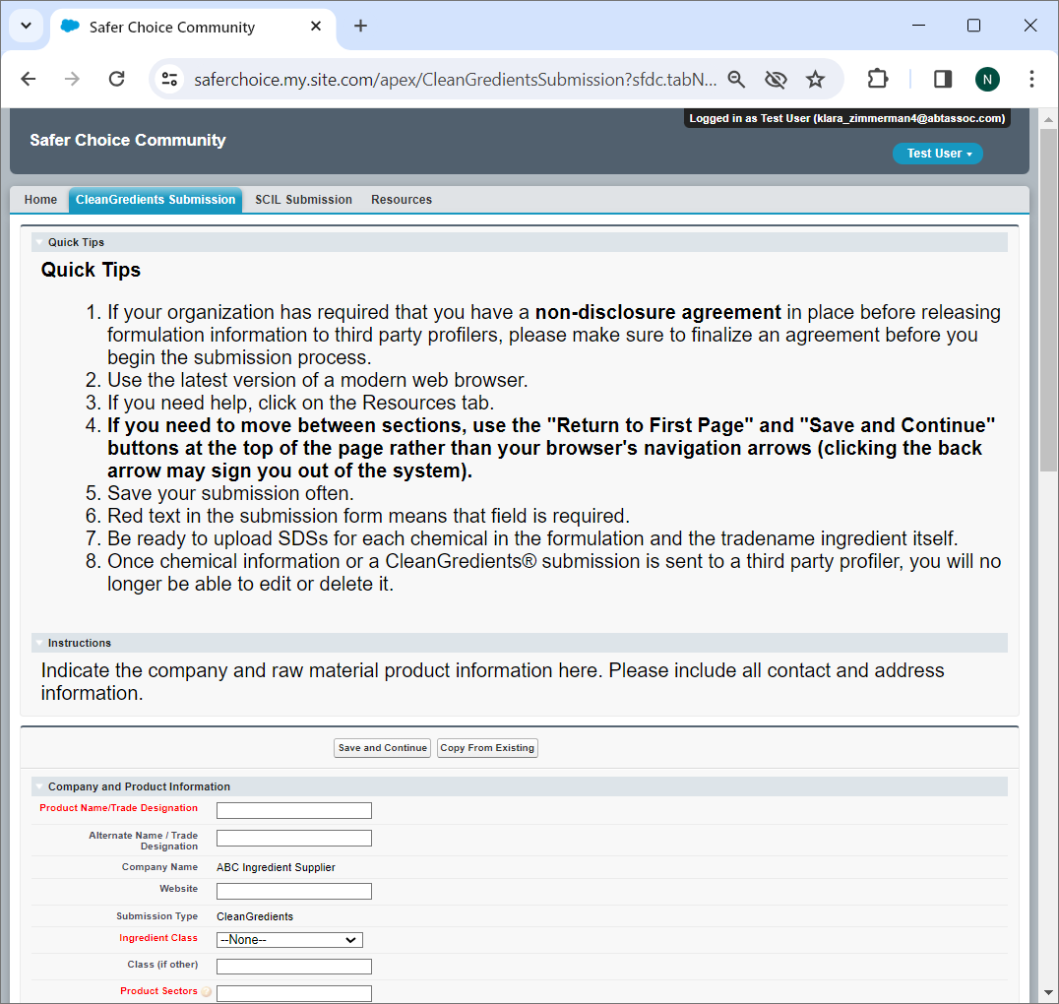
Ingredient Class: Dropdown options are Abrasive, Active, Antifoaming Agent, Antioxidant, Buffer, Builder, Chelant, Colorant, Corrosion Inhibitor, Deicer, Denaturant, Deodorant, Dispersant, Emollient, Enzyme, Fragrance, Hydrotrope, Impurity, Leveling Aid, Microorganism, Optical Brightener, Oxidant, pH Adjuster, Plasticizer, Polymer, Preservative, Propellant, Residual, Sequestrant, Solvent, Stabilizer, Surfactant, Thickener, Wax, Wetting, Other (please specify)

CleanGredients Submission Page (cont.)

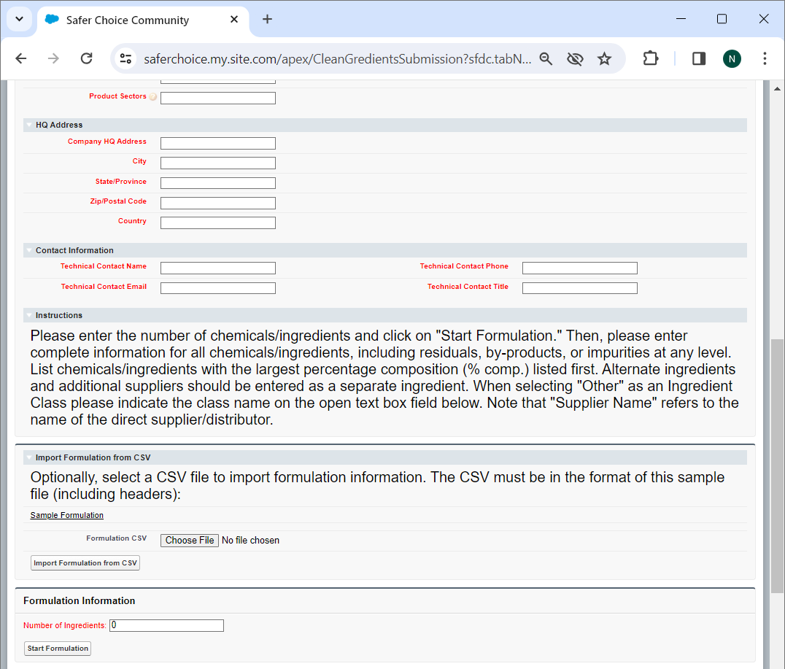

CleanGredients Submission Page (cont.)

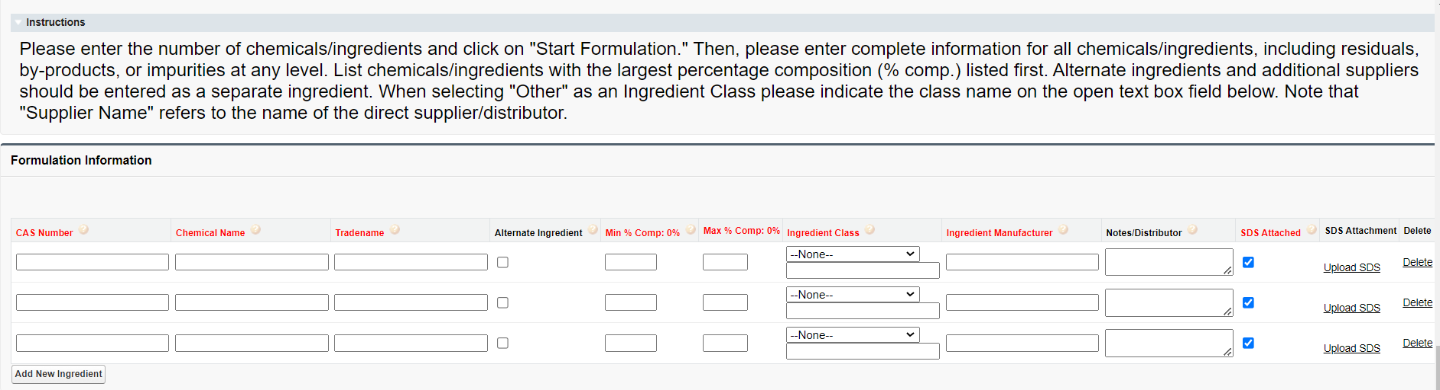Ingredient Class: Dropdown options are Abrasive, Active, Antifoaming Agent, Antioxidant, Buffer, Builder, Chelant, Colorant, Corrosion Inhibitor, Deicer, Denaturant, Deodorant, Dispersant, Emollient, Enzyme, Fragrance, Hydrotrope, Impurity, Leveling Aid, Microorganism, Optical Brightener, Oxidant, pH Adjuster, Plasticizer, Polymer, Preservative, Propellant, Residual, Sequestrant, Solvent, Stabilizer, Surfactant, Thickener, Wax, Wetting, Other (please specify)

CleanGredients Submission Page (cont.)

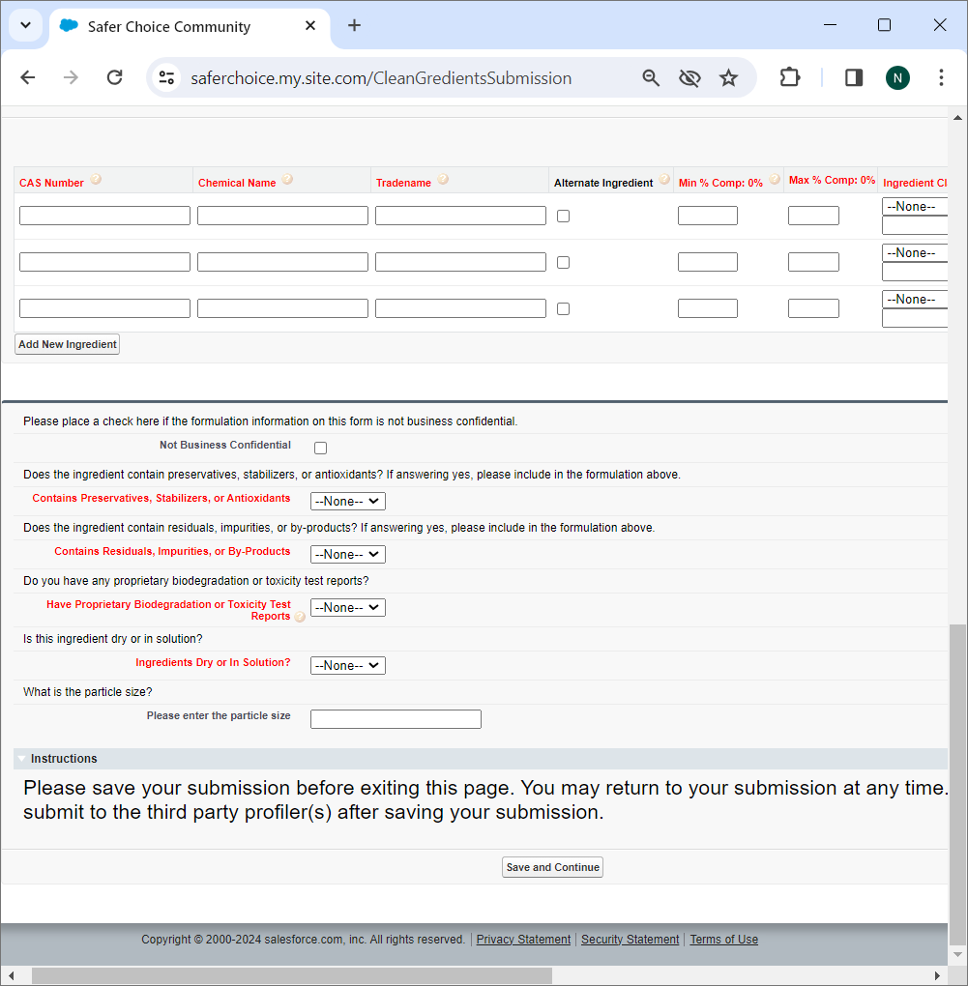

Contains Preservatives, Stabilizers, or Antioxidants: Dropdown options are Yes, No

Contains Residuals, Impurities, or By-Products: Dropdown options are Yes, No

Have Proprietary Biodegradation or Toxicity Test Reports: Dropdown options are Yes, No

Ingredients Dry or In Solution: Dropdown options are Dry, Solution

Attachment Page for CleanGredients Submission

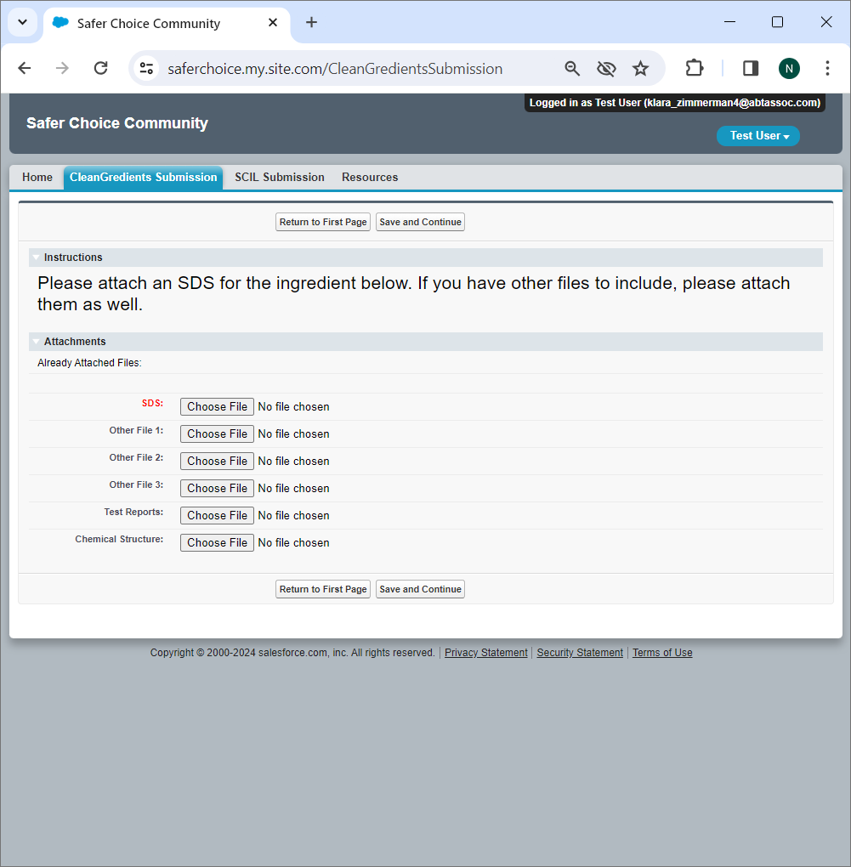

Missing Info Page for CleanGredients Submission

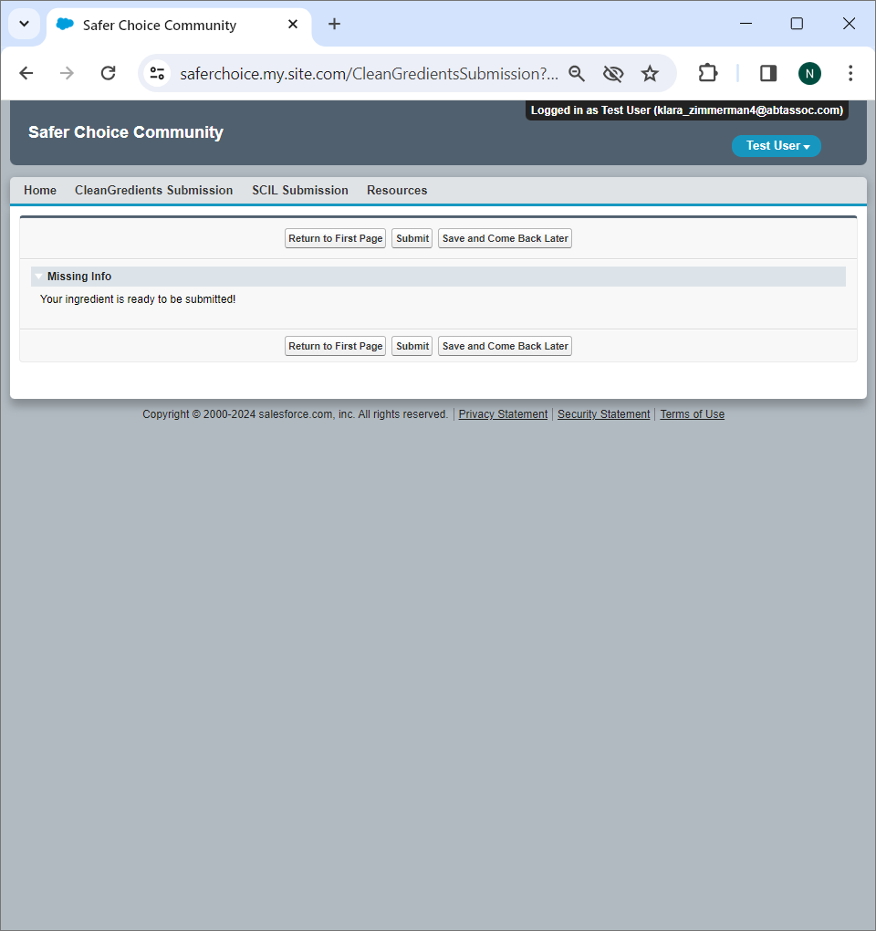

Safer Chemical Ingredients List (SCIL)

Safer Chemical Ingredients List (SCIL) Submission Page

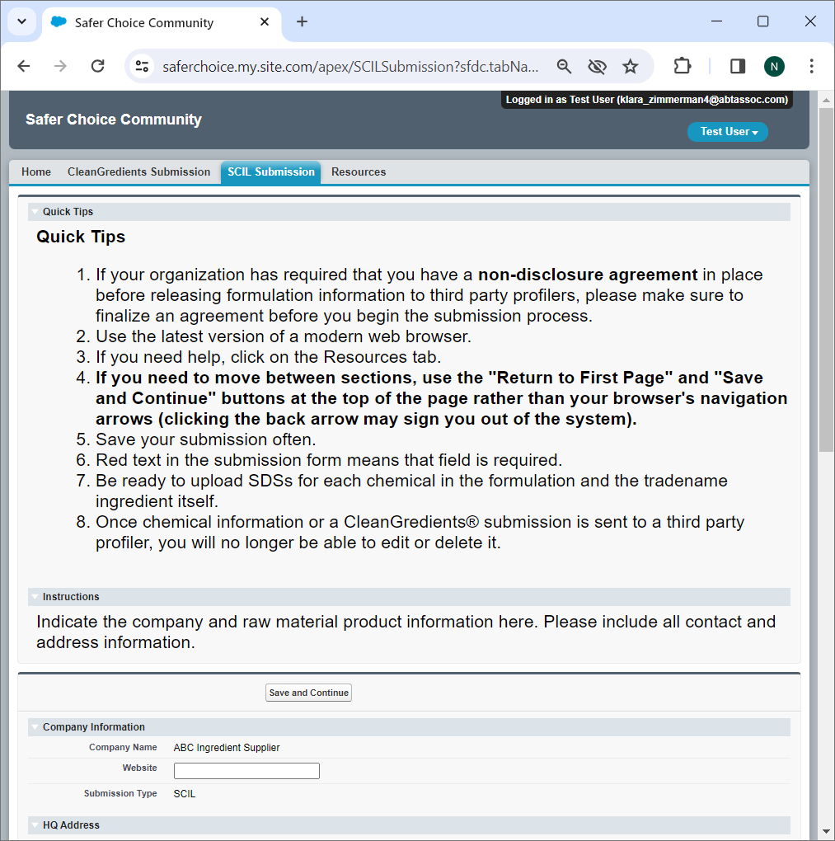

Safer Chemical Ingredients List (SCIL) Submission Page (cont.)

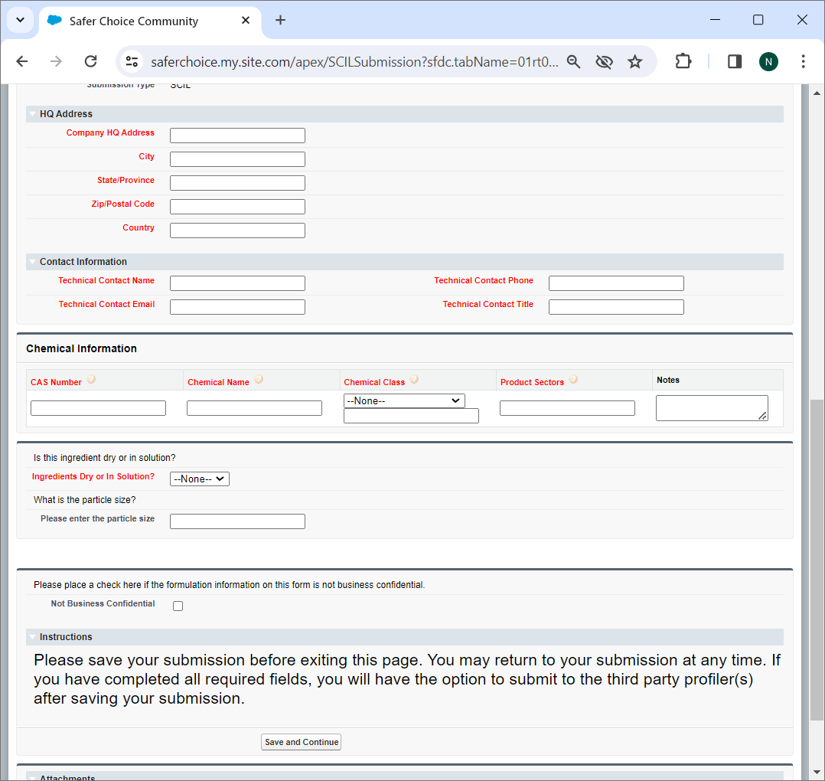

Chemical Class: Dropdown options are Abrasive, Active, Antifoaming Agent, Antioxidant, Buffer, Builder, Chelant, Colorant, Corrosion Inhibitor, Deicer, Denaturant, Deodorant, Dispersant, Emollient, Enzyme, Fragrance, Hydrotrope, Impurity, Leveling Aid, Microorganism, Optical Brightener, Oxidant, pH Adjuster, Plasticizer, Polymer, Preservative, Propellant, Residual, Sequestrant, Solvent, Stabilizer, Surfactant, Thickener, Wax, Wetting, Other (please specify)

Ingredients Dry or In Solution: Dropdown options are Dry, Solution

Attachment Page for SCIL Submission

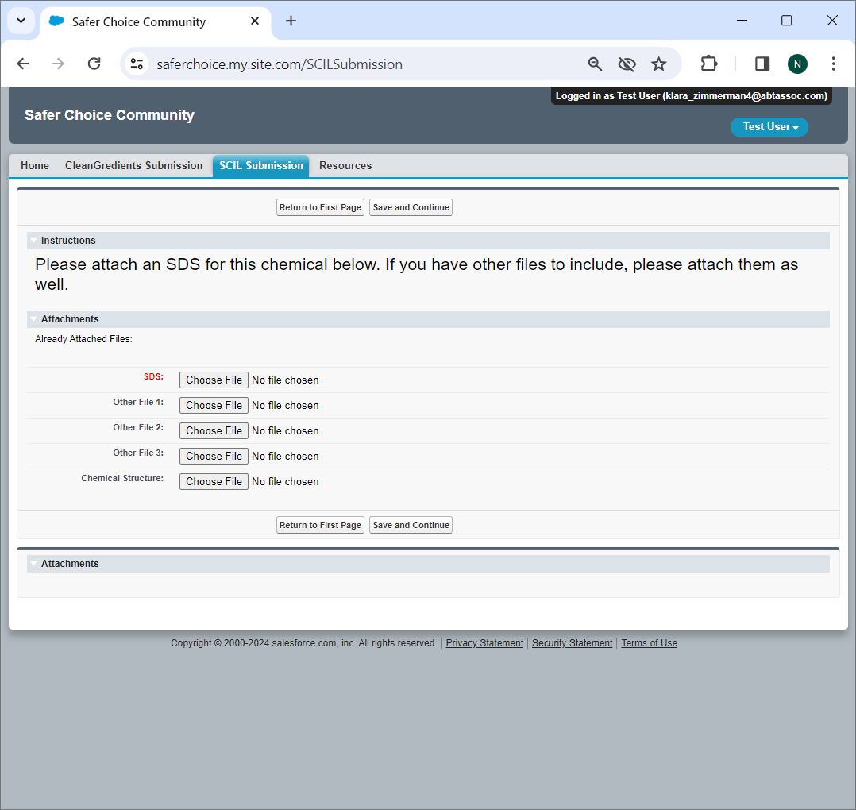

Missing Info Page for SCIL Submission

