60002A Form – Guided Flow - External View
Screen 1 - Start Form
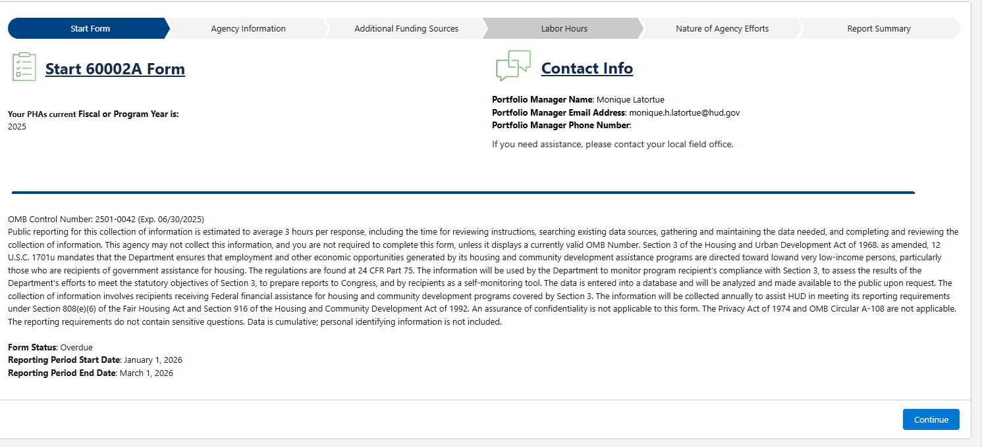
Screen 2 – Agency Information
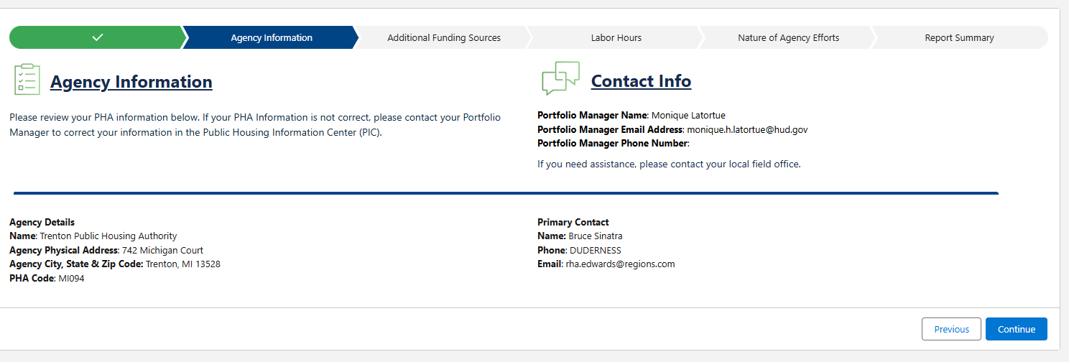

Screen 3 – Additional Funding Sources
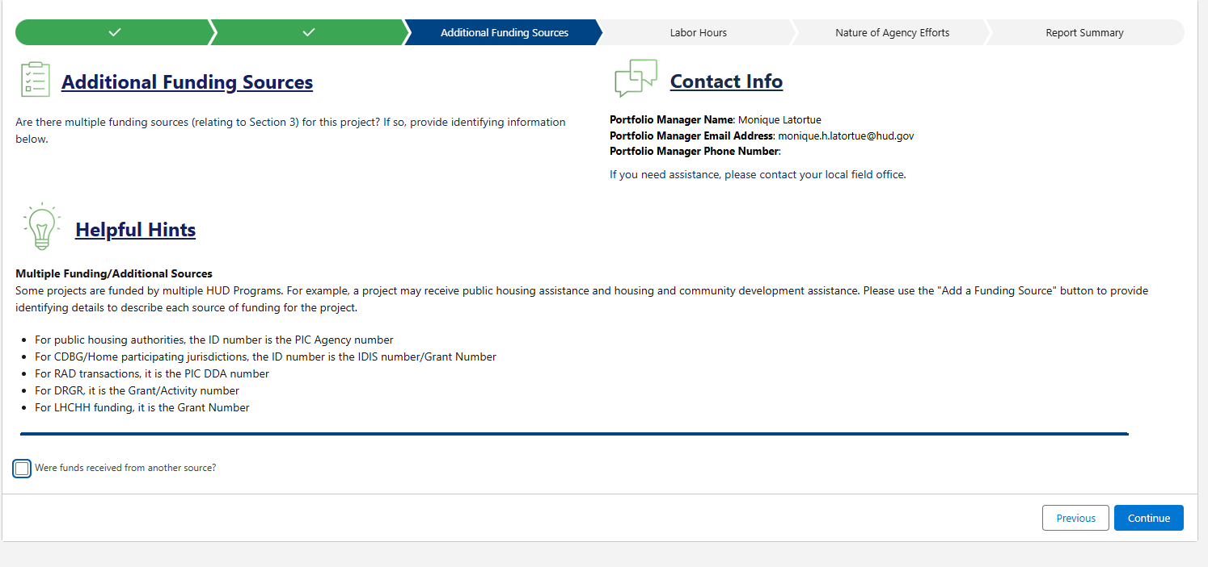
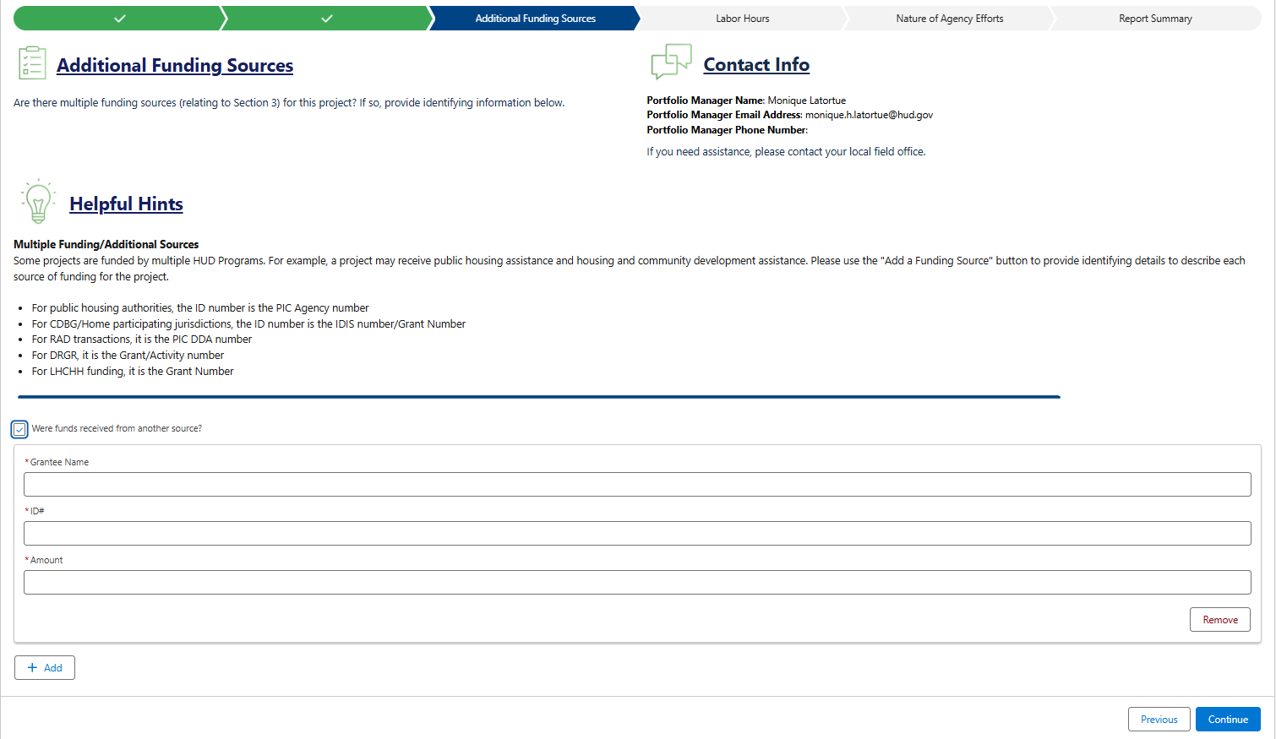

Screen 4 – Labor Hours & Calculations
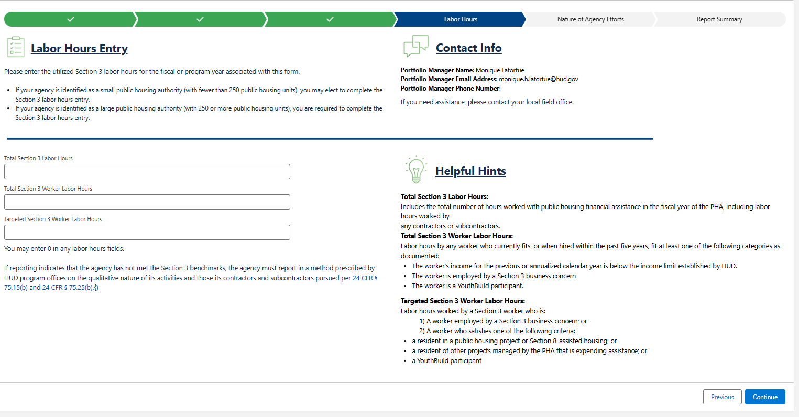
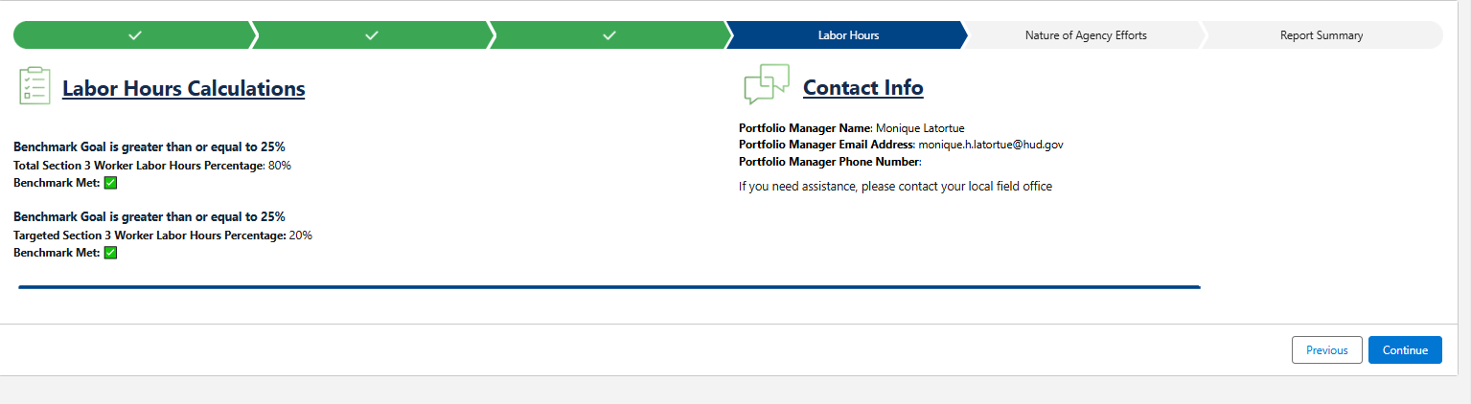

Screen 5 – Nature of Agency Efforts
