U.S. Department of Housing and Urban Development  Office of Housing Office of Multifamily Housing Programs    ENTERPRISE INCOME VERIFICATION  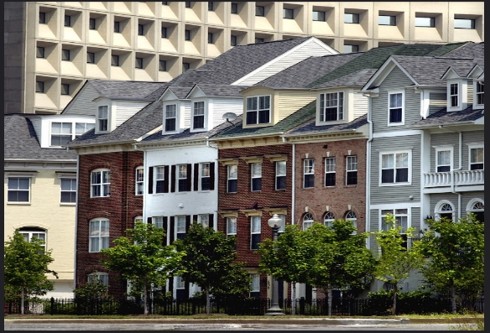  RENTAL HOUSING INTEGRITY IMPROVEMENT PROJECT  & You  EIV |  | “Strive not to be a success, but rather to be of value.”  - Albert Einstein  The EIV system provides the owner and/or manager of the property where you live with your income information, employment history and to verify your identity. This information is used to meet HUD’s requirement to independently verify your employment and/ or income when you recertify for continued rental assistance. Getting the information from the EIV system is more accurate and less time consuming and costly to the owner or manager than contacting your income source directly for verification.  What is the information in EIV used for?  The Social Security Administration:  - Social Security (SS) benefits  - Supplemental Security Income (SSI) benefits  - Dual Entitlement SS benefits  - Social Security Disability Insurance (SSDI)  What income information is in EIV and where does it come from?  The Department of Health and Human Services (HHS), and the National Directory of New Hires (NDNH)  - Wages  - Unemployment compensation  - New Hire (W-4)  What is EIV?  [Grab your reader’s attention with a great quote from the document or use this space to emphasize a key point. To place this text box anywhere on the page, just drag it.]  EIV is a web-based computer system containing employment and income information on individuals participating in HUD’s rental assistance programs. This information assists HUD in making sure the right benefits go to the right persons. |  | Yes. When you sign form HUD-9887, Notice and Consent for the Release of Information, and form HUD-9887-A, Applicant’s/Tenant’s Consent to the Release of Information, you are giving your consent for HUD and the property owner or manager to obtain information about you to verify your employment and/or income and determine your eligibility for HUD rental assistance. Your failure to sign the consent forms may result in the denial of assistance or termination of assisted housing benefits.  Who has access to the EIV information?  Is my consent required to get information about me from EIV?  - Used a false social security number  - Failed to report or under reported the income of a spouse or other household member  - Receive rental assistance at another property  They will also be able to determine if you:  Only you and those parties listed on the consent form HUD-9887 that you must sign have access to the information in EIV pertaining to you.
What YOU Should Know  if You are Applying For or Are Receiving  Rental Assistance through the Department of  Housing and Urban Development (HUD |  | Property owners and managers are able to use the EIV system to determine if you correctly reported your income or employment history. |  | As a tenant in a HUD assisted property, you must certify that information provided on an application for housing assistance and the form used to certify and recertify your assistance (form HUD-50059) is accurate and honest. This is also described in the Tenants’ Rights & Responsibilities brochure that your property owner or manager is required to give to you every year.  What are my responsibilities?

- Income from wages  - Welfare payments  - Unemployment benefits  - Social Security (SS) or Supplemental Security Income (SSI) benefits  - Social Security Disability Insurance (SSDI)  - Veteran benefits  - Pensions, retirement, etc.  - Income from assets  - Monies received on behalf of a child such as:  - Child support  - TANF payments  - Social security for children, etc.  If you have any questions on whether money received should be counted as income, ask your property owner or manager.  When changes occur in your household income or family composition, immediately contact your property owner or manager to determine if this will affect your rental assistance.  Your property owner or manager is required to provide you with a copy of the fact sheet “How Your Rent Is Determined” which includes a listing of what is included or excluded from income.  Protect yourself, follow HUD reporting requirements  When completing applications and recertifications, you must include all sources of income you or any member of your household receives. Some sources include:  Penalties for providing false information  Providing false information is fraud. Penalties for those who commit fraud could include eviction, repayment of overpaid assistance received, fines up to $10,000, imprisonment for up to 5 years, prohibition from receiving any future rental assistance and/or state and local government penalties. |  | EIV has the capability to uncover cases of potential identity theft; someone could be using your social security number. If this is discovered, you must notify the Social Security Administration by calling them toll-free at 1-800-772-1213. Further information on identity theft is available on the Social Security Administration website at: https://www.ssa.gov/pubs/ EN-05-10064.pdf.  What if the information in EIV is not about me?  If the EIV report discloses income from a prior period that you did not report, you have two options: 1) you can agree with the EIV report if it is correct, or 2) you can dispute the report if you believe it is incorrect. The property owner or manager will then conduct a written third-party verification with the reporting source of income. If the source confirms this income is accurate, you will be required to repay any overpaid rental assistance and you may be subject to penalties if it is determined that you deliberately tried to conceal your income.  What if I did not report income previously and it is now being reported in EIV?  If you do not agree with the employment and/or income information in EIV, you must tell your property owner or manager. Your property owner or manager will contact the income source directly to obtain verification of the employment and/or income you disagree with. Once the property owner or manager receives the information from the income source, you will be notified in writing of the results.  What if I disagree with the EIV information? |  | First, contact your property owner or manager for an explanation.  If you need further assistance, you may contact the contract administrator for the property you live in. If it is not resolved to your satisfaction, you may contact HUD.  For help locating the HUD office nearest you, which can also provide you contact information for the contract administrator, please call the Multifamily  Housing Complaint Line at 1-800-685-8470. HUD welcomes and is prepared to receive calls from individuals who are deaf or hard of hearing, as well as individuals with speech or communication disabilities. To learn more about how to make an accessible telephone call, please visit https://www.fcc.gov/consumers/guides/telecommunications-relay-service-trs.  Whom do I contact if my income or rental assistance is not being calculated correctly?  Where can I obtain more information on EIV and the income verification process?  Your property owner or manager can provide you with additional information on EIV and the income verification process. They can also refer you to the appropriate contract administrator or your local HUD office for additional information.  If you have access to a computer, you can read more about EIV and the income verification process on HUD’s Multifamily EIV homepage at: https://www.hud.gov/program_offices/housing/mfh/rhiip/eiv/eivapps

