# Supporting Statement for Collection of Information Follow-up Activities for Product-Related Injuries

1. **Justification**

## Information to be collected and circumstances that make the collection of information necessary

Section 5(a) of the Consumer Product Safety Act (CPSA)(15 U.S.C. § 2054(a)) requires the Commission to collect information related to the cause and prevention of death, injury, and illness associated with consumer products. CPSC staff conducts continuing studies and investigations of deaths, injuries, diseases, other health impairments, and economic losses resulting from incidents involving consumer products. CPSC staff obtains information about product-related deaths, injuries, and illnesses from a variety of sources, including news outlets, death certificates, consumer complaints, and medical facilities.

CPSC staff also operates the National Electronic Injury Surveillance System (NEISS), which provides timely data on consumer product-related injuries treated in hospital emergency departments in the United States. CPSC staff also uses the NEISS system to collect information on childhood poisonings in accordance with the Poison Prevention Packaging Act of 1970.

From these sources, the CPSC staff selects cases of interest for further investigation by contacting persons who witnessed or were injured in incidents involving consumer products. These investigations are conducted on-site (face-to-face), by telephone, or by the Internet. On-site investigations are usually made in cases where the CPSC staff needs photographs of the incident site, the product involved, or detailed information about the incident. This information can come from face-to- face interviews with persons who were injured or who witnessed the incident, as well as via contact with state and local officials, including police, coroners and fire investigators, and others with knowledge of the incident.

Through Interagency Agreements, the CPSC staff also uses the NEISS system to collect information on injuries for the Centers for Disease Control and Prevention (NEISS All Injury Program (NEISS-AIP)). In addition to the standard data variables collected on all NEISS injuries, the NEISS-AIP collects additional variables on several studies for CDC (Firearm-Related Injuries, Adverse Drug Events, Assaults, and Self- Inflicted Violence) and one study on non-crash motor vehicle-related injuries for the National Highway and Transportation Safety Administration (NHTSA).

## Use and sharing of collected information

CPSC staff uses the information from this collection to support development and improvement of voluntary standards; proceedings for the development of

mandatory standards and regulations; information and education campaigns; and administrative and judicial proceedings for enforcement of the statutes, standards, and regulations administered by the agency. The information informs the agency in its efforts to remove unsafe products from channels of distribution and consumers' homes, and it provides information to the public about the safety of consumer products.

No records released to the public contain personally identifiable information; geographic and personal identifiers have been masked.

## Use of information technology (IT) in information collection

All NEISS data are reported electronically, and NEISS respondents directly submit data to CPSC through the Internet on a CPSC-developed application called WebNEISS. Information for follow-up investigations from NEISS and other sources are collected through traditional face-to-face, telephone, or Internet-based interviews with consumers, witnesses, and other knowledgeable parties, such as fire, police, and healthcare professionals.

## Efforts to identify duplication

There is no other national surveillance system of product-related injuries, childhood poisonings, and other injuries treated in emergency departments. The detailed information obtained from hospital emergency records about incidents associated with consumer products is not available from any other source.

## Impact on small business

This collection of information is voluntary and does not have a disproportionate impact on small businesses.

## 6a. Consequences to Federal program or policy activities if collection is not conducted or is conducted less frequently

CPSC has a mandatory statutory obligation to “maintain an Injury Information Clearinghouse to collect, investigate, analyze, and disseminate injury data, and information, relating to the causes and prevention of death, injury, and illness associated with consumer products.” 15 U.S.C. § 2054(a)(1). If this information were not collected or were collected less frequently, the CPSC and other agencies that rely on this data would lack timely and detailed information to identify new hazards and support rulemaking proceedings**,** assist in efforts to develop or improve voluntary standards, perform actions to obtain correction of products that present a substantial product hazard, and conduct informational campaigns.

## 6b. Consequences to Federal program or policy activities if collection is not used for statistical estimates

In September 2019, CPSC contracted with Westat Inc. under CPSC contract 61320619F0134, to give an independent statistical assessment of the NEISS and the NEISS-AIP samples[1]. The primary focus of this contract was to analyze the pros and cons of keeping, expanding, or resampling the current samples of NEISS and NEISS- AIP hospitals. The final Westat recommendation was for a redesign of the NEISS sample.

The current NEISS (and NEISS-AIP) probability sample was drawn in 2021 with recruitment of new NEISS hospitals starting shortly after and continuing to the present. CPSC staff used a resampling method that maximizes the probability of retaining as many of the current NEISS hospitals as possible, while maintaining the statistical integrity of the NEISS. Among eligible hospital emergency departments, some have migrated from one stratum to another; come into existence since the last resampling of the NEISS; or ceased to exist. The method used in resampling the NEISS is an extension of the Keyfitz procedures for stratified simple random samples[2]. The advantage of retaining as many of the old NEISS hospitals as possible is that the contracting, data collection, and quality-control mechanisms already exist in the hospitals in the old sample, and it is a cost-effective procedure. Another advantage is that there is far less disruption in trend analysis.

Since the NEISS sample was redrawn in 2021 and recruitment started, fifteen new hospitals have joined, seven that were in the old and the new NEISS sample and eight that are in the new NEISS sample only. Eighteen hospitals have dropped off of the NEISS, 8 that chose not to continue that are part of the new sample and ten that were no longer part of the new NEISS sample. As of January 1, 2025, there are seventy-seven hospitals participating in the new NEISS sample.

One of the advantages of a long-running NEISS sample is the ability to track trends across time. Updating the NEISS sample interferes with that analysis. One of the best ways to adjust any time series that crosses over two NEISS samples is to have an overlap or bridge period, during which data are collected from the old and the new samples. CPSC staff conducted a 12-month overlap as part of the implementation of the new NEISS sample during calendar year 2024 when there were seventy-seven hospitals participating in the old NEISS sample and seventy-seven hospitals participating in the new sample. Sixty-nine of the hospitals were in both the old and new NEISS sample. Having a full 12-month overlap period better accounts for seasonality of some consumer product-related injuries. By comparing estimates calculated from both samples, it is possible to adjust (backcast) old estimates to be consistent with the new sample.

Because it takes several years to ramp up NEISS recruitment and get new hospitals to start reporting, the 2022 and 2023 NEISS national estimates are based on the previous NEISS sample design. It was not until 2024 that the number of hospitals participating in the new NEISS sample (77) was equal to or surpassed the number of hospitals participating in the old sample (77). The national estimates for 2024 are calculated using the new NEISS sample with historical estimates from 2023, and prior years “backcast” to adjust for the sample update.

**Table 1**

**New NEISS Sample**

|  |  |  |  |  |
| --- | --- | --- | --- | --- |
| Stratum | 2021 NEISS  Design | 2024 NEISS:  Reporting | 1997 NEISS Design | 2024 NEISS:  Reporting |
| Small | 43 | 31 | 48 | 33 |
| Medium | 26 | 18 | 14 | 9 |
| Large | 12 | 10 | 9 | 9 |
| Very Large | 11 | 10 | 23 | 19 |
| Children’s | 8 | 8 | 8 | 7 |
| Total | 100 | 77 | 102 | 77 |

## Special circumstances requiring respondents to report information more often than quarterly or to prepare responses in fewer than 30 days

Timely reporting of consumer product-related injuries and childhood poisonings treated in emergency departments is necessary to identify, investigate, and respond to new or changing hazards. In CY2023, 50% of the NEISS records were received within 7 days of treatment and 90% within 52 days.

The NEISS currently collects two separate variables for a person’s race and ethnicity. Ethnicity is collected as a drop-down variable with Yes/No/Unknown as possible selections. Race is also collected in 2023 as a drop-down variable with White; Black/African American; Asian; American Indian/Alaska Native; Native Hawaiian/Pacific Islander; Other; and Unknown as possible selections. If ‘Other’ is chosen, a Race Other variable with a free text answer is provided.

**WebNEISS Data Entry Screen**

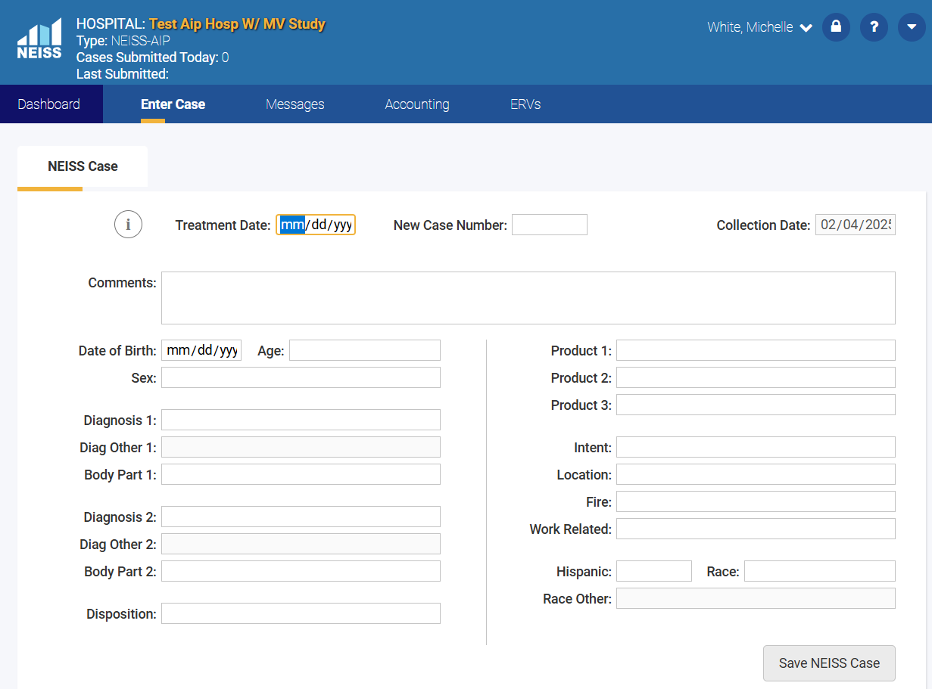

For 2023 NEISS data, the following tables show the distribution of race and ethnicity reported:

**Table 2**

**2023 NEISS Data: Ethnicity**

|  |  |
| --- | --- |
| **Hispanic?** | **Percent** |
| Yes | 12 |
| No | 64 |
| Unknown | 24 |

**Table 3**

**2023 NEISS Data: Race**

|  |  |
| --- | --- |
| **Race** | **Percent** |
| White | 52 |
| Black/African American | 19 |
| Asian | 2 |
| American Indian/Alaska Native | <1 |
| Native Hawaiian/Pacific Islander | <1 |
| Other | 1 |
| Unknown | 25 |

On March 28, 2024, the Office of Management and Budget (OMB) published a set of revisions to Statistical Policy Directive No. 15: Standards for Maintaining, Collecting, and Presenting Federal Data on Race and Ethnicity (SPD 15), the first since 1997.[3] SPD 15 introduces a singular combined race and ethnicity question, allowing multiple responses; requires Federal agencies to collect more detailed data beyond the default; and adds a new category for Middle Eastern or North African descent.

CPSC intends to implement the updated race and ethnicity question in the NEISS on January 1, 2026. In addition to Figure 1 below, the NEISS will have an additional category for ‘Other’ with a write-in response area and ‘Unknown’. The NEISS data are entered by the hospital coders who review the hospital emergency department charts. There is no face-to-face interviewing of the injured person. As seen in the 2023 NEISS data, race and ethnicity are unknown approximately 25% of the time. In addition, the most common write-in response for Race = Other is bi-racial or multi-racial with the races not specified.

Prior to implementing SPD 15, WebNEISS and multiple data base and data lake systems must be updated. IT contract work began at the start of fiscal year 2025 and is scheduled to be completed in the summer or fall of 2025. Training materials and training of the NEISS coders will be completed in late 2025 with implementation of SPD15 in the NEISS data collection schedule to start in January 2026.

**Figure 1: Race and Ethnicity Question with Minimum Categories, Multiple Detailed Checkboxes, and Write-In response Areas with Example Groups**

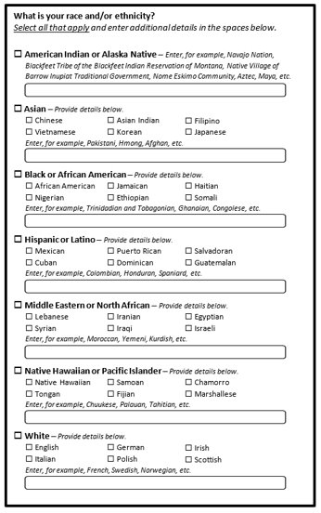

## Agency’s Federal Register Notice and related information

A notice in the *Federal Register* was published February 27, 2025 (90 FR 10815). [4] comments were received.

## Decision to provide payment or gift

NEISS respondents enter into contracts with CPSC and are compensated for their efforts. See Section 12(a) for details of the estimated burden and costs. A number of persons are contacted through a face-to-face, telephone, or Internet interview to provide additional information about selected injuries or incidents associated with consumer products of special interest to CPSC. See Section 12(b) for details of the estimated burden and costs. In general, respondents are not compensated for participating in an interview.

## Assurance of confidentiality

If a person who is asked to provide information about a product-related injury or incident claims that any information submitted to the CPSC is trade secret or confidential business information, that information is subject to the agency's procedures for withholding confidential information from public disclosure codified at 16 CFR part 1015, subpart B. If such information is requested under provisions of the Freedom of Information Act, the person who provided the information is notified and given the opportunity to respond and seek judicial relief before the CPSC's release of the information. In addition, any accident or investigation report made under the CPSA by an officer or employee of the CPSC shall be made available to the public in a manner that will not identify any injured person or any person treating him or her, without the consent of the person so identified.

## Questions of a sensitive nature

The CPSC’s staff takes care to design interview guides so that those who witness or are injured in incidents associated with consumer products are not requested to provide any information of a sensitive nature.

## 12 (a). Estimate of hour burden to NEISS respondents

The NEISS system collects information on consumer product-related incidents and other injuries from a statistical sample of hospitals in the United States. The number of hospitals participating in CY2025-CY2029 will fluctuate from the current 77 reporting to a maximum of 100 as hospital recruitment continues.

Respondents to NEISS include hospitals that directly report information to NEISS, and hospitals that allow access to a CPSC contractor who collects the data. Collecting emergency department records for review, correcting error messages, and other tasks takes between 2.5 and 6 hours weekly. Each record takes about 30 seconds to review. Coding and reporting records that involve consumer products or other injuries takes about 2 minutes per record. Coding and reporting on additional special study information (Adverse Drug Effects) takes about 2 minutes and other special studies take approximately 90 seconds per record . Respondents also spend about 8-36 hours per year in related activities (training, evaluations, and communicating with other hospital staff).

During CY2025, with a maximum of 100 hospitals participating in the NEISS, there will be an estimated 160 NEISS respondents (total hospitals and CPSC contractors). These NEISS respondents will review an estimated 4.5 million emergency department records and report 1.15 million total cases (450,000 consumer product-related injuries for CPSC, and 775,000 other injuries for the NEISS-AIP). The table below lists the estimated number of reported cases, and the estimated number of reported cases with additional special study information.

**Table 4**

**Estimated NEISS records**

|  |  |
| --- | --- |
| **Total NEISS Cases Reported** | **1.15 million** |
| Consumer Product-Related Injuries | **450,000** |
| CDC NEISS-AIP | **700,000** |
| **Special Studies Reported (subset of above)** |  |
| Child Poisoning (CPSC) | **6,000** |
| Adverse Drug Effects (CDC) | **82,000** |
| Assaults (CDC) | **60,000** |
| Self-Inflicted Violence (CDC) | **38,000** |
| Motor Vehicle Non-Crash Injuries (NHTSA) | **12,500** |
| Firearm-Related Injuries (CDC) | **9,500** |

The total burden hours for all NEISS respondents are estimated to be 115,000 for CY 2025. The average burden hours per respondent is 720 hours. However, the total burden hours on each respondent varies, due to differences in the sizes of the hospitals (*e.g*., small rural hospitals versus large metropolitan hospitals). The smallest hospital will report an estimated 250 cases with a burden of about 150 hours, while the largest hospital will report an estimated 65,000 cases with a burden of about 4,500 hours.

The total costs to NEISS respondents for CY 2025 are estimated at approximately

$6.9 million. NEISS respondents enter into contracts with CPSC and are compensated for these costs. The average cost per respondent is estimated to be about $43,000. The average cost per burden hour is estimated to be $60 per hour (including wages and overhead). However, the actual cost to each respondent varies, due to the type of respondent (hospital versus CPSC contractor), size of hospital, and regional differences in wages and overhead. Therefore, the actual annual cost for any given respondent may vary between $3,000 at a small rural hospital, and $550,000 at the largest metropolitan hospital.

## 12 (b). Estimate of hour burden to other respondents

CPSC staff completes field interviews of about 2,950 people each year using the supplementary Criteria and Rationales manual. On average, an on-site interview takes about 4.5 hours. Staff also completes about 750 in-depth investigations (IDIs) by telephone through the use of a Computer Assisted Telephone Interview (CATI) or self-administered Computer Assisted Internet Interviews (CAII) questionnaires. Each CATI or CAII IDI requires about 20 minutes to complete.

CPSC staff estimates 13,523 annual burden hours on these respondents: 13,275 hours for face-to-face interviews; 248 hours for in-depth telephone or internet interviews.

CPSC’s staff estimates the value of the time required for reporting is $46.84 an hour, the average cost for employee compensation for civilian workers (U.S. Bureau of Labor Statistics, “Employer Costs for Employee Compensation,” September 2024: https://www.bls.gov/news.release/archives/ecec_12172024.pdf). At this valuation, the estimated annual cost to the public is about $633,417 (13,523 burden hours × $46.84 per hour = $633,417.32).

## Estimate of other total annual cost burden to respondents or recordkeepers

The only costs to respondents from this collection of information are those described in item 12 above.

## Estimate of annualized costs to the Federal government

The cost to the government of the collection of the NEISS information is estimated to be about $9.4 million a year. This estimate includes $6.9 million in compensation to NEISS respondents described in section 12(a) above. This estimate also includes

$2.458 million for about 174 professional staff months each year. The estimate of professional staff months includes the time required to: oversee NEISS operations (*e.g*., administration, training, quality control); prepare questionnaires, interviewer guidelines, and other instruments and instructions used to collect the information; conduct face-to-face and telephone interviews; and evaluate responses obtained from interviews and completed forms. Each month of professional staff time costs the agency about $14,125. This is based on a GS-12 step-5 salaried employee.

The average yearly wage rate for a step-5 salaried GS-12 employee in the Washington, DC metropolitan area (effective as of January 2025) is $114,923 (https://www.opm.gov/policy-data-oversight/pay-leave/salaries-wages/salary-tables/25Tables/html/DCB.aspx, GS-12, step 5). This represents 67.8 percent of total compensation[4]. Adding an additional 32.2 percent for benefits brings average yearly compensation for a step-1 salaried GS-13 employee to $169,503. These estimates include participation by CDC in the All Injury Program, subject to availability of funds.

## Program changes or adjustments

This request for the approval of an estimated 128,523 (115,248 NEISS and 13,275 other) burden hours per year is a decrease of 3,832 hours since this collection of information was last approved by OMB in May 2022. The decrease is due mainly to a lower number of records reviewed as the new NEISS sample on average has smaller sized hospitals than the previous sample.

This information collection request excludes the burden associated with other publicly available Consumer Product Safety Information Databases, such as Internet complaints, Hotline, and MECAP reports, which is accounted for under OMB control number 3041-0146. This information-collection request also excludes the burden associated with follow-up investigations conducted by other federal agencies.

## Plans for tabulation and publication

The agency provides yearly reports of NEISS data to the public on its website. NEISS data are also available for public use through the CPSC website. The CPSC publishes results from some of its investigations of product-related injuries and incidents in *Federal Register* notices during rulemaking proceedings and in safety alerts, news releases, and other informational materials that are disseminated to the general public, voluntary standards groups, firms, and trade associations. The agency has no specific plan to publish all the data obtained from this collection of information.

## Rationale for not displaying the expiration date for OMB approval

Not applicable.

## Exception to the certification statement

Not applicable.

# Collection of Information Employing Statistical Methods

* 1. The potential respondent universe includes patients treated in statistically selected hospitals participating in NEISS to report emergency department-treated, product-related injuries and other injuries. The affiliated NEISS hospitals will report about 1.15 million emergency department visits annually using existing information extracted from hospital records. Of those reported visits, about 450,000 will be consumer product-related cases. Since hospital record data are limited, further information is frequently necessary, and about 7,000 of these cases are selected for further investigation. Of the 7,000 cases selected, 1,025 (15%) are successfully contacted and 750 (11%) of the investigations are completed.

The potential respondent universe also includes individuals involved with incidents recorded in newspaper articles, consumer complaints, death certificates, coroner’s reports and any other injury sources that may be reported to the CPSC. These other data sources contribute more than 525,000 cases annually, of which about 4,000 are selected for further investigation. Of the 4,000 cases selected, 3,775 (94%) are successfully contacted and 2,950 (74%) of the investigations are completed.

* 1. Cases associated with categories of interest are selected daily from the hundreds of incident reports received each day by the CPSC. CPSC investigators call to interview or to arrange to visit the victim or others to determine specific details about the accident sequence. Information collected from the victim, family member, witness, or others is reported on an investigation form designed for this purpose.

When less than 100 percent of the surveillance cases are selected for investigation, the universe of cases is stratified by relevant factors, such as type of injury or consumer product involved, and a simple random sample of cases is selected.

The estimation procedure for probability surveys involves multiplying the original surveillance case weight by the case weight appropriate for the follow-back investigation. Normally, the latter is the reciprocal of the probability of selection, adjusted, where needed, for non-response and an annual ratio adjustment to take into account hospitals that open and close and/or change in size.

* 1. About 44 percent of the victims involved in the selected incidents are successfully contacted. Of those contacted, about 77 percent agree to provide information voluntarily on the circumstances of the incident. For probability surveys, responses are weighted to account for non-responses. The results from probability surveys can be generalized to the universe studied.
  2. No tests of procedures or methods will be undertaken.
  3. Contact for collection and analysis of NEISS data: Thomas Schroeder

U.S. Consumer Product Safety Commission 4330 East West Highway

Bethesda, MD 20814

tschroeder@cpsc.gov

1. David Marker, Jim Green, Frost Hubbord, Richard Valliant, “Statistical Assessment of the NEISS and NEISS-AIP Samples: Final Technical Report,” Westat Inc., September 24, 2020.
2. J. Michael Brick, David R. Morganstein, Charles, L. Wolter, “Additional Uses for Keyfitz Selection,” Westat Inc., 1987. [(http://www.asasrms.org/Proceedings/papers/1987_140.pdf).](http://www.asasrms.org/Proceedings/papers/1987_140.pdf))
3. [spd15revision.gov](https://spd15revision.gov/)
4. U.S. Bureau of Labor Statistics, “Employer Costs for Employee Compensation,” September 2024, Table 2) percentage of wages and salaries for all civilian management, professional, and related employees: https://www.bls.gov/news.release/archives/ecec_12172024.htm.