NIFA Reporting System: Add/Edit Project/Program Initiation

Classifications: Knowledge Area Dropdown Option Revision
As proposed, KA 132 will be updated from “Weather and Climate” to “Short Term and Decadal Weather” as pictured in the mockup below.
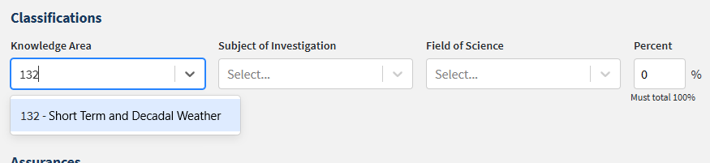

Classifications: Subject of Investigation Dropdown Option Revision
As proposed, SOI 430 will be updated from “Climate” to “Decadal Weather Patterns” as pictured in the mockup below.
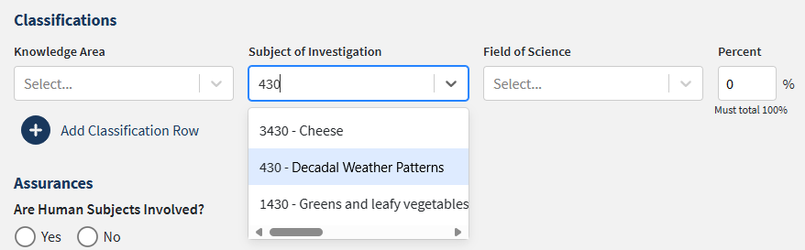

Classifications: Field of Science Dropdown Option Revision
As proposed, FOS 2070 will be updated from “Meteorology and Climatology” to “Meteorology” as pictured in the mockup below.
