Contents
REEport Project Initiation Form – Knowledge Area (KA) Dropdown Revision 1
REEport Project Initiation Form – Subject of Investigation (SOI) Dropdown Revision 3
REEport Project Initiation Form – Field of Science (FOS) Dropdown Revision 3

REEport Project Initiation Form – Knowledge Area (KA) Dropdown Revision
As proposed, KA 132 will be updated from “Weather and Climate” to “Short Term and Decadal Weather” as pictured in the mockup below.
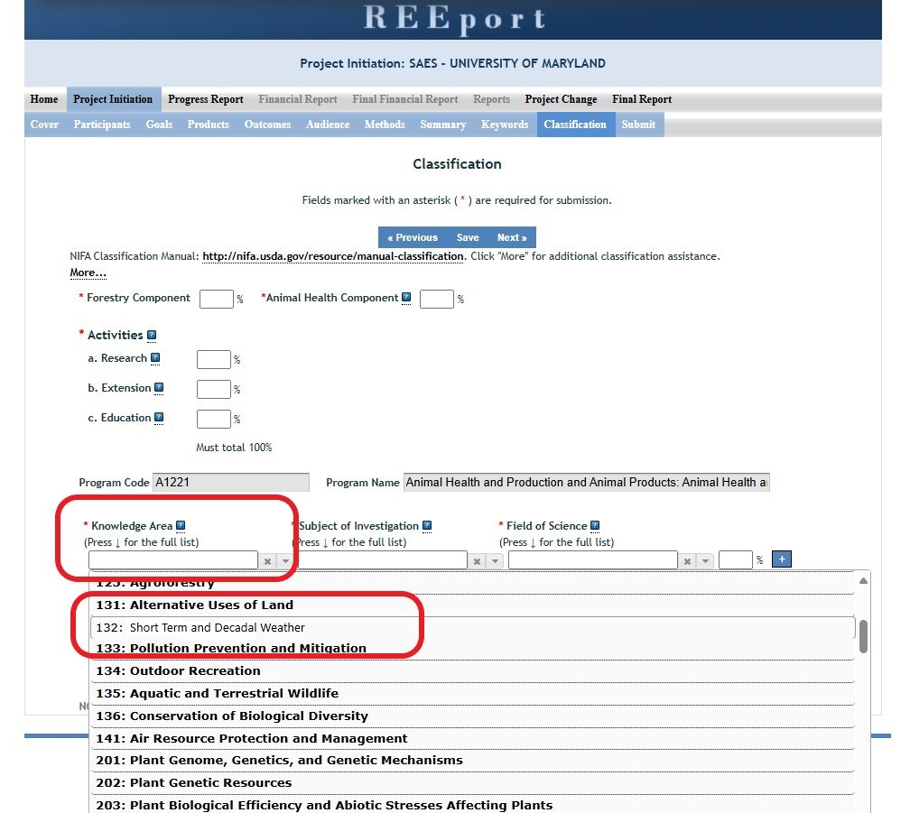

REEport Project Initiation Form – Subject of Investigation (SOI) Dropdown Revision
As proposed, SOI 0430 will be updated from “Climate” to “Decadal Weather Patterns” as pictured in the mockup below.
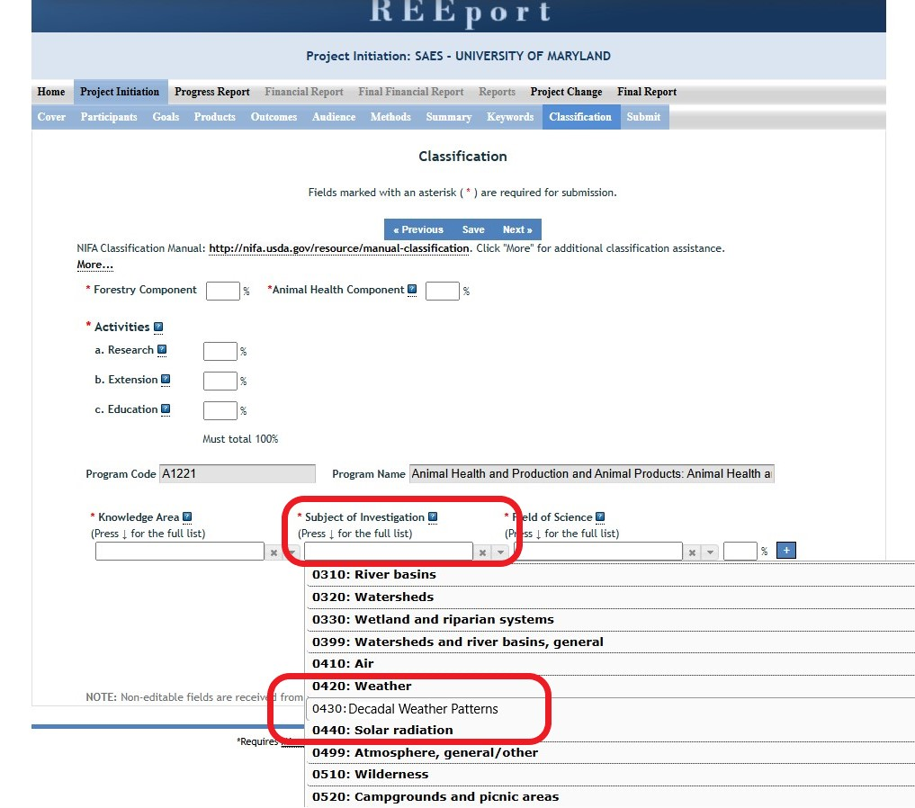

REEport Project Initiation Form – Field of Science (FOS) Dropdown Revision
As proposed, FOS 2070 will be updated from “Meteorology and Climatology” to “Meteorology” as pictured in the mockup below.
