**Request for Nonsubstantive Change**

**ICR 0560-0265**

**March 13, 2025**

FSA has reviewed form AD-2047 and requests approval for nonsubstantive changes with the justification.

The changes do not affect response time or burden hours.

**Justification:** The Office of Management and Budget's (OMB), Revisions to OMB’s Statistical Policy Directive No. 15: Standards for Maintaining, Collecting, and Presenting Federal Data on Race and Ethnicity directs USDA to develop and submit to OMB within 18 months of publication of these standards, an Action Plan on Race and Ethnicity Data describing how we intend to bring our agency collections and publications into compliance with these standards by March 28, 2029.  FSA will have to update this form after the issuance of USDA's Action Plan to ensure conformity with the Figure (1, 2, or 3) outlined in USDA's Action Plan and leverage that Action Plan in consultation with leadership on bringing this data collection into compliance with the revised SPD-15 standards, by the March 2029, in combined consideration of the Deputy Areas for Farm Programs, Farm Loans, and Field Operations which collect and/or utilize such data and in consideration of budget and software enhancements yet needed to correctly capture detailed categories.

It is noted that the proposed AD-2047 includes the addition of Middle Eastern or North African in effort to partially comply with the SDP-15 requirements at this time, and that the collection of information is conducted in a manner consistent with the guidelines in 5 CFR 1320.5 and current Departmental Regulation 4370-001.

**FORM: AD-2047 (4 changes)**

**Change 1: Items 4A (Race) and 4B (Ethnicity) are being combined into 4A (Race/Ethnicity) and updated in accordance with OMB’s SPD-15 and remove “I do not want to provide…” response option.**

**CURRENT CHANGE**

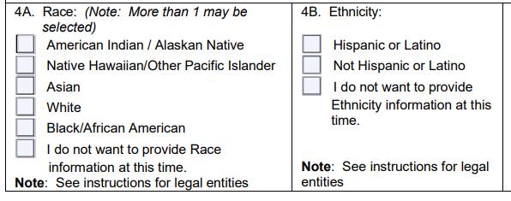

**Change 2: Item 4C Gender (Individual) is updated to 4B. Sex (Individual) and to remove the Non-Binary and “I do not want to provide Gender information at this time.” response options.**

**CURRENT CHANGE**

**Change 3: Item 4D Gender (Legal Entity) is updated to 4C. Sex (Legal Entity) and to remove Non-Binary and “I do not want to provide Gender information at this time.” response options.**

**CURRENT CHANGE**

**Change 4: Demographic Information Section has been updated to reference sex instead of gender, and reference questions 4A-4C as updated instead of 4A-4D as previously existed prior to the Change 1 combination.**

**CURRENT**

**CHANGE**

