
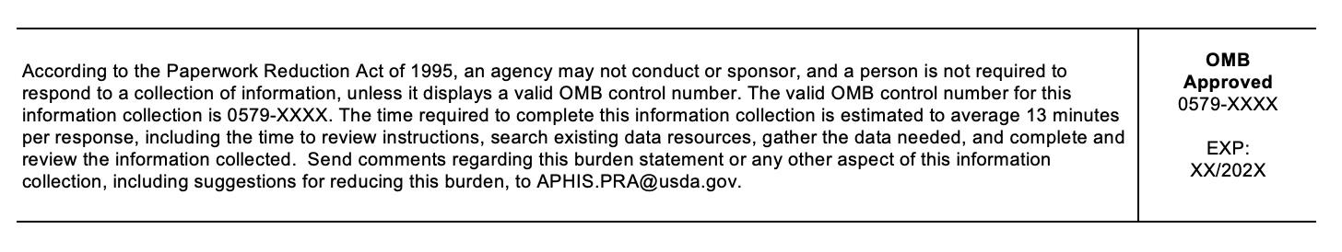
Interactions with Deer Questionnaire

You are invited to take part in a research study funded by USDA’s Animal and Plant Health Inspection Service (APHIS) about human-deer interactions in [the study site]. As part of this study, we will be investigating residents’ experiences, concerns, and management preferences related to deer in your community. In doing so, we hope to better understand how and why people interact with deer in and around their communities.
You have been identified as a potential participant in the study based on your residency close to [the study site]. We believe that your experience and knowledge will be helpful in informing current and future deer management and deer-related disease surveillance in the state.
If you agree to take part in the study, you will be asked to respond to a series of short questions about human-deer interactions in your area. The questionnaire will take less than 15 minutes to complete.
You will receive $20 as a token of appreciation upon completion of the questionnaire.
Participation is voluntary. You can refuse to take part or stop at any time without penalty. You may opt out of any activities you do not wish to participate in for any reason without penalty. Your decision to participate in the study will have no impact on future coordination or research efforts through the University of Minnesota.
Any time information is collected; there is a potential risk of loss of privacy. Every effort will be made to keep your information private; however, this cannot be guaranteed. All information you provide will be kept private to the degree permitted by the technology being used. All participants have been assigned randomly a numeric code to act as identifiers in place of names and personnel identifiers. These identifiers will be stored as a separate list and not linked to any data collected as part of this study. Also, with appropriate privacy protections, we might use information that we collect during this study for other research or share it with other researchers without additional consent from you. Any future research reports, future data use, or publication manuscripts will have all personally identifiable information removed.
If you have questions about this research, please feel free to contact me at smi01220@umn.edu.
You indicate that you voluntarily agree to participate in this research study by submitting the survey.

Powered by Qualtrics

