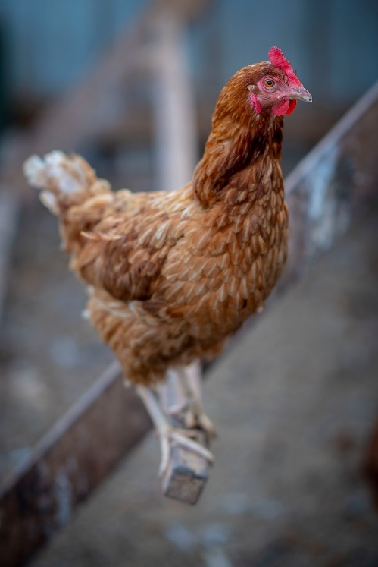

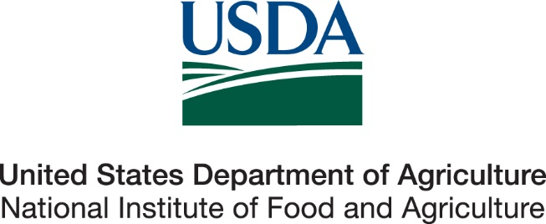

Thank you for participating in the NAHMS Poultry 2025 Small Enterprise study. We appreciate the time you took to answer all our questions. We know these studies can be time consuming, however they provide valuable information to the U.S. poultry industry. These studies could not be completed without you. To view reports from the Poultry 2025 study please visit our website at <http://www.aphis.usda.gov/nahms>.

Thanks again,

NAHMS Poultry 2025 Team