**Attachment J**

**NVDRS Web-based Data Entry (Sample Screenshots of System)**

**Introduction**

**This document displays the screens that abstractors used to enter required data elements. The variable name associated with each data entry field is provided to help user interpret and analyze data. Any new variables on the righthand side are flagged in red with additional numbers, and the corresponding variable names given below.**

**I. Landing Page: *Displays once securely logged on to Secure Access Managemt Services (SAMS) and granted entry into the application.***

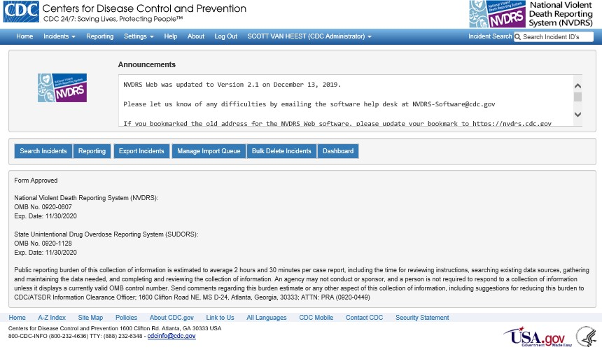

**II. Demographic Variables for Victims*:***

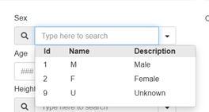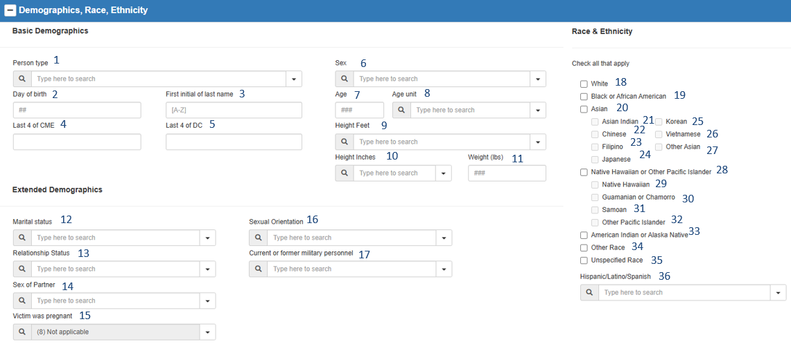

**Sex dropdown menu**:

|  |  |  |  |  |  |  |  |
| --- | --- | --- | --- | --- | --- | --- | --- |
| 1 | PersonType |  | 13 | RelationshipStatus |  | 25 | RaceKorean |
| 2 | BirthDayofMonth |  | 14 | SexofPartner |  | 26 | RaceVietnamese |
| 3 | LastNameFirstInitial |  | 15 | Pregnant |  | 27 | RaceOtherAsian |
| 4 | CMENumberLastFour |  | 16 | SexualOrientation |  | 28 | RacePacificIslander |
| 5 | DCNumberLastFour |  | 17 | Military |  | 29 | RaceHawaiian |
| 6 | Sex |  | 18 | RaceWhite |  | 30 | RaceGuamanian |
| 7 | Age |  | 19 | RaceBlack |  | 31 | RaceSamoan |
| 8 | AgeUnit |  | 20 | RaceAsian |  | 32 | RaceOtherPacIslander |
| 9 | HeightFeet |  | 21 | RaceAsianIndian |  | 33 | RaceAmericanIndian |
| 10 | HeightInches |  | 22 | RaceChinese |  | 34 | RaceOther |
| 11 | Weight |  | 23 | RaceFilipino |  | 35 | RaceUnspecified |
| 12 | MaritalStatus |  | 24 | RaceJapanese |  | 36 | Ethnicity |

# III. Place of Residence, Birthplace, Industry, Occupation, and Education

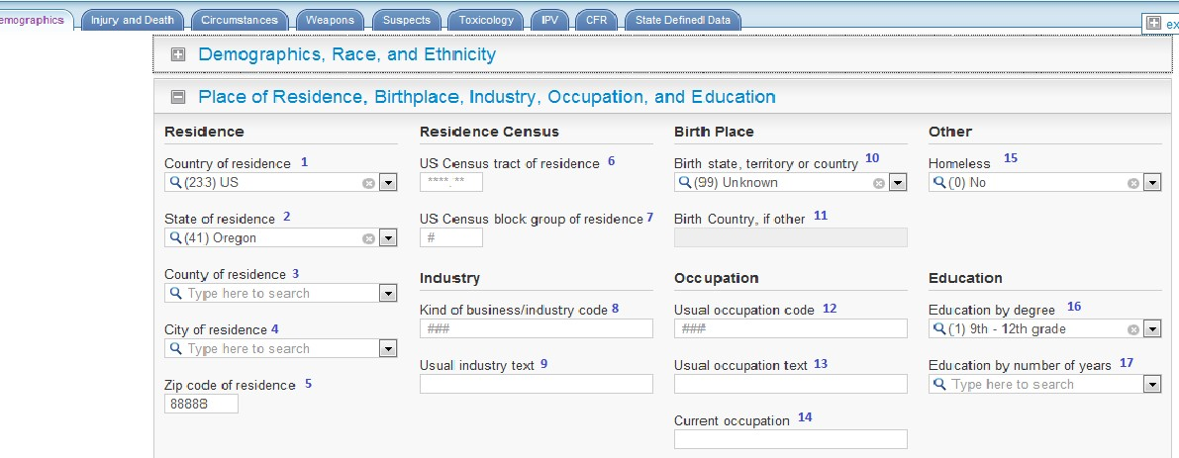

|  |  |  |  |  |  |  |  |
| --- | --- | --- | --- | --- | --- | --- | --- |
| 1 | Country |  |  |  |  | 10 | BirthPlace |
| 2 | ResidenceState |  |  |  |  | 11 | BirthCountryOther |
| 3 | ResidenceCounty |  |  |  |  | 12 | UsualOccupation |
| 4 | ResidenceCity |  |  |  |  | 13 | OccupationText |
| 5 | ResidenceZip |  |  |  |  | 14 | OccupationCurrentText |
| 6 | ResidenceCensusTract |  |  |  |  | 15 | Homeless |
| 7 | ResidenceCensusBlock |  |  |  |  | 16 | EducationLevel |
| 8 | Industry |  |  |  |  | 17 | EducationYears |
| 9 | IndustryText |  |  |  |  |  |  |

# IV. Injury and Death

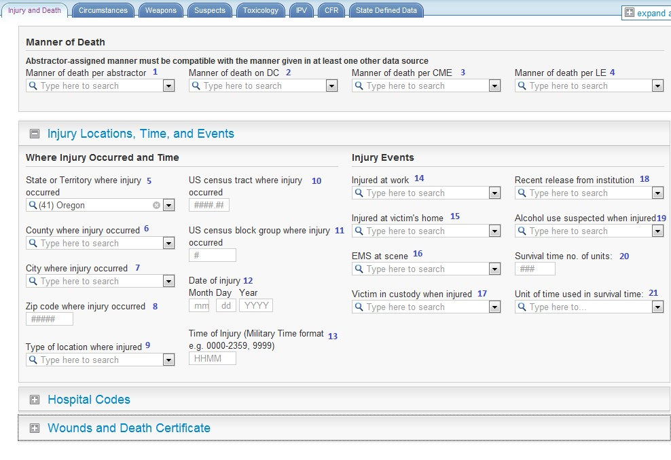

|  |  |  |  |  |  |  |  |  |
| --- | --- | --- | --- | --- | --- | --- | --- | --- |
| 1 | DeathMannerAbstractor |  |  | 9 | InjuryLocationType |  | 17 | VictimInCustody |
| 2 | DeathMannerDC |  |  | 10 | CensusTract |  | 18 | RecentRelease |
| 3 | DeathMannerCME |  |  | 11 | CensusBlock |  | 19 | AlcoholUseSuspected |
| 4 | DeathMannerLE |  |  | 12 | InjuryDate |  | 20 | SurvivalTime |
| 5 | InjuryState |  |  | 13 | InjuryTime |  | 21 | SurvivalTimeUnit |
| 6 | InjuryCounty |  |  | 14 | InjuredAtWork |  |  |  |
| 7 | InjuryCity |  |  | 15 | InjuredAtVictimHome |  |  |  |
| 8 | InjuryZip |  |  | 16 | EMSPresent |  |  |  |

# V. Hospital Codes

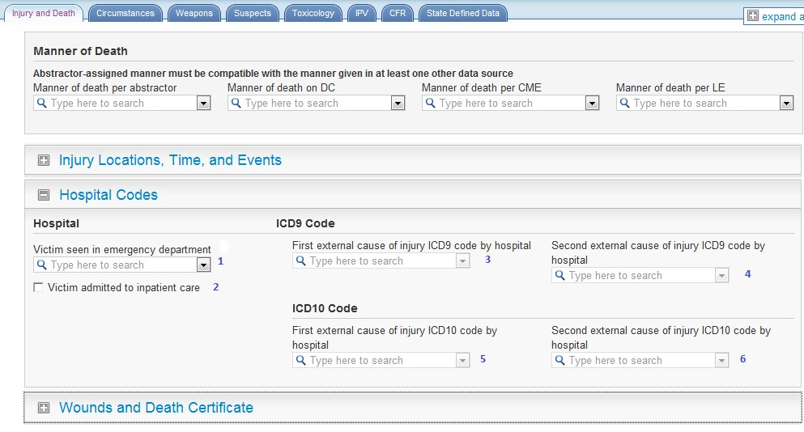

1 EmergencyDepartment 2 HospitalAdmit 3 ExternalCause1ICD9 4 ExternalCause2ICD9 5 ExternalCause1ICD10 6 ExternalCause2ICD10

# VI. Wounds and Death Certificate: Part 1: Underlying Cause of Death & Location of Death

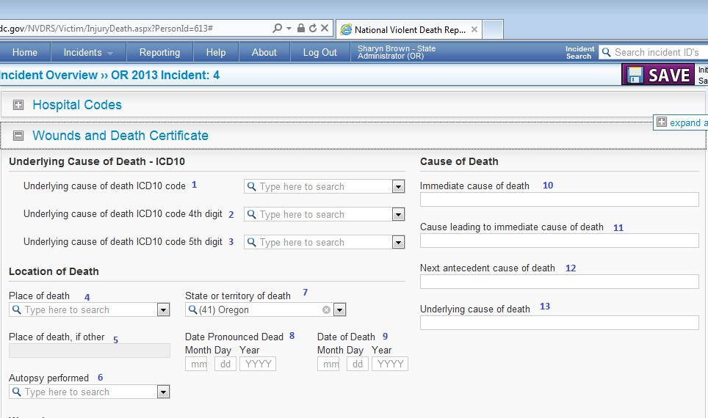

|  |  |
| --- | --- |
| 1 UnderlyingCauseCode | 8 DatePronouncedDate |
| 2 UnderlyingCauseCode4thDigit | 9 DeathDate |
| 3 UnderlyingCauseCode5thDigit | 10 DeathCause1 |
| 4 DeathPlace | 11 DeathCause2 |
| 5 DeathPlaceText | 12 DeathCause3 |
| 6 AutopsyPerformed | 13 DeathCause4 |
| 7 DeathState |  |

# VII. Wounds and Death Certificate: Part 2: Wounds and Multiple Conditions

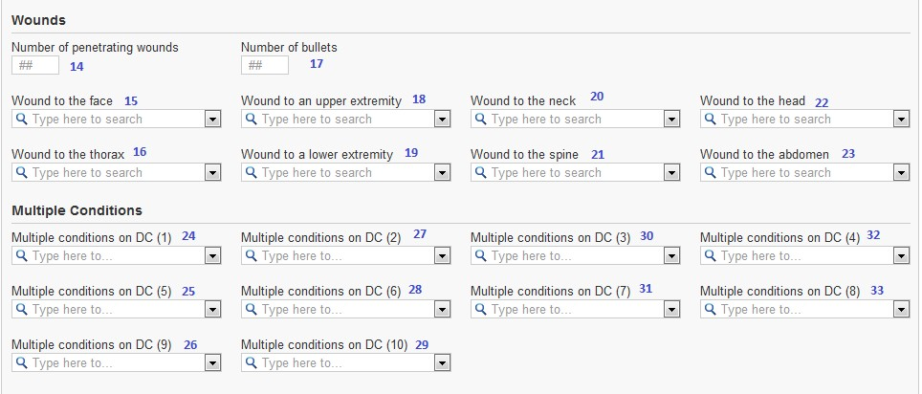

14 NumberWounds 21 WoundToSpine 28 MultiCondition06ICD10 15 WoundToFace 22 WoundToHead 29 MultiCondition10ICD10 16 WoundToThorax 23 WoundToAbdomen 30 MultiCondition03ICD10 17 NumberBullets 24 MultiCondition01ICD10 31 MultiCondition07ICD10 18 WoundToUpperExtremity 25 MultiCondition05ICD10 32 MultiCondition04ICD10 19 WoundToLowerExtremity 26 MultiCondition09ICD10 33 MultiCondition08ICD10 20 WoundToNeck 27 MultiCondition02ICD10

# VIII. Circumstances: Mental, Health, Substance Abuse, and Other Addiction & Relationship and Life Stressors

|  |  |  |  |
| --- | --- | --- | --- |
| |  | | --- | | **CIRCUMSTANCE VARIABLE**  **NAMES BY DATA SOURCE**  **(CME AND LE)** Variables abstracted from both the CME and the LE reports are exported into two variables. If the CME report is the source, the variable name is preceded by “CME_” (e.g., “CME_VariableName”). If the LE report is the source, the variable name is preceded by  “LE_” (e.g.,  “LE_VariableName”). For instance, information on the “Argument” variable will be stored in “CME_Argument” and “LE_Argument” | | |  | | --- | | **CRISIS VARIABLE NAMES**  Whether a circumstance was a crisis  (i.e., checking the “LE Crisis” or “CME Crisis” checkbox) is stored in a separate variable from the circumstance in the export file. Specifically, crisis variables will have the word “crisis” inserted between the data source (i.e., LE and CME) and the circumstance name in the variable label variable (e.g.,  CME_CrisisVariableName,  LE_CrisisVariableName). For example, the crisis variables for “Stalking” will be CME_CrisisStalking and LE_CrisisStalking. | |

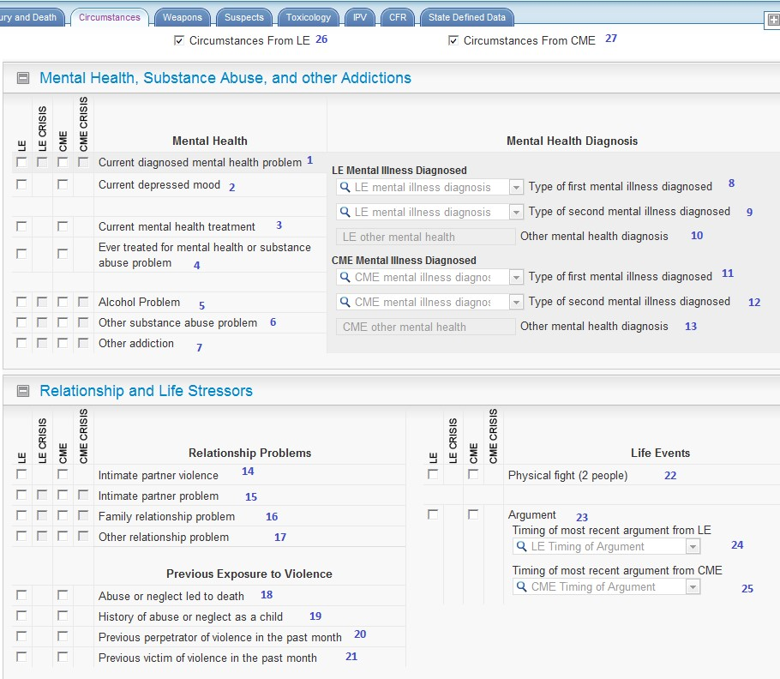

|  |  |  |  |
| --- | --- | --- | --- |
| 1. MentalHealthProblem 2. DepressedMood 3. MentalIllnessTreatmentCurrent 4. HistoryMentalIllnessTreatment 5. AlcoholProblem 6. SubstanceAbuseOther 7. OtherAddiction 8. LE_MentalHealthDiagnosis1 | 1. LE_MentalHealthDiagnosis2 2. LE_MentalHealthDiagnosisOther 3. CME_MentalHealthDiagnosis1 4. CME_MentalHealthDiagnosis2 5. CME_MentalHealthDiagnosisOther 6. IntimatePartnerViolence 7. IntimatePartnerProblem 8. FamilyStressors | 1. RelationshipProblemOther 2. DeathAbuse 3. AbusedAsChild 4. InterpersonalViolencePerpetrator 5. InterpersonalViolenceVictim 6. FightBetweenTwoPeople 7. Argument 8. LE_ArgumentTiming 9. CME_ArgumentTiming | 1. LE_CircumstancesKnown 2. CME_CircumstancesKnown |

# IX. Circumstances: Mental, Health, Substance Abuse, and Other Addiction & Relationship and Life Stressors

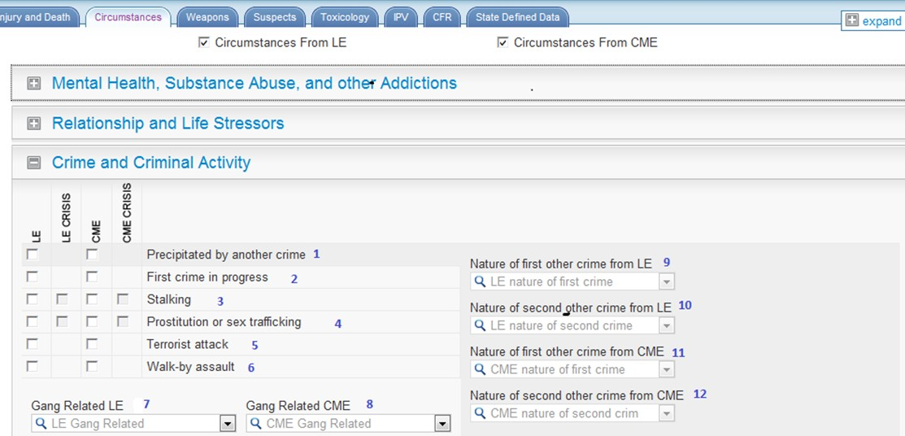

|  |  |
| --- | --- |
| 1 PrecipitatedByOtherCrime | 7 LE_GangType |
| 2 OtherCrimeinProgress | 8 CME_GangType |
| 3 Stalking | 9 LE_NatureOtherCrime1 |
| 4 Prostitution | 10 LE_NatureOtherCrime2 |
| 5 TerroristAttack | 11 CME_NatureOtherCrime1 |
| 6 WalkByAssault | 12 CME_NatureOtherCrime2 |

# X. Circumstances: Manner Specific Circumstances for Homicide and Suicide Deaths

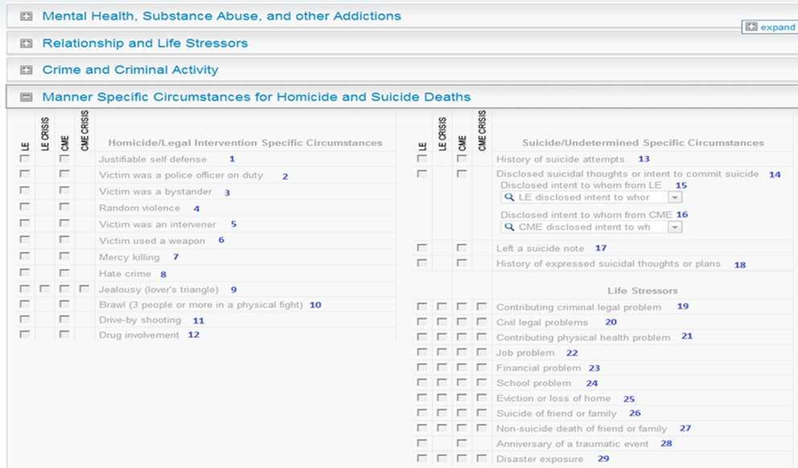

|  |  |  |  |
| --- | --- | --- | --- |
|  |  |  |  |
| 1 JustifiableSelfDefense | 8 HateCrime | 15 LE_DisclosedIntentToWhom | 22 JobProblem |
| 2 VictimPoliceOfficeOnDuty | 9 Jealousy | 16 CME_DisclosedIntentToWhom | 23 FinancialProblem |
| 3 Bystander | 10 Brawl | 17 SuicideNote | 24 SchoolProblem |
| 4 RandomViolence | 11 DriveByShooting | 18 SuicideThoughtHistory | 25 EvictionorLossofHome |
| 5 IntervenerAssistingVictim | 12 DrugInvolvement | 19 RecentCriminalLegalProblem | 26 RecentSuicideFriendFamily |
| 6 VictimUsedWeapon | 13 SuicideAttemptHistory | 20 LegalProblemOther | 27 DeathFriendorFamilyOther |
| 7 MercyKilling | 14 SuicideIntentDisclosed | 21 PhysicalHealthProblem | 28 TraumaticAnniversary |

# XI. Circumstances: Manner Specific Circumstances for Unintentional Firearm Deaths

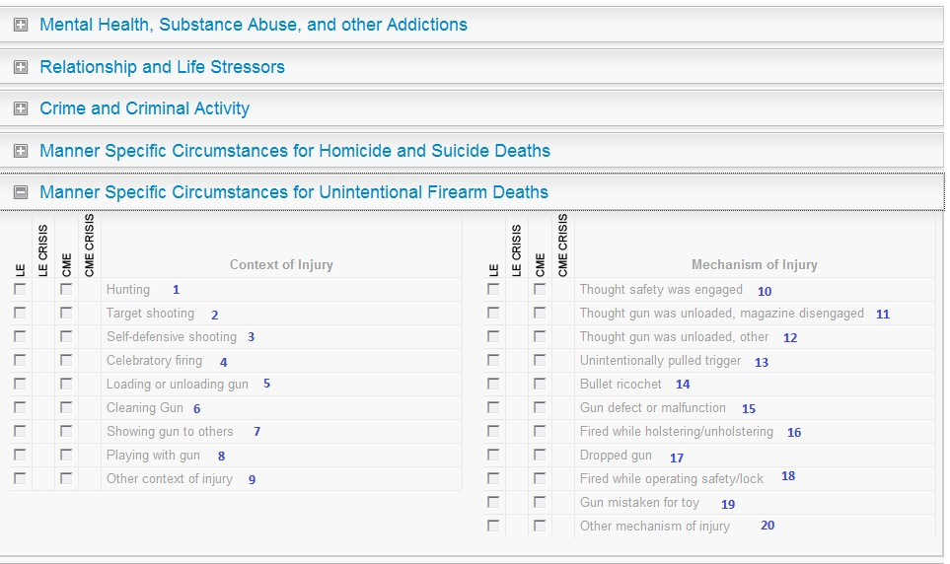

|  |  |  |  |  |
| --- | --- | --- | --- | --- |
| 1 | Hunting |  | 10 | GunThoughtSafetyEngaged |
| 2 | TargetShooting |  | 11 | GunThoughtUnloadedMagazineDisengaged |
| 3 | SelfDefense |  | 12 | GunThoughtUnloadedOther |
| 4 | CelebratoryFiring |  | 13 | GunUnintentionallyPulledTrigger |
| 5 | GunFiredLoadingUnloading |  | 14 | BulletRicochet |
| 6 | GunCleaning |  | 15 | GunDefectMalfunction |
| 7 | GunShowing |  | 16 | GunFiredHolstering |
| 8 | GunPlaying |  | 17 | GunDropped |
| 9 | OtherContextInjury |  | 18 | GunFiredOperatingSafetyLock |
|  |  |  | 19 | GunThoughtToy |
|  |  |  | 20 | OtherMechanismInjury |

# XII. Circumstances: Manner Specific Circumstances for Unintentional Firearm Deaths

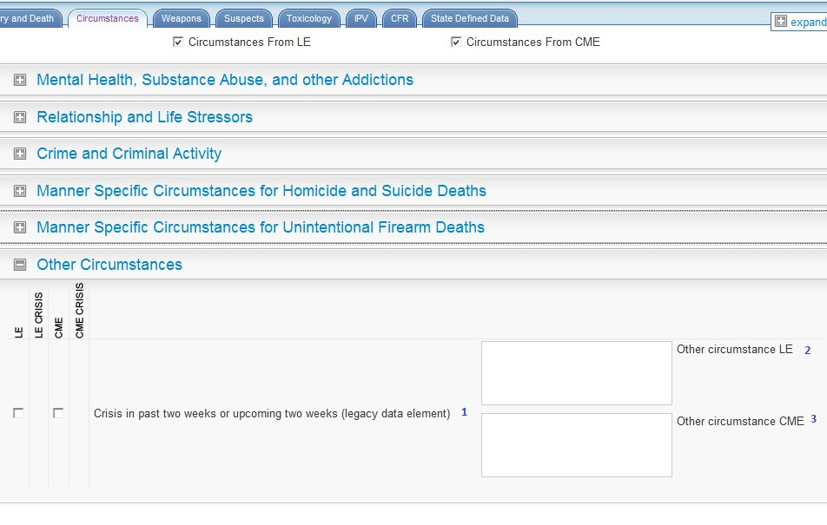

1 CrisisRecent 2 LE_CircumstancesOtherText 3 CME_CircumstancesOtherText

# XIII. Weapons

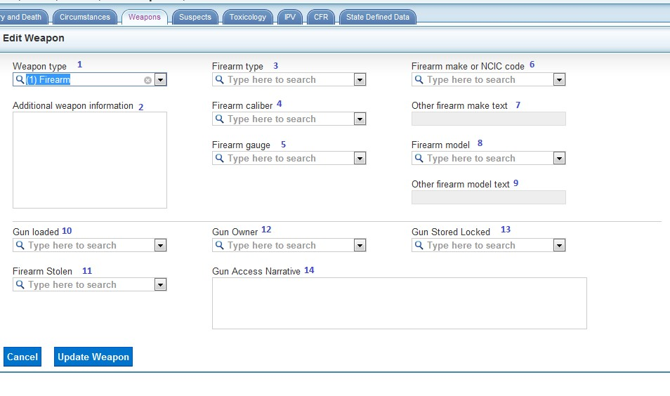

|  |  |  |  |  |  |  |  |
| --- | --- | --- | --- | --- | --- | --- | --- |
| 1 | WeaponType |  |  |  |  | 10 | GunLoaded |
| 2 | WeaponOther |  |  |  |  | 11 | FirearmStolen |
| 3 | FirearmType |  |  |  |  | 12 | GunOwner |
| 4 | FirearmCaliber |  |  |  |  | 13 | GunStoredLocked |
| 5 | FirearmGauge |  |  |  |  | 14 | YouthGunAccessNarrative |
| 6 | FirearmMake |  |  |  |  |  |  |
| 7 | FirearmMakeText |  |  |  |  |  |  |
| 8 | FirearmModel |  |  |  |  |  |  |
| 9 | FirearmModelText |  |  |  |  |  |  |

**XIV. Suspects:**

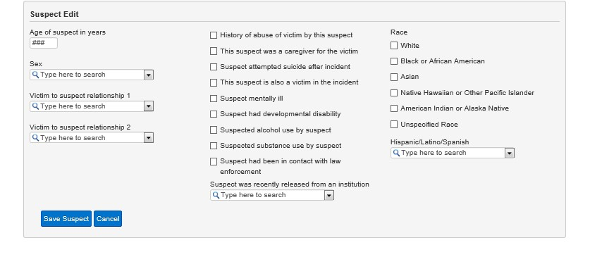

1

2

3

4

14

13

12

11

10

9

8

7

6

5

15

16

17

18

19

20

21

|  |  |  |  |  |  |  |  |
| --- | --- | --- | --- | --- | --- | --- | --- |
| 1 | AgeYears |  | 5 | AbuseHistory |  | 15 | RaceWhite |
| 2 | Sex |  | 6 | CareGiver |  | 16 | RaceBlack |
| 3 | VictimSuspectRelationship1 |  | 7 | AttemptedSuicide |  | 17 | RaceAsian |
| 4 | VictimSuspectRelationship2 |  | 8 | SuspectAlsoVictim |  | 18 | RacePacificIslander |
|  |  |  | 9 | SuspectMentallyIll |  | 19 | RaceAmericanIndian |
|  |  |  | 10 | SuspectDisabilityDevelopmental |  | 20 | RaceUnspecified |
|  |  |  | 11 | SuspectAlcoholUseSuspected |  | 21 | SuspectEthnicity |
|  |  |  | 12 | SuspectSubstanceUseSuspected |  |  |  |
|  |  |  | 13 | SuspectRecentRelease |  |  |  |
|  |  |  | 14 | SuspectContactPolice |  |  |  |

# XV. Toxicology: Toxicology Specimen Date & Toxicology Findings

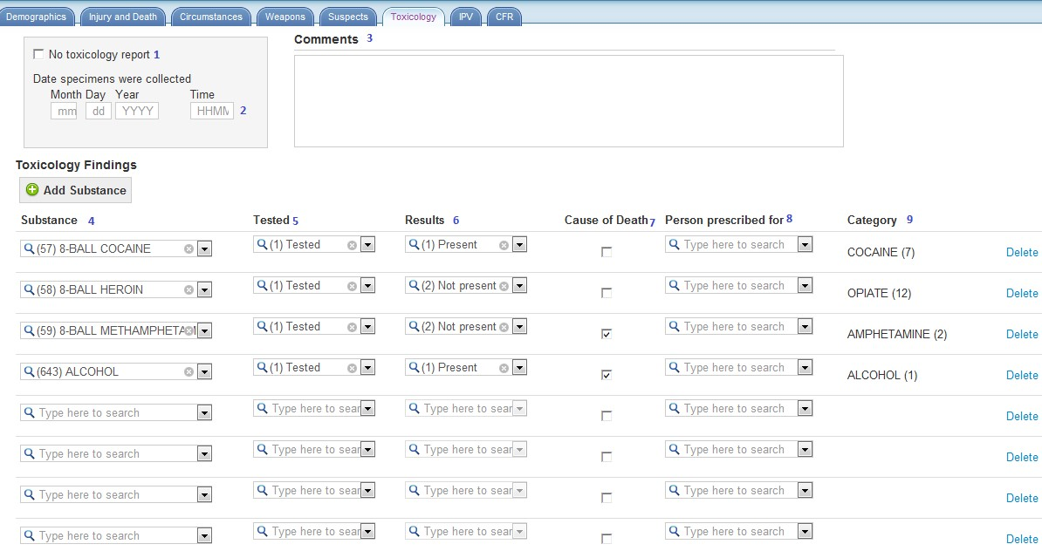

1 No Toxicology Available 7 SubstanceCausedDeath 2 SpecimensTime 8 DrugObtainedFor 3 Comments 9 SubstanceClass 4 SubstanceName  5 SubstanceTested  6 SubstanceResult

# XVI. Toxicology Templates: new addition to the software

There is now a “templates” feature that may assist in entering tox data that comes to abstractors in standardized formats. State administrators can create toxicology templates, and then abstractors can add a template to a victim record by clicking the “apply template” button on the toxicology tab.

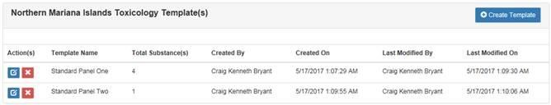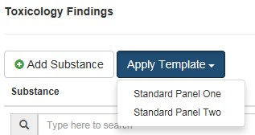

**XVII. Toxicology: Toxicology Summary:**

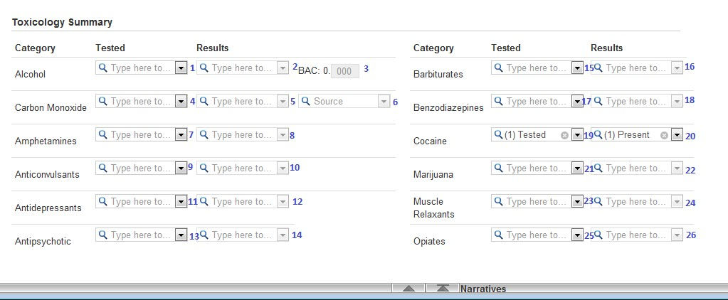

|  |  |  |  |
| --- | --- | --- | --- |
| 1 AlcoholTested | 9 AnticonvulsantsTested | 17 BenzodiazepinesTested | 25 OpiateTested |
| 2 AlcoholResult | 10 AnticonvulsantsResult | 18 BenzodiazepinesResult | 26 OpiateResult |
| 3 AlcoholLevel | 11 AntiDepressantTested | 19 CocaineTested |  |
| 4 CarbonMonoxideTested | 12 AntiDepressantResult | 20 Cocaine test result |  |
| 5 CarbonMonoxideResult | 13 AntipsychoticTested | 21 MarijuanaTested |  |
| 6 CarbonMonoxideSource | 14 AntipsychoticResult | 22 MarijuanaResult |  |
| 7 AmphetamineTested | 15 BarbituratesTested | 23 MuscleRelaxantTested |  |
| 8 AmphetamineResult | 16 BarbituratesResult | 24 MuscleRelaxantResult |  |

# XVIII. Documents Page

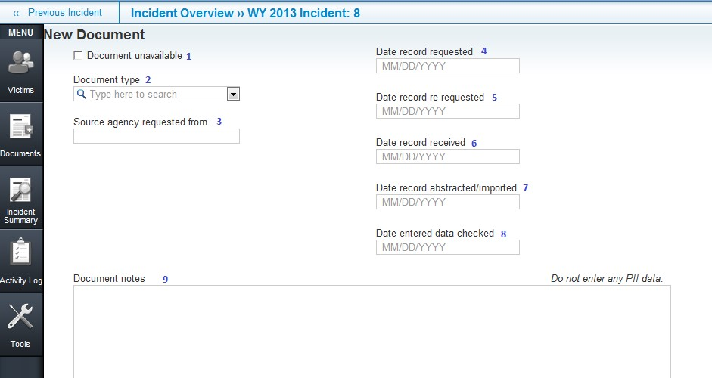

|  |  |
| --- | --- |
|  |  |
| 1 DocumentUnavailable | 5 Date record re-requested |
| 2 DocumentType | 6 Date record received |
| 3 AgencySource | 7 AbstractedDate |
| 4 Date record requested | 8 Date entered data checked |
|  | 9 DocumentNotes |

# XIX. Incident Overview Page: Acts as a home page for the incident, it displays when and incident is first created

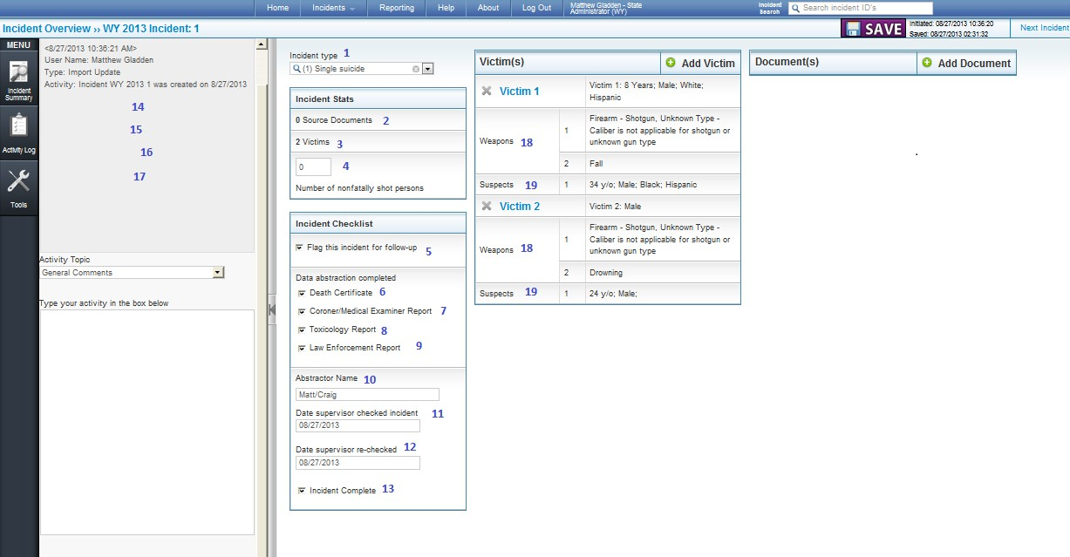

|  |  |  |
| --- | --- | --- |
| 1 IncidentType | 8 CompleteToxicology | 15 LastUpdateDate |
| 2 NumberOfDocuments | 9 CompleteLE | 16 DateDeleted |
| 3 NumberofVictims | 10 AbstractorName | 17 DateMerged |
| 4 NumberNonfatallyShot | 11 SupervisorCheckedDate | 18 NumberOfWeapons |
| 5 FollowUp | 12 SupervisorRecheckedDate | 19 NumberOfSuspects |
| 6 CompleteDC | 13 CompleteIncident |  |
| 7 CompleteCME | 14 CreateDate |  |

# XX. CME and LE Incident Narratives

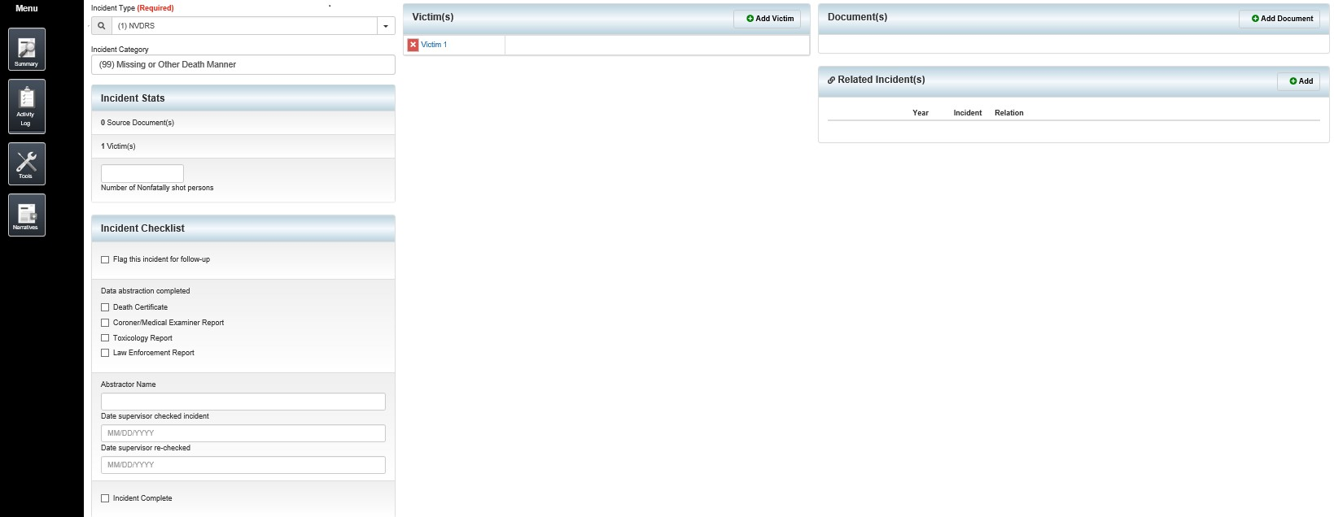



## 1 NarrativeLE 2 NarrativeCME

**XXI. Import Page: *Available to states to import information from death certificates, including ICD-10 and Coroner/Medical Examiner records. One new option added, the ability to identify the incident types for casing being imported.***

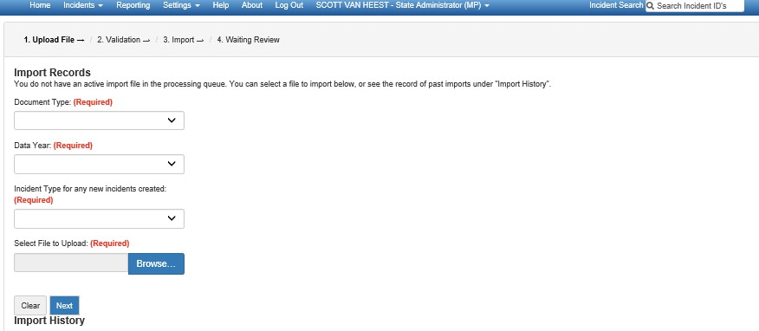

# XXII. The Dashboard: Displays on the Home Page, tool for each state to monitor and evaluate performance

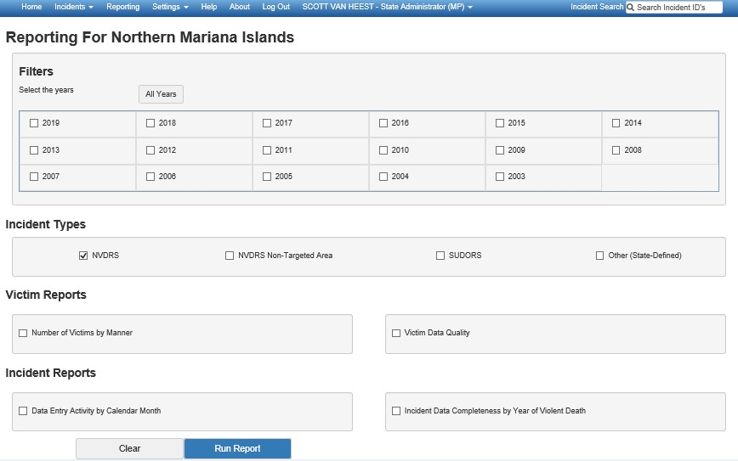

# XXIII. Incident Validation: this is a new addition to the software

The new software architecture has allowed us to pull together all of the validation rules on the various data elements into a single screen. Now, you can click the “validate” button next to the “save” button and receive a report on all validation rules for the incident, like this:

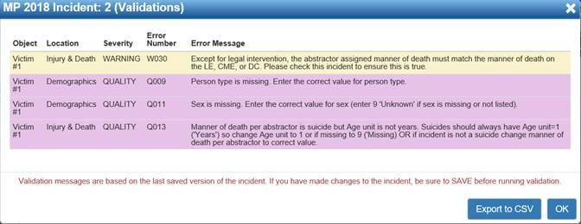

In addition to the errors and warnings that have always been in the software, we have added about two dozen “data quality checks” that we have been running in SAS as part of the data closeout process. We plan to add more checks in the future.

# XXIV. Related Incidents: this is a new addition to the software

We have added a panel to the Incident screen that allows users to create links between incidents. Each link has a description field and allows users to click through to see the related incident. The panel looks like this:

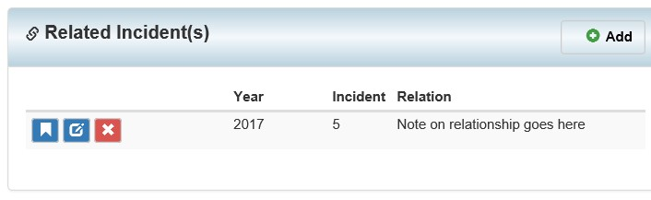

States will have a lot of freedom in determining what constitutes a “related” incident in NVDRS. Related incidents might include multiple homicides taking place outside of our 24-hour case definition criterion, unintentional drug overdoses with related suicides or homicides, and so on. In the future, we may add a drop down with relationship categories, based on how this feature is used in practice.

**XXV. Overdose Module: *An optional module added to NVDRS web-based system for the State Unintentional Drug Overdose Reporting System (SUDORS). The existence of NVDRS and its web-system made rapid scale-up of SUDORS to respond to the increase in overdose deaths possible. NVDRS does not collect these data elements.***

