Non-substantive Change Request
OMB Control Number 0920-0607
The National Violent Death Reporting System
Date Submitted: 2/28/2025

Summary of request: CDC/NCIPC is requesting a change request to revise questions to align with EO 14168 Defending Women From Gender Ideology Extremism and Restoring Biological Truth to the Federal Government.

Description of Changes Requested: This request updates sex and gender variables used in the National Violent Death Reporting System to be in accordance with EO 14168. Please check the boxes below if your request includes:

x Revision of an existing question(s)
x Deletion of an existing question(s)

If revising an existing question, CDC is advised to use one of the two versions below and can state that CDC has changed the current Gender/Sex question to (please see red circle in attached screenshot):

What is your Sex?
- Male
- Female
- Unknown

CDC has also disabled and removed the transgender variable in the system software.

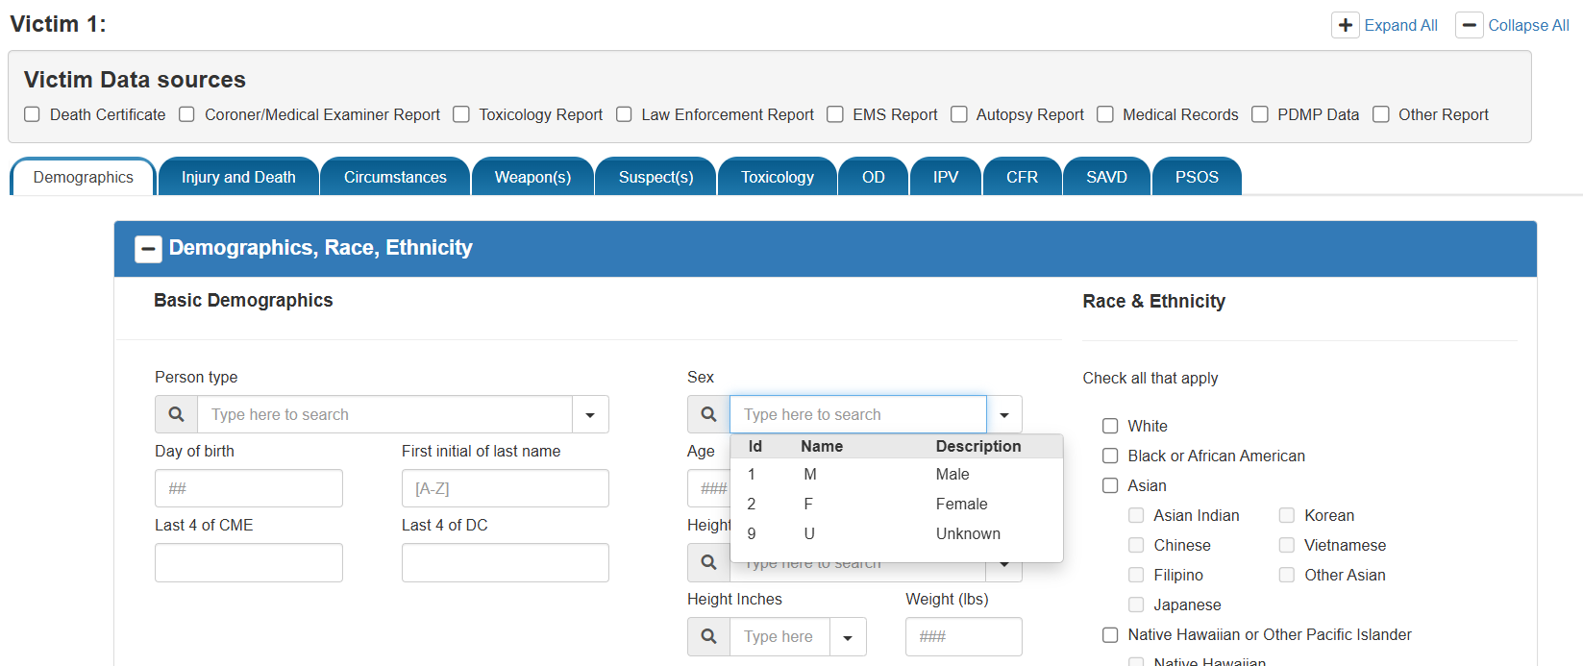

Description of these actions could also be included in the Table at the bottom of this document.

Description of Changes to Burden: There is no change in Burden Hours associated with the modifications made to comply with EO 14168.

Description of Changes to Burden (if applicable): Form | Approved Burden | Requested Burden
Form 1 | TOTAL TIME  TIME per response # respondents | TOTAL TIME  TIME per response # respondents
Form 2 | TOTAL TIME  TIME per response # respondents | TOTAL TIME  TIME per response # respondents
Total | TOTAL TIME | TOTAL TIME

Other Considerations (optional): CDC can include other aspects associated with the submission of this Non-Substantive Change Request here (e.g., timing sensitivities, implementation requirements, etc.,).

Table A: Description of Changes (optional, helpful if multiple changes to multiple forms): | Type of Change | Question/Item | Requested Change
Form 1 | Question Revision
Form 2 | Question Deletion

