**Non-substantive Change Request**

**OMB Control Number 0920-0607**

**State Unintentional Drug Overdose Reporting System (SUDORS)**

**Date Submitted: 03/04/2025**

**Summary of request:** CDC/NCIPC is requesting a change request to revise questions to align with EO 14168 *Defending Women From Gender Ideology Extremism and Restoring Biological Truth to the Federal Government.*

**Description of Changes Requested:** This request updates sex questions used in the State Unintentional Drug Overdose Reporting System (SUDORS) to be in accordance with EO 14168. Please check the boxes below if your request includes:

x□ Revision of an existing question(s)

x□ Deletion of an existing question(s)

CDC will be changing the current Gender/Sex question to:

**What is your Sex?**

**- Male**

**- Female**

**- Unknown**

**- Missing Value [Null]**

CDC will be removing the checkbox to indicate that a person who died of drug overdose identified as transgender:

□Transgender

Before deletion of question:



After deletion of question, with updated response options for revision of question:

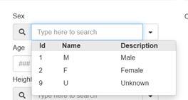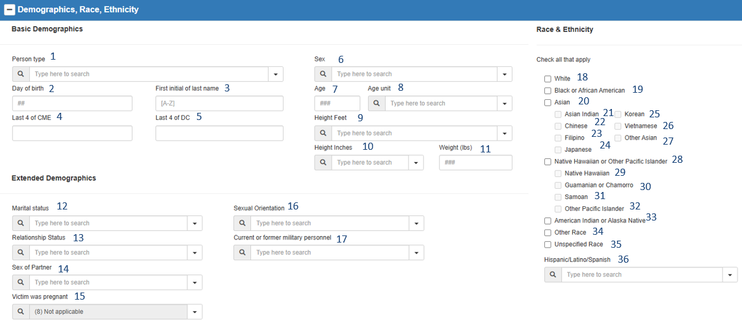

**Sex drop-down menu**

Description of these actions could also be included in the Table at the bottom of this document.

**Description of Changes to Burden (if applicable):** N/A. There is no change in Burden Hours associated with the modifications made to comply with EO 14168.

**Other Considerations (optional):** CDC can include other aspects associated with the submission of this Non-Substantive Change Request here (*e.g., timing sensitivities, implementation requirements, etc.,).*

|  |  |  |  |
| --- | --- | --- | --- |
| **Table A: Description of Changes (optional, helpful if multiple changes to multiple forms):** | Type of Change | Question/Item | Requested Change |
| Form 1 | Question Revision | Sex | Drop option of “X” to leave response options of “Male,” “Female,” “Unknown,” or blank/missing |
| Form 2 | Question Deletion | Transgender | Remove checkbox to indicate transgender identification of decedents |