**II. Demographic Variables for Victims*:***

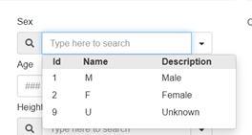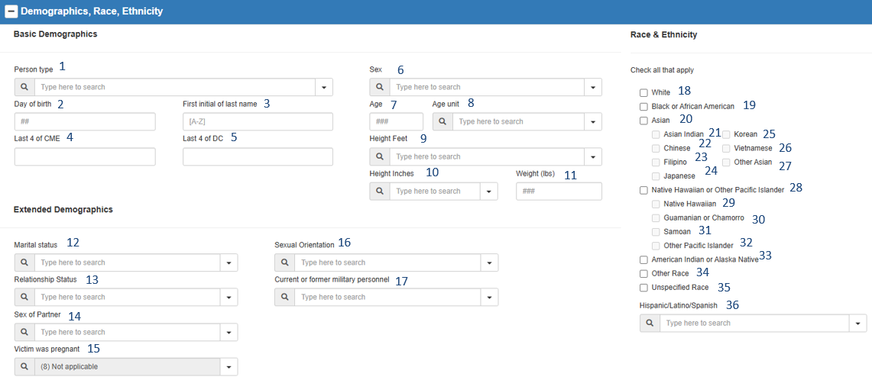

**Sex dropdown menu**:

|  |  |  |  |  |  |  |  |
| --- | --- | --- | --- | --- | --- | --- | --- |
| 1 | PersonType |  | 13 | RelationshipStatus |  | 25 | RaceKorean |
| 2 | BirthDayofMonth |  | 14 | SexofPartner |  | 26 | RaceVietnamese |
| 3 | LastNameFirstInitial |  | 15 | Pregnant |  | 27 | RaceOtherAsian |
| 4 | CMENumberLastFour |  | 16 | SexualOrientation |  | 28 | RacePacificIslander |
| 5 | DCNumberLastFour |  | 17 | Military |  | 29 | RaceHawaiian |
| 6 | Sex |  | 18 | RaceWhite |  | 30 | RaceGuamanian |
| 7 | Age |  | 19 | RaceBlack |  | 31 | RaceSamoan |
| 8 | AgeUnit |  | 20 | RaceAsian |  | 32 | RaceOtherPacIslander |
| 9 | HeightFeet |  | 21 | RaceAsianIndian |  | 33 | RaceAmericanIndian |
| 10 | HeightInches |  | 22 | RaceChinese |  | 34 | RaceOther |
| 11 | Weight |  | 23 | RaceFilipino |  | 35 | RaceUnspecified |
| 12 | MaritalStatus |  | 24 | RaceJapanese |  | 36 | Ethnicity |