OAHPMData.net

Secure Log In
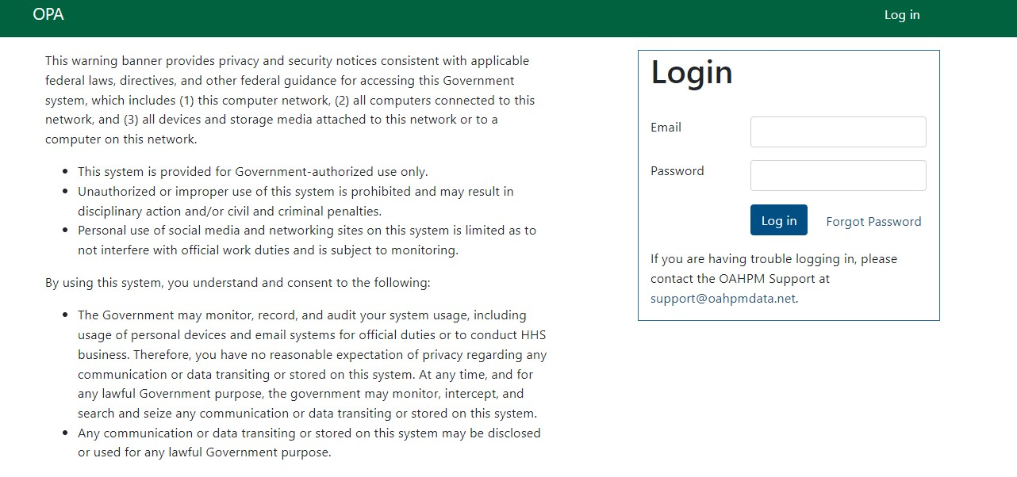

Multifactor Authentication (example via text)
