Joshua Tree National Park
Management Survey
2025

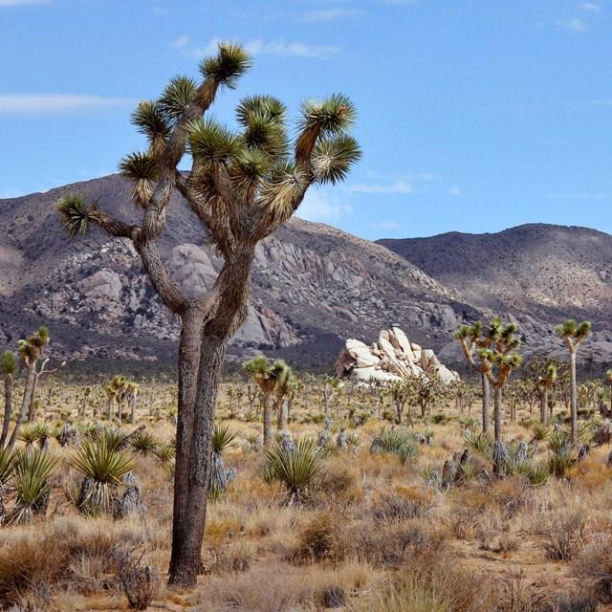

To be completed by field staff:

ID ______ Time ________ Location__________ Date _____
Field staff____________

PRIVACY ACT and PAPERWORK REDUCTION ACT statement:
The Paperwork Reduction Act requires us to tell you why we are collecting this information, how we will use it, and whether or not you have to respond. We are authorized by the National Park Service Protection Interpretation and research in System (54 USC §100702) to collect this information. The routine uses of this information will be for the benefit of NPS Managers and Planning staff in North Cascades National Park in future initiatives related to the visitor use and resource management within the site. The data collected will be summarized to evaluate visitor uses and expectations during their visit at North Cascades National Park. Your responses to this collection are completely voluntary and will remain anonymous. You can end the process at any time and will not be penalized in any way for choosing to do so. All contact information collected for the purpose of the follow-up survey will be destroyed at the end of the collection period and no personal identifiable records will be maintained or stored for any purposes. Data collected will only be reported in aggregates and no individually identifiable responses will be reported. A Federal agency may not conduct or sponsor, and you are not required to respond to, a collection of information unless it displays a currently valid OMB Control Number (1024-0224).
BURDEN ESTIMATE STATEMENT: We estimate that it will take about 10 minutes to complete this questionnaire. You may send comments concerning the burden estimates or any aspect of this information collection to: Megan McBride, National Park Service, megan_mcbride@nps.gov (email).

NOTE: In this questionnaire, “personal group” is defined as anyone that you are visiting the park with, such as spouse, family, friends, etc. This does not include the larger group that you might be traveling with, such as school, church, scouts, or tour group.
TOPIC AREA 3: CVIS3; CVIS2; CVIS1
(Variation: Expanded questions to obtain information about seasonal visitation and site-specific visitation)

- Please tell us about your past visitation to Joshua Tree National Park (referred to as “the park” in the survey).
- Including today, how many days in the last month (30 days) have you visited the park?

________________________________________________

- Including today, how many days in the last year (12 months) have you visited the park?

________________________________________________

- Including today, how many years (total) have you visited the park?

________________________________________________

- In what year did you first visit the park? (YYYY)

________________________________________________

TOPIC AREA 3: DEST17

- On this trip, how long did you and your personal group spend visiting Joshua Tree NP? Please list partial hours / days as ¼, ½, ¾.

________ | Number of hours, if fewer than 24 hours
 | OR
________ | Number of days, if 24 hours or more

TOPIC AREA 3: CVIS8; DEST26
- On this visit to Joshua Tree NP, please select all the park locations that you and your personal group visited in Joshua Tree NP? Select all white boxes with location names that apply.
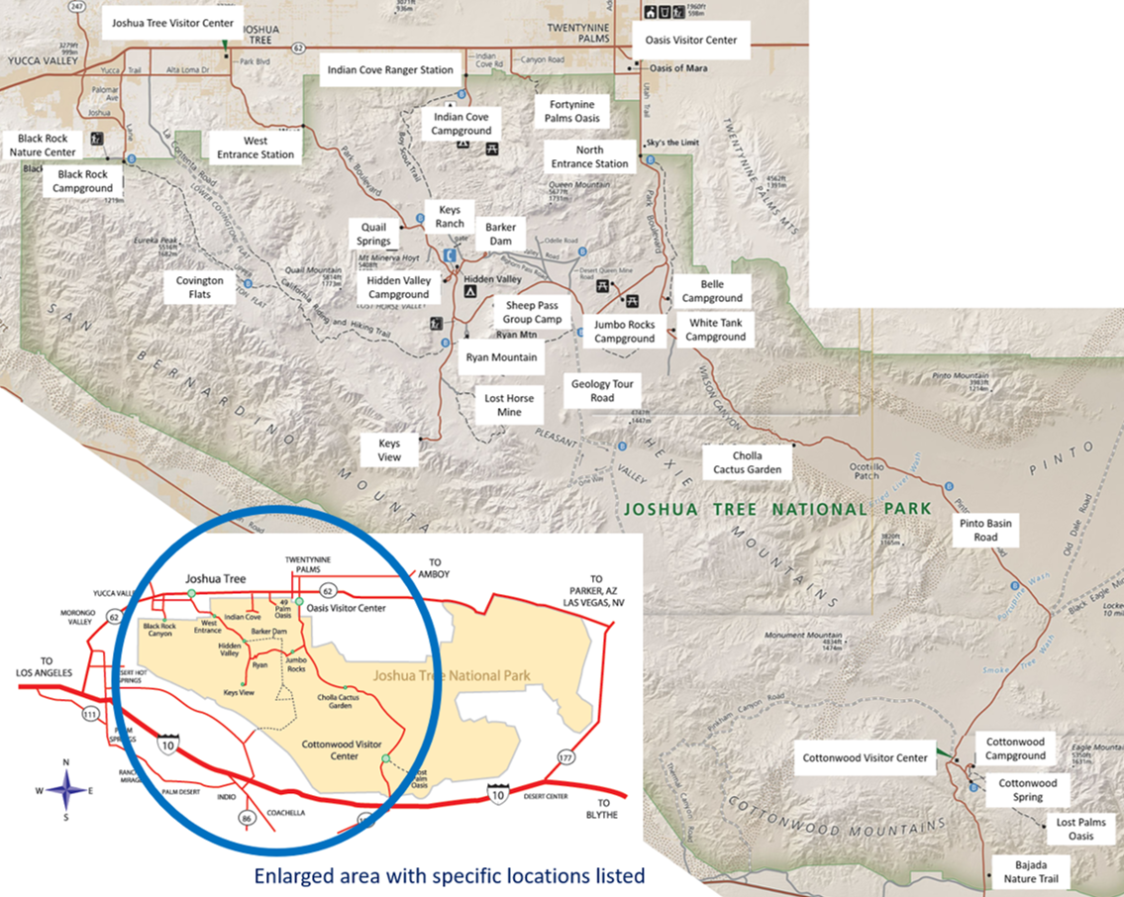

- Please list any other locations visited in the park on this trip.
________________________________________________________________
TOPIC AREA 3: CVIS8, CVIS9
- For this trip, where did you and your personal group spend the longest amount of time? Please select only one location.
- North Entrance Station | - Sheep Pass Group Camp
- West Entrance Station | - Bajada Nature Trail
- Indian Cove Ranger Station | - Barker Dam
- Cottonwood Visitor Center | - Cholla Cactus Garden
- Joshua Tree Visitor Center | - Cottonwood Spring
- Oasis Visitor Center | - Covington Flats
- Black Rock Nature Center | - Fortynine Palms Oasis
- Belle Campground | - Geology Tour Road
- Black Rock Campground | - Keys Ranch
- Cottonwood Campground | - Keys View
- Hidden Valley Campground | - Lost Horse Mine
- Indian Cove Campground | - Lost Palms Oasis
- Jumbo Rocks Campground | - Pinto Basin Road
- White Tank Campground | - Quail Springs
- Ryan Mountain | - Other _____________

TOPIC AREA 5: ACT18c
- On this visit, in which activities did you and your personal group participate within Joshua Tree NP? Mark all that apply.

- Attended field classes or  other guided activities | - Picnicking
- Attended ranger-led programs | - Rock scrambling  (without specialized gear or skills)
- Backpacking overnight | - Seeking spiritual connection
- Bicycling | - Sightseeing
- Bouldering  (using pads and bouldering guides) | - Slacklining
- Camping | - Stargazing / viewing night sky
- Created content for social media / blogs | - Technical climbing  (with specialized gear or skills)
- Day hiking | - Trail running
- Enjoyed nature | - Viewed plants and/or wildlife
- Exercised to promote physical fitness | - Visited historical or archaeological sites
- Family / friend gathering or celebration | - Visited visitor center(s)
- Horseback riding | - Walking self-guided nature trails  (with brochures/signs)
- Photography / videos | - Other (Please specify) ______________________

TOPIC AREA 5: ACT18 (Variation: Focused on primary activity.)
- Which one of the above activities was the primary activity in which you and your personal group participated at Joshua Tree NP on this visit? Please select one.
[item list will populate based on answers to Question #6]
TOPIC AREA 6: CROWD3
- Please indicate if you changed any of the following during this visit or a previous visit to Joshua Tree NP because of too many people or crowding? Select all that apply.
 | Changed during a previous visit to the park | Changed during this current visit to the park
Chose not to visit the park |  | -----------
Changed the times of the day that you visited the park
Changed the dates or seasons that you visited the park
Chose not to visit your desired places at the park
Changed the times of day that you visited places at the park
Changed the order of places visited at the park
Chose not to participate in your desired activities at the park

TOPIC AREA 5a&b: ITIN15 (Variation: focused wording on campsite availability)
- Have you ever changed your trip plans because a campsite in a particular campground at Joshua Tree NP was not available on the date you initially desired?
- Yes | - No
- Not applicable - I did not plan to camp

- Please tell us how you changed your trip plans. Select all that apply.
- I changed the dates of my trip
- I camped at another location within Joshua Tree NP
- I camped at a location other than Joshua Tree NP
- I came to Joshua Tree NP but chose not to camp

TOPIC AREA 4: TRANSMGMT1; TOPIC AREA 8: MGMTOPT3, MGMTOPT13
- Please indicate your level of opposition or support for the following potential future management actions concerning park access, transportation, and car camping at Joshua Tree NP. The list of items below are not necessarily actions that are going to occur at the park. However, we are interested in your opinions about these potential actions.
 | Strongly oppose | Oppose | Somewhat oppose | Neither oppose nor support | Somewhat support | Support | Strongly support | Unable to answer or need more information
Implement reservation system to enter the park
Add parking spaces at major attractions
Add additional traffic lanes at park entrances
Increase entry fees
Temporarily close specific roads and parking areas based on congestion (e.g., Keys View, road to Barker Dam)
Require riding shuttle buses within the park on the park’s busiest days (e.g., weekends, holidays, spring break)
Develop paved access to more popular locations and attractions
Implement a parking reservation or parking permit system
Decrease the number of nights that visitors can stay at developed campgrounds
Develop more campsites in existing campgrounds like Hidden Valley
Use online park communications to inform visitors about the availability and characteristics of sites in developed campgrounds

TOPIC AREA 4: TRANSMGMT1; TOPIC AREA 8: MGMTOPT3, MGMTOPT13
- Please indicate your level of opposition or support for the following potential future management actions concerning trails and wilderness backpacking at Joshua Tree NP. The list of items below are not necessarily actions that are going to occur at the park. However, we are interested in your opinions about these potential actions.
 | Strongly oppose | Oppose | Somewhat oppose | Neither oppose nor support | Somewhat support | Support | Strongly support | Unable to answer or need more information
Reduce the number of trails in the park to provide better conditions on fewer trails
Develop new trails in the southern half of the park
Provide more information about trails to help visitors find trails that match their preferences for length and things they can see and enjoy
Expand and develop new trailhead parking lots for existing trails
Implement a wilderness backpacking reservation system
Establish designated and assigned wilderness camping sites
Introduce fees for overnight backpacking to support wilderness services
Require mandatory wilderness backpacking orientation to receive a wilderness backpacking permit
Require visitors to pack out human waste when using the backcountry

TOPIC AREA 4: TRANSMGMT1; TOPIC AREA 8: MGMTOPT3, MGMTOPT13
- Please indicate your level of opposition or support for the following potential future management actions concerning rock climbing and bouldering at Joshua Tree NP. The list of items below are not necessarily actions that are going to occur at the park. However, we are interested in your opinions about these potential actions.
 | Strongly oppose | Oppose | Somewhat oppose | Neither oppose nor support | Somewhat support | Support | Strongly support | Unable to answer or need more information
Limit the addition of new fixed anchors / bolts in wilderness areas
Remove illegally installed (unpermitted) bolts from wilderness areas
Require visitors to pack out human waste when using popular climbing areas
Close climbing routes / staging areas with sensitive cultural or natural resources
Provide signs and directions to all climbing rock formations
Require time-specific permits for climbing on popular routes and walls
Require location-specific permits for climbing on popular routes and walls
Require location-specific permits for popular bouldering areas
Require visitors to pack out human waste when using popular bouldering areas
Close bouldering routes / staging areas with sensitive cultural or natural resources
Improve signs and directions to all bouldering formations
Require time-specific permits for popular bouldering areas
Identify designated crash pad areas free from vegetation and sensitive soil

TOPIC AREA 4: TRANSMGMT3
- To what extent did the following factors impact your visit to Joshua Tree National Park? (Check one box for each statement)

 | Level of Impact
 | Not at  all | Very  little | Somewhat | To a great extent | Not  applicable
Too few parking spaces at pullouts and overlooks along scenic drives
Too few parking spaces at trailheads
Too few restrooms
Congestion on park roads
Too little directional signage on park trails
Confusion about wilderness backpacking rules and regulations
Confusion about camping rules and regulations
Not enough ranger-led activities
Congestion in the visitor centers
Too little directional signage on the main park roads
Vandalism (e.g., graffiti, tire tracks, illegal campfire scars)
Limited information to plan your trip before you enter the park
Too little signage on wilderness / backcountry trails in the park
Too few informational signs
Too few directional signs on trails
Conflicts with other visitors on park roads or trails

Topic Area 1: RES2
- Are you a permanent resident or citizen of the United States?

☐ NO - What is your country of origin? _______________________
☐ YES - What is your zip code and state of your primary residence?
State_____________ Zip code ______________

Topic Area 1: AGE1
- What is your age? _______
Topic Area 1: GEND1
- What is your gender? (select one)
Male
Female
Transgender, non-binary, or another gender
Prefer not to answer

Topic Area 1: EDUC1
- What is the highest level of school you have completed? (select one)
❑ Less than high school | ❑ Two-year college graduate
❑ Some high school | ❑ Four-year college graduate
❑ High school graduate | ❑ Graduate or professional degree
❑ Some college | ❑ Do not wish to answer

Topic Area 1: ECON9
- Which category best describes your total household income in U.S. dollars during 2024 before taxes? (select one)
❑ Less than $24,999 | ❑ $50,000 to $74,999 | ❑ $150,000 to $199,999
❑ $25,000 to $34,999 | ❑ $75,000 to $99,999 | ❑ $200,000 or more
❑ $35,000 to $49,999 | ❑ $100,000 t $149,999 | ❑ Do not wish to answer

Topic Area 1: RACE/ETH2
- What is your race and/or ethnicity? Select all that apply and enter additional details in the spaces below.
- American Indian or Alaska Native—Enter, for example, Navajo Nation, Blackfeet Tribe of the Blackfeet Indian Reservation of Montana, Native Village of Barrow Inupiat Traditional Government, Nome Eskimo Community, Aztec, Maya, etc.

- Asian—Provide details below.
- Chinese | - Asian Indian | - Filipino
- Vietnamese | - Korean | - Japanese
Enter, for example, Pakistani, Hmong, Afghan, etc.

- Black or African American—Provide details below.
- African American | - Jamaican | - Haitian
- Nigerian | - Ethiopian | - Somali
Enter, for example, Trinidadian and Tobagonian, Ghanaian, Congolese, etc.

- Hispanic or Latino—Provide details below.
- Mexican | - Puerto Rican | - Salvadoran
- Cuban | - Dominican | - Guatemalan
Enter, for example, Colombian, Honduran, Spaniard, etc.

- Middle Eastern or North African—Provide details below.
- Lebanese | - Iranian | - Egyptian
- Syrian | - Iraqi | - Israeli
Enter, for example, Moroccan, Yemeni, Kurdish, etc.

- Native Hawaiian or Pacific Islander—Provide details below.
- Native Hawaiian | - Samoan | - Chamorro
- Tongan | - Fijian | - Marshallese
Enter, for example, Chuukese, Palauan, Tahitian, etc.

- White—Provide details below.
- English | - German | - Irish
- Italian | - Polish | - Scottish
Enter, for example, French, Swedish, Norwegian, etc.

Thank you for your help with this survey!
Please click "next" to finalize your response.

