Bryce Canyon National Park Visitor Study 2024
___________________________________________________________________

OMB Approval Number: xxxx-xxxx
Expiration Date: xx/xx/xxxx

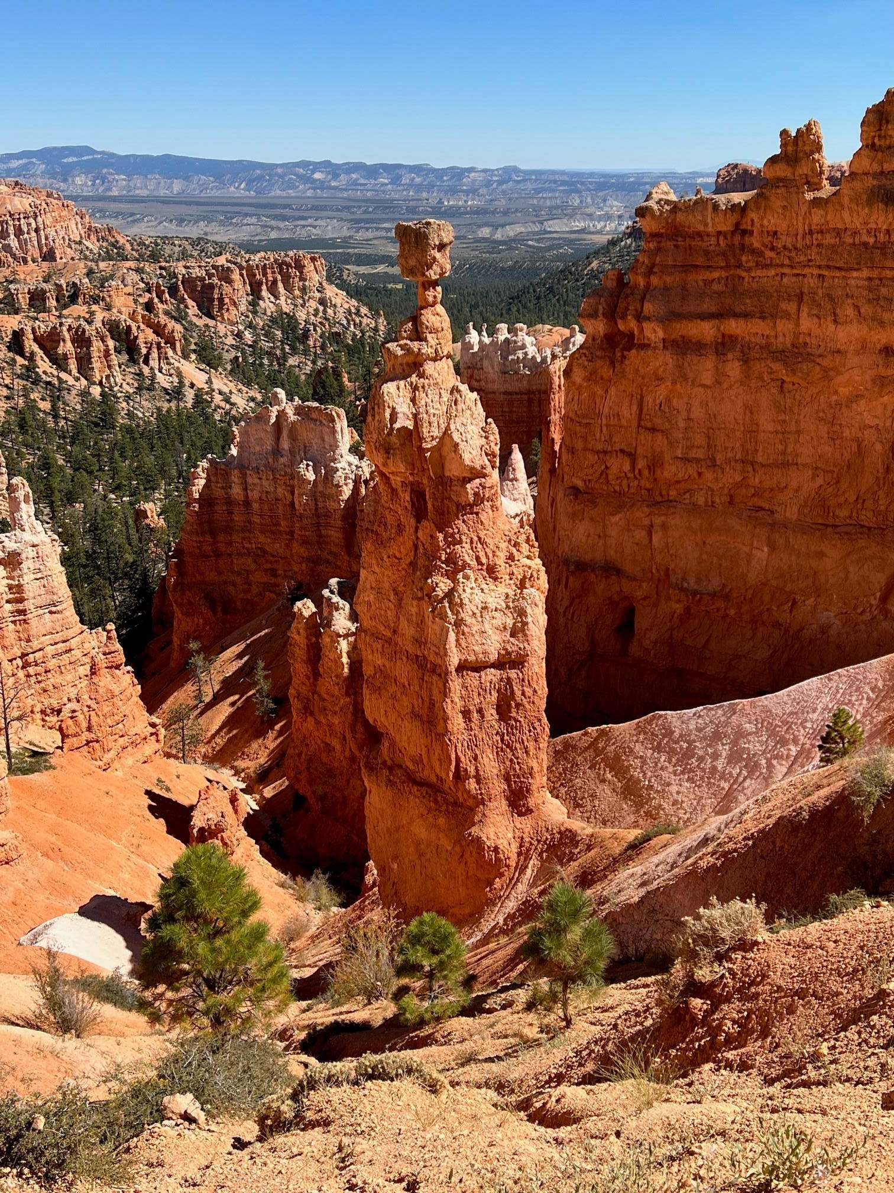

Paperwork Reduction Act Statement: The National Park Service is authorized by the NPS Research Mandate (54 USC 100702) to collect this information. This information will be used by park managers to understand more about visitors to Bryce Canyon National Park to help inform park management and planning now and into the future. Responses to this request are voluntary and anonymous. Your name will never be associated with your answers, and all contact information will be destroyed when the data collection is concluded. No action may be taken against you for refusing to supply the information requested. An agency may not conduct or sponsor, and a person is not required to respond to, a collection of information unless it displays a currently valid OMB control number and expiration date.
BURDEN ESTIMATE: We estimate that it will take about 10-15 minutes to complete this questionnaire. You may send comments concerning the burden estimates or any aspect of this information collection to: Megan McBride at megan_mcbride@nps.gov or 970-502-7353

Section 1 – This section asks you some questions about your visit to Bryce Canyon National Park
TOPIC AREA 3: CVIS1,2,3
- Are you a first-time visitor to Bryce Canyon National Park?
Yes
No
If no, in which year did you make your first visit to Bryce Canyon? _______ Year

- Over the past twelve months, how many visits have you made to Bryce Canyon not including this visit? _____ Number of visits

TOPIC AREA 3: GROUP3
- Which one of the following best describes the group you are traveling with?
Myself (alone)
Myself with family (including spouse/partner/ and/or other family members/relatives
Myself with family and friends
Myself with friends
Commercially guided tour group
Club/organization/school
Other organized group (such as business group, scout group, etc.)
Other (please specify):_____________________________________________________

TOPIC AREA 1: GROUP4 (Variation: Split response options into adults and children)
- Including yourself, how many people are in your personal group? (This does not include a larger group with which you may be visiting such as a church group or organized tour.)
____ | Adults (18 years or older) | ____ | Children (under 18 years)
TOPIC AREA 3: DEST17
- On this visit, how long did you and your personal group stay at Bryce Canyon?
____ | # of hours, if less than 24 hours OR | ____ | # of days, if 24 hours or more
TOPIC AREA 3: FVIS1
- Would you consider visiting Bryce Canyon again?
 | Yes, likely |  | No, unlikely |  | Not sure
Why or why not? ______________________________________________

Section 2 – This section asks you some questions about your activities and experiences at Bryce Canyon
TOPIC AREA 5: ACT11
- Below is a list of activities available at Bryce Canyon. Please indicate:
- Which one of these activities is your primary activity during this visit?
- Which of these activities have you participated in on this visit?
 | (A)  Primary Activity  (Check only one) | (B)  Participated in on this visit  (Check all that apply)
Camping
Backcountry camping
Hiking (no guide)
Hiking (with NPS guide)
Hiking (with commercial guide)
Horseback riding (commercial)
Horseback riding (private)
Photography
Ranger programs
Other (please specify):___________

TOPIC AREA 5: ACT14
Reviewer Note: The question will auto populate with the respondent’s primary activity as noted in question 7a.
- Please rate your current ability/ experience level in [primary activity]. Please select only one.
 | Beginner | Novice | Intermediate | Advanced | Expert
 | 1 | 2 | 3 | 4 | 5
TOPIC AREA :HUNTFISH3 (Variation: swapped activity and timeframe to be relevant to study parameters.)
- Including today, approximately how many days in the last year (12 months) have you….
  - Engaged in [primary recreational activity] anywhere? _______________
  - Engaged in [primary recreational activity] in Bryce Canyon? ___________

TOPIC AREA 7: ABV4 (Variation: Revised wording to reflect opportunities rather than resources.)
- Please rate the level of importance you place on each of the following opportunities at Bryce Canyon (Select one number for each item).
 | Not all Important | Slightly Important | Moderately Important | Very Important | Extremely Important
Seeing vegetation in the park (e.g., trees, plants, wildflowers, etc.) | 1 | 2 | 3 | 4 | 5
Seeing the scenery in daylight | 1 | 2 | 3 | 4 | 5
Being able to hike the trails | 1 | 2 | 3 | 4 | 5
Horseback riding in the park | 1 | 2 | 3 | 4 | 5
Learning about the cultural history of the park | 1 | 2 | 3 | 4 | 5
Seeing wildlife in the park | 1 | 2 | 3 | 4 | 5
Experiencing the natural night environment (e.g., dark sky, nocturnal animals) | 1 | 2 | 3 | 4 | 5
Experiencing trails with only hikers | 1 | 2 | 3 | 4 | 5
Experiencing trails with only horseback riders | 1 | 2 | 3 | 4 | 5

Section 3 – This section asks you some questions about your trail experience at Bryce Canyon. Please answer the following questions with reference to the specific trail you were or are using.
TOPIC AREA 11: PERSAFE4 (Variation; Specified wording to activities of interest.)
- Did you or anyone in your personal group experience any safety issues during your hike or horseback ride on this trail?
No
Yes
If yes, what was the safety related problem? ________________________________________

TOPIC AREA 8: ENVIHEALTH5
- In your opinion, how do each of the following recreational activities impact the natural environment of Bryce Canyon on this trail?
 | High Impact | Moderate Impact | Low Impact | No Impact
Trail hiking | 1 | 2 | 3 | 4
Off-trail hiking | 1 | 2 | 3 | 4
Photography | 1 | 2 | 3 | 4
Horseback riding | 1 | 2 | 3 | 4

TOPIC AREA 5: ACT17 (Variation to make question wording better match agreement scale.)
- Please indicate how much you agree or disagree with the following statements regarding the trail today. Please select only one for each item.
There were/was… | Strongly Disagree | Disagree | Neutral | Agree | Strongly Agree
Too many hikers | 1 | 2 | 3 | 4 | 5
Too many horseback riders | 1 | 2 | 3 | 4 | 5
Inappropriate actions or behaviors of hikers | 1 | 2 | 3 | 4 | 5
Inappropriate actions or behaviors of horseback riders | 1 | 2 | 3 | 4 | 5
Litter on or beside the trail | 1 | 2 | 3 | 4 | 5
Informal (visitor-created) trails | 1 | 2 | 3 | 4 | 5
Excessive horse waste on the trail | 1 | 2 | 3 | 4 | 5
Excessive dust due to hikers | 1 | 2 | 3 | 4 | 5
Excessive dust due to horseback riders
Trampled tree roots and fragile plants | 1 | 2 | 3 | 4 | 5
Visible human waste | 1 | 2 | 3 | 4 | 5
Excessive horse waste odor | 1 | 2 | 3 | 4 | 5
Individuals cutting switchbacks | 1 | 2 | 3 | 4 | 5
Individuals unprepared for the hike | 1 | 2 | 3 | 4 | 5
Trail surface quality issues (erosion, muddy, rough, uneven, too wide, too narrow): Please specify:____________ | 1 | 2 | 3 | 4 | 5
Other (please specify):________________ | 1 | 2 | 3 | 4 | 5

TOPIC AREA 5: ACT17
- Please indicate how much you agree or disagree with the following statements regarding the trail today. Please select only one for each item.
 | Strongly  Disagree | Disagree | Neutral | Agree | Strongly  Agree
There was adequate information about trails before arriving at the trailhead | 1 | 2 | 3 | 4 | 5
I had difficulty finding the trailhead | 1 | 2 | 3 | 4 | 5
There was adequate information and signs at the trailhead | 1 | 2 | 3 | 4 | 5
There were adequate signs marking the trail route | 1 | 2 | 3 | 4 | 5
There was adequate parking at the trailhead | 1 | 2 | 3 | 4 | 5

TOPIC AREA 3: PA4
- Please indicate your level of agreement or disagreement with each of the statements regarding the specific trail you were or are using, and the activity in which you were/are participating (hiking or horseback riding). Please select only one response for each item.
 | Strongly Disagree | Disagree | Neutral | Agree | Strongly Agree
This trail means a lot to me | 1 | 2 | 3 | 4 | 5
I enjoy this trail in Bryce Canyon more than trails in any other park | 1 | 2 | 3 | 4 | 5
I am very attached to this trail | 1 | 2 | 3 | 4 | 5
I wouldn't substitute any other similar trail to do the activity I was I doing on this trail | 1 | 2 | 3 | 4 | 5
I identify strongly with this trail | 1 | 2 | 3 | 4 | 5
I get more satisfaction out of using this trail than from using other trails. | 1 | 2 | 3 | 4 | 5
Hiking/horseback riding on this trail is more important than on any other trail | 1 | 2 | 3 | 4 | 5
No other trail can compare to this trail | 1 | 2 | 3 | 4 | 5
I feel that I can really be myself on this trail | 1 | 2 | 3 | 4 | 5
I feel this trail is part of me | 1 | 2 | 3 | 4 | 5
Few people know this trail like I do | 1 | 2 | 3 | 4 | 5
Using this trail says a lot about who I am | 1 | 2 | 3 | 4 | 5
It means a lot to me that I can meet new people while using this trail | 1 | 2 | 3 | 4 | 5
This trail is important to me because I can be around people who have similar interests as me | 1 | 2 | 3 | 4 | 5
The time I have spent here with friends and or family makes this trail special to me | 1 | 2 | 3 | 4 | 5
This trail means a lot to me because of the people I have met here | 1 | 2 | 3 | 4 | 5
I feel a sense of pride in my heritage when I am on this trail | 1 | 2 | 3 | 4 | 5
This trail is a special place for my family | 1 | 2 | 3 | 4 | 5
Many important family memories are tied to this trail | 1 | 2 | 3 | 4 | 5
This trail contributes to the character of my community | 1 | 2 | 3 | 4 | 5
My community’s history is strongly tied to this trail | 1 | 2 | 3 | 4 | 5

TOPIC AREA 5: CROWD20
- How crowded did you feel while engaging in your primary activity on this trail today? (Select one response)
Not at all Crowded | Slightly Crowded | Moderately Crowded | Very Crowded | Extremely Crowded
1 | 2 | 3 | 4 | 5
TOPIC AREA 5: CROWD21
- How did the number of hikers you encountered on the trail affect your overall experience today? (Select one response)
Added Greatly | Added Somewhat | Had no Effect | Detracted Somewhat | Detracted Greatly
1 | 2 | 3 | 4 | 5
Please explain how hikers added to or detracted from your experience: _________________________________________________________
_________________________________________________________

TOPIC AREA 5: CROWD (New question: Needed as a screening question for question 19).
- How many groups of horseback riders did you encounter on the trail today?
________# of groups [If zero is entered, survey will skip to question 20.]

TOPIC AREA 5: CROWD22
- If you did encounter horseback riders on the trail, how did the number of groups affect your overall experience today (Select one response)
Added Greatly | Added Somewhat | Had no Effect | Detracted Somewhat | Detracted Greatly
1 | 2 | 3 | 4 | 5
Please explain how horseback riders added to or detracted from your experience:
__________________________________________________________________

TOPIC AREA 5: EXP4
- Please indicate how your experience of each of the following items during this hike or horseback ride compared with your expectations. (Select one response for each item.)
 | How did it compare to your expectations?
 | A lot more than expected | More than expected | About as expected | Less than expected | A lot less than expected | I had no expectation
The number of hiking groups you saw while you were using the trail | 1 | 2 | 3 | 4 | 5 | 6
The number of horseback riding groups you saw while you were using the trail | 1 | 2 | 3 | 4 | 5 | 6

TOPIC AREA 5: CROWD10
- Please indicate the extent to which you agree or disagree with each of the following statements concerning management of trails in general in Bryce Canyon (Select one number for each item.)
 | Strongly Agree | Agree | Neutral | Disagree | Strongly Disagree
If people feel crowded, use limits should be imposed | 1 | 2 | 3 | 4 | 5
If visitor-caused resource impacts are high, use limits should be imposed | 1 | 2 | 3 | 4 | 5
Use limits should never be imposed, even if use is high | 1 | 2 | 3 | 4 | 5
If solitude is lost, use limits should be imposed | 1 | 2 | 3 | 4 | 5
More trails should be added to reduce the number of people seen | 1 | 2 | 3 | 4 | 5
The number of groups of horses on the trails should be reduced to minimize resource impacts | 1 | 2 | 3 | 4 | 5
The number of groups of horses on the trails should be reduced to improve the visitor experience | 1 | 2 | 3 | 4 | 5
The number of hikers on the trails should be reduced to minimize resource impacts | 1 | 2 | 3 | 4 | 5
The number of hikers on the trails should be reduced to improve the visitor experience | 1 | 2 | 3 | 4 | 5
More trailheads should be added to disperse use away from busy areas | 1 | 2 | 3 | 4 | 5
Hiking and horseback riding should not occur on the same trail | 1 | 2 | 3 | 4 | 5

Section 4 -- We would like to know how visitors experience different conditions while on the trails in Bryce Canyon. To help us with this, we will ask some questions about a series of photographs of the trails showing different numbers of visitors.

TOPIC AREA 5: VERP1
Note: Visitors will be shown 6-8 photos with differing numbers of hiker and horseback riders to answer questions 22-27.
Example photographs are included a supplementary document with this submission in ROCIS. Note that the NPS and research team are working to improve the quality and precision of the photos, but the attached serve as examples.
- Please rate each photograph by indicating how acceptable you find each one based on the number of visitors shown. A rating of “-3” means the number of visitors is “very unacceptable”, and a rating of “+3” means the number of visitors is “very acceptable”. (Circle one number for each photograph.)
 | Very Unacceptable | Unacceptable | Slightly Unacceptable | Neutral | Slightly Acceptable | Acceptable | Very Acceptable
Photo 1 | -3 | -2 | -1 | 0 | +1 | +2 | +3
Photo 2 | -3 | -2 | -1 | 0 | +1 | +2 | +3
Photo 3 | -3 | -2 | -1 | 0 | +1 | +2 | +3
Photo 4 | -3 | -2 | -1 | 0 | +1 | +2 | +3
Photo 5 | -3 | -2 | -1 | 0 | +1 | +2 | +3
Photo 6 | -3 | -2 | -1 | 0 | +1 | +2 | +3
Photo 7 | -3 | -2 | -1 | 0 | +1 | +2 | +3
Photo 8 | -3 | -2 | -1 | 0 | +1 | +2 | +3

- Which photograph shows the level of use that you would prefer to experience on the trail?
Photo number | ___________
TOPIC AREA 5: VERP2
- Which photograph shows the highest level of use that Bryce Canyon should allow on the trail? In other words, at what point should trail users be restricted from touring the area within Bryce Canyon? If use should not be restricted at any point represented in the photographs, or not restricted at all, you may indicate that by checking one of the boxes below.
Photo number |  | ___________
 | None of the photographs show a level of use high enough to restrict the number of visitors on this trail
 | The number of visitors on this trail should not be restricted.

TOPIC AREA 5: VERP3 (Variation: Slightly revised question wording to understand expectations vs. experiences)
- Which photograph best shows the level of use that you saw on the trail today?
Photo number | ___________

TOPIC AREA 5: VERP3 (Variation: Slightly revised wording to understand preferences vs. experiences)
- Which photograph shows the level of use that you expected to see on the trail today?
Photo number
TOPIC AREA 5: VERP3 (Variation: Slightly revised wording to understand preferences vs. experiences)
- Which photograph shows the level of use that you would have preferred to see on the trail today?
Photo number | ___________
Section 5 – This last section asks for some descriptive information about you. Remember that this information is completely anonymous; we use it only to see if we have adequately represented our visitors.
TOPIC AREA 1: AGE1
- What is your age? _______
TOPIC AREA 1: EDUC1
- What is the highest level of formal education you have completed? Please select only one response.
 | Less than high school/Some high school |  | Bachelor’s degree
 | High school graduate |  | Master’s degree
 | Vocational/trade school certificate |  | Professional degree
 | Some college |  | Doctorate degree
 | Associate’s degree

TOPIC AREA 1: GEND1
- What is your gender? Please select one.
Male
Female
Transgender, non-binary, or another gender
Prefer not to answer

Is there anything else you would like to tell us about your visit to Bryce Canyon National Park?
___________________________________________________________________________
Thank you so much for your participation!

