Capitol Reef National Park Visitor Use and Experience Survey Photos

Hickman Bridge Trail

Image #1 (0 People) | 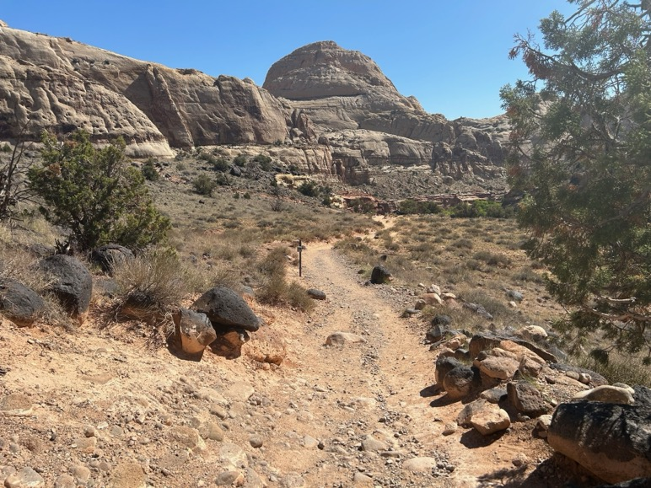
Image #2 (3 People) | 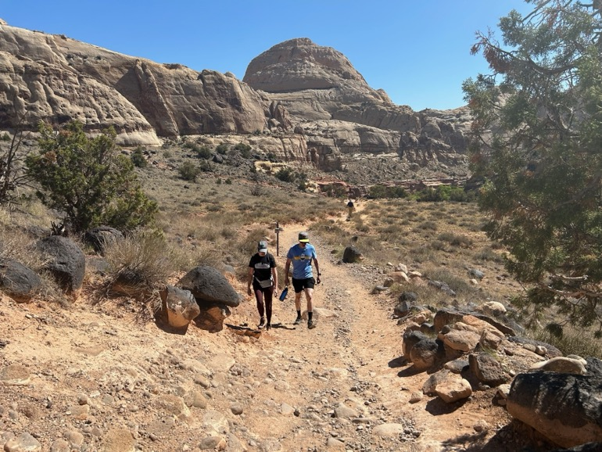
Image #3 (6 people) | 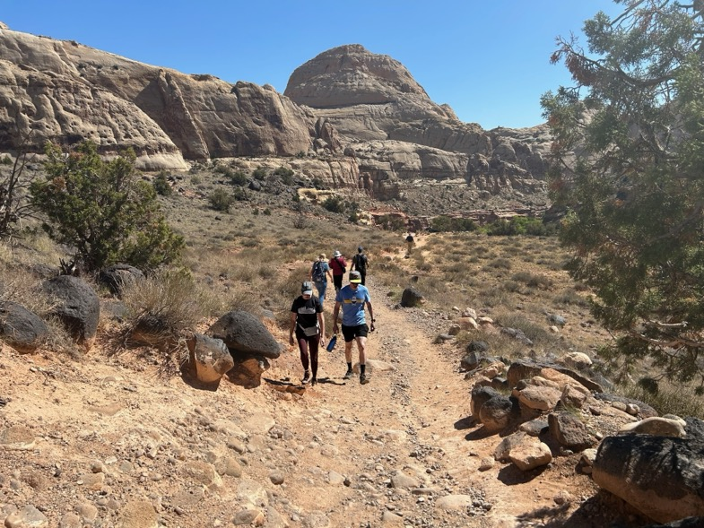
Image #4 (9 people) | 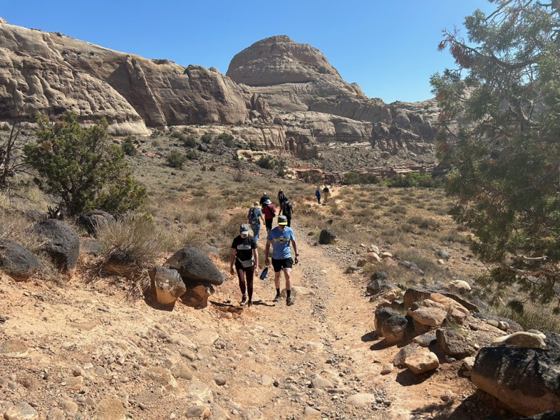
Image #5 (14 people) | 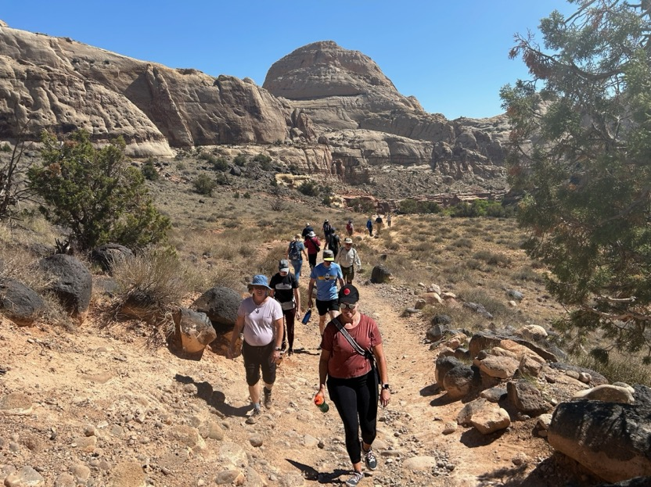
Image #6 (18 people) | 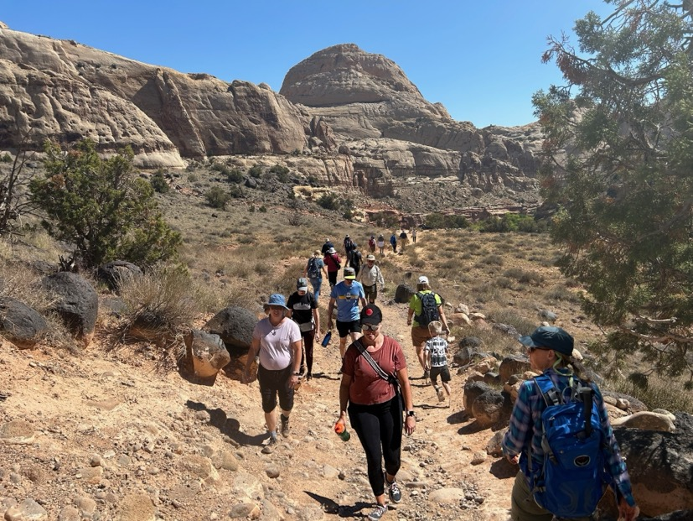
Image #7 (21 People) | 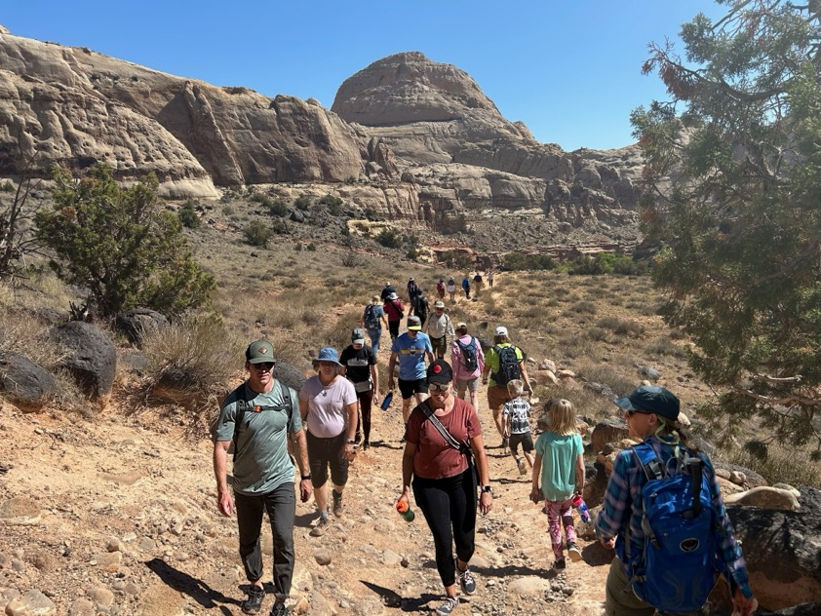

Cassidy Arch Viewpoint

Image #1 (0 People) | 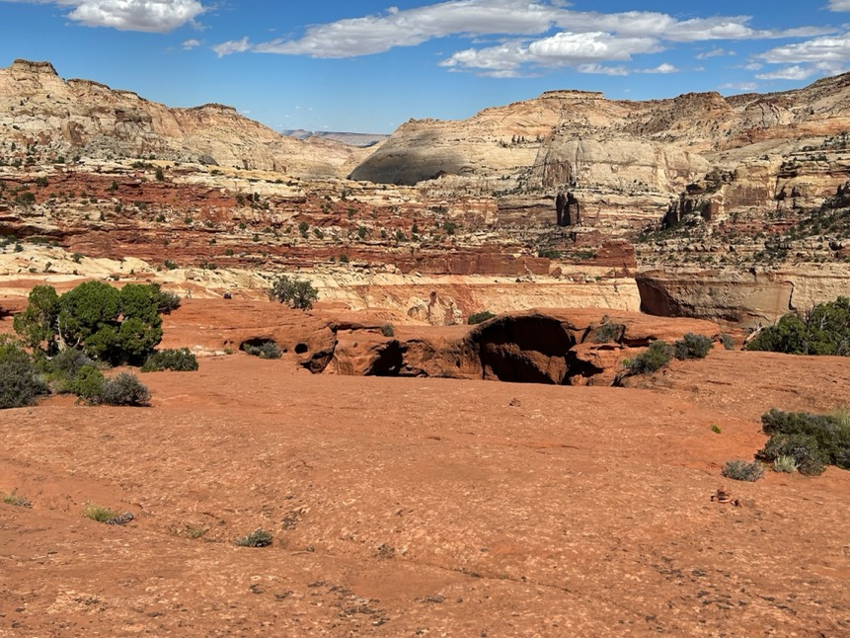
Image #2 (6 People) | 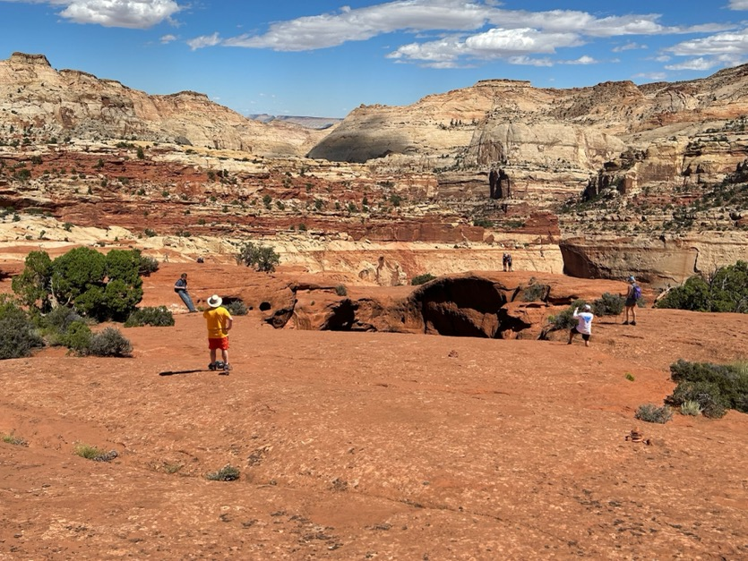
Image #3 (9 people) | 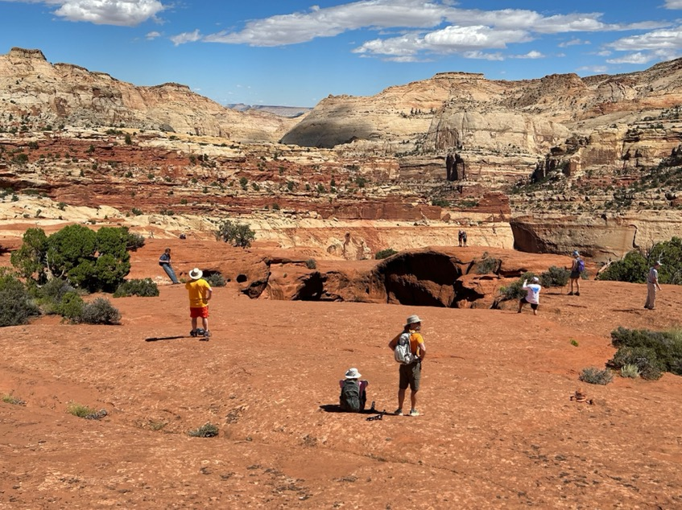
Image #4 (15 people) | 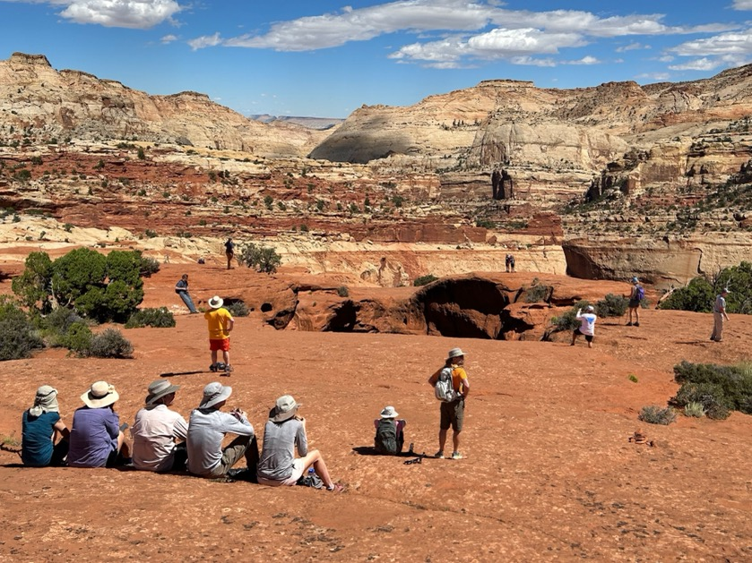
Image #5 (23 people) | 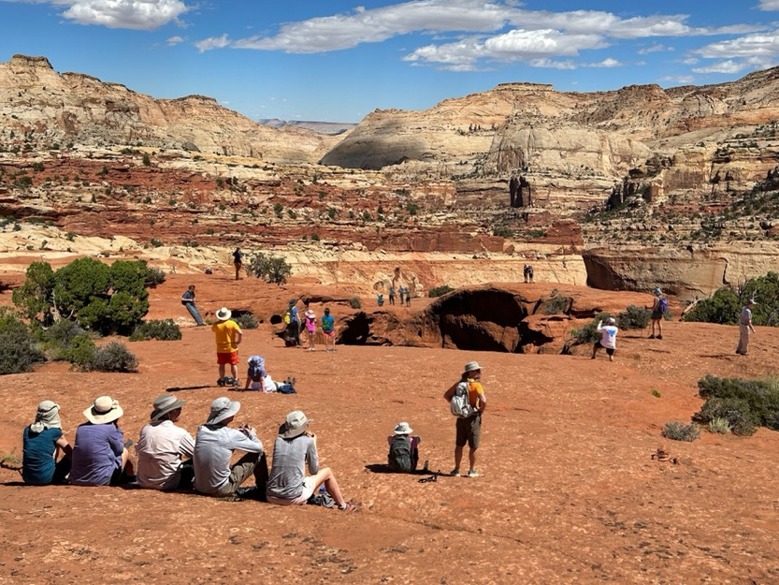
Image #6 (30 people) | 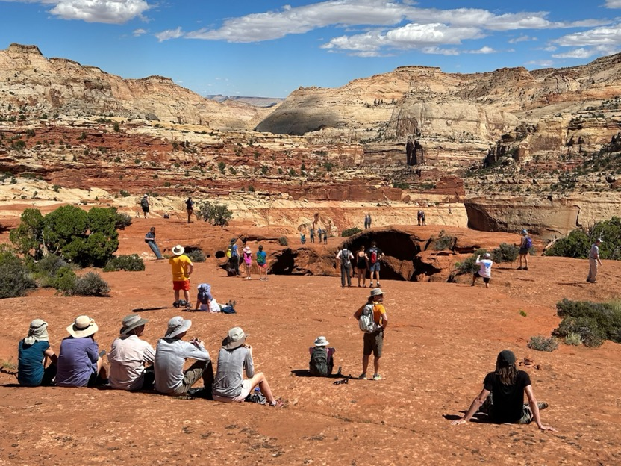
Image #7 (35 People) | 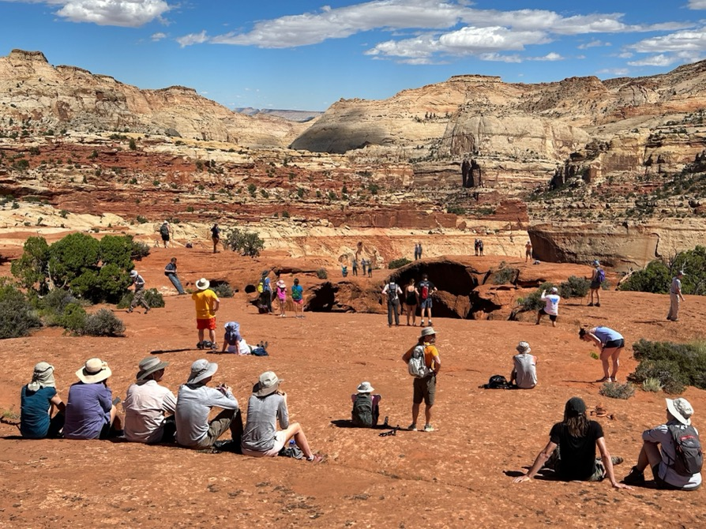

Pioneer Panel Viewpoint in Capitol Gorge

Image #1 (0 People) | 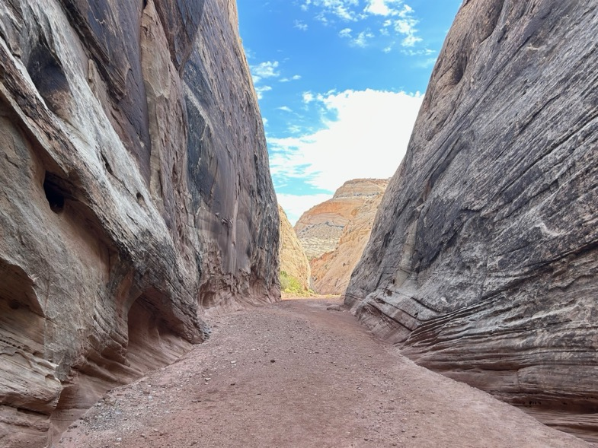
Image #2 (3 People) | 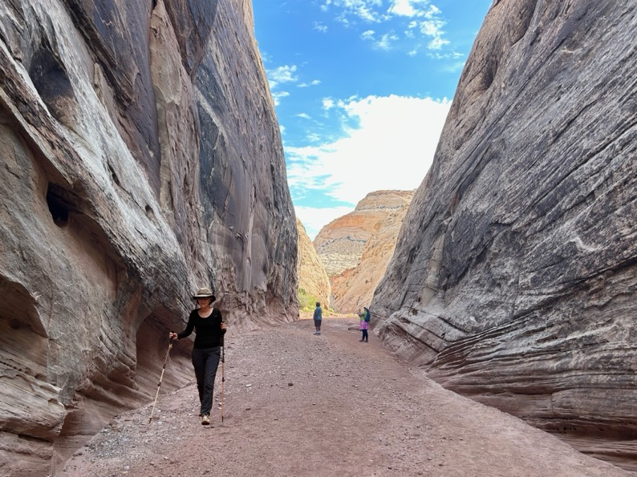
Image #3 (6 people) | 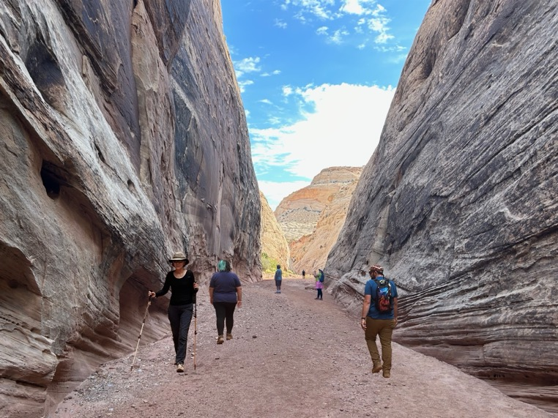
Image #4 (10 people) | 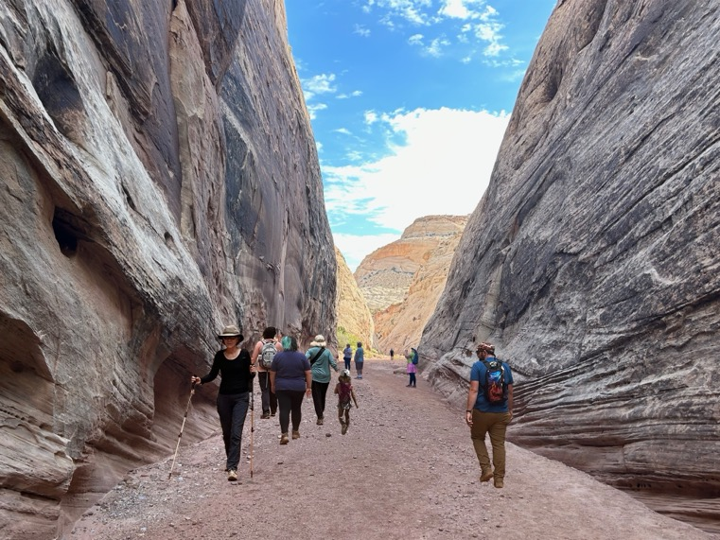
Image #5 (16 people) | 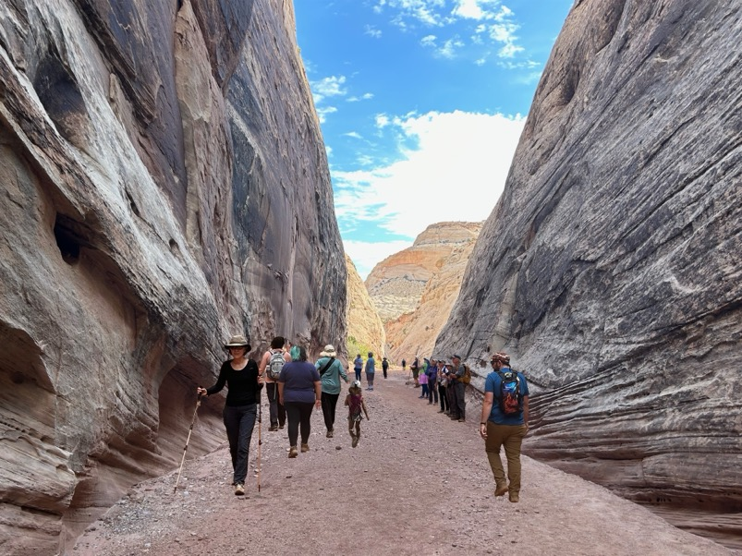
Image #6 (21 people) | 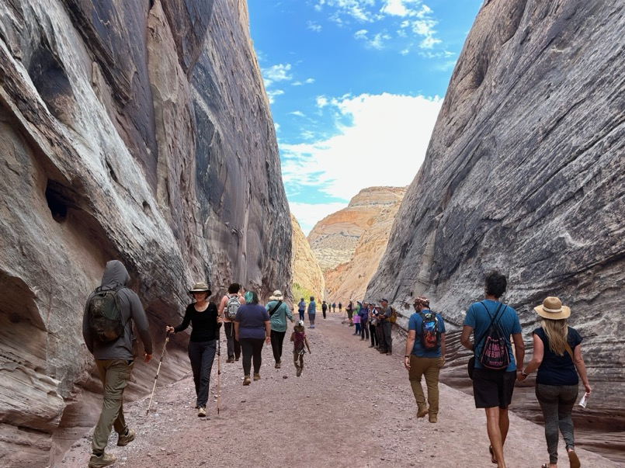
Image #7 (24 People) | 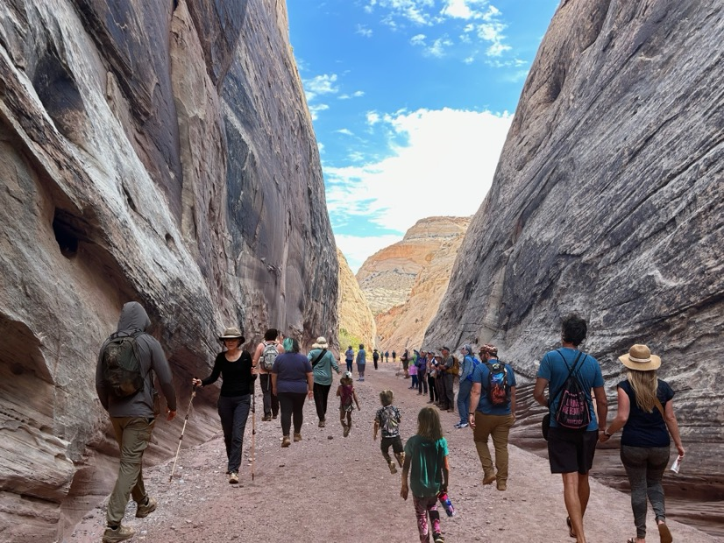

Developing Number of People-Per-Viewscape for each photo series

Preliminary Person-Per-Viewscape (PPV) counts were conducted at each site during a period of high visitation in the park. The research technician followed established office protocols to collect estimates from the same viewpoint that will be featured in the photos. Using these collected counts, the maximum number of people in an image and the mean number of individuals were identified. Further estimates of a 30% and 50% increase from the max count were calculated. These estimates are then rounded to the nearest whole number. In addition to these 4 interval estimates, a photo with zero individuals was added, and two additional photos were added between the max count and the mean count to ensure intermittent intervals between images for modeling/graphing purposes.

Site | Image #1: PPV Image with no people | Image #2:  Average PPV | Image #3:  Additional Interval | Image #4:  Additional Interval | Image #5 Top PPV Count for site | Image #6  30% increase from top count | Image #7  50% increase  from top count
Cassidy | 0 | 6 | 9 | 15 | 23 | 30 | 35
Pioneer Panel | 0 | 3 | 6 | 10 | 16 | 21 | 24
Hickman | 0 | 3 | 6 | 9 | 14 | 18 | 21

Photo Manipulation decision rules

- First, create the image with the most number of people.
- Apply 1x1” grid to the image.
- Number each grid square. (1-130)
- Assign a number for each square from 1 to 130.
- Split grid squares between midground and foreground.
- Using a random number generator, select a series of random numbers between 1 and 130. Sequentially select numbers from this list, and when the number coincides with a square with people in it, remove these individuals.
- Proportionately reduce the foreground and midground using a 4:1 ratio (for example, for every 4 individuals removed from the foreground, remove one individual from the midground).

