Joshua Tree National Park
General Visitor Survey
2025

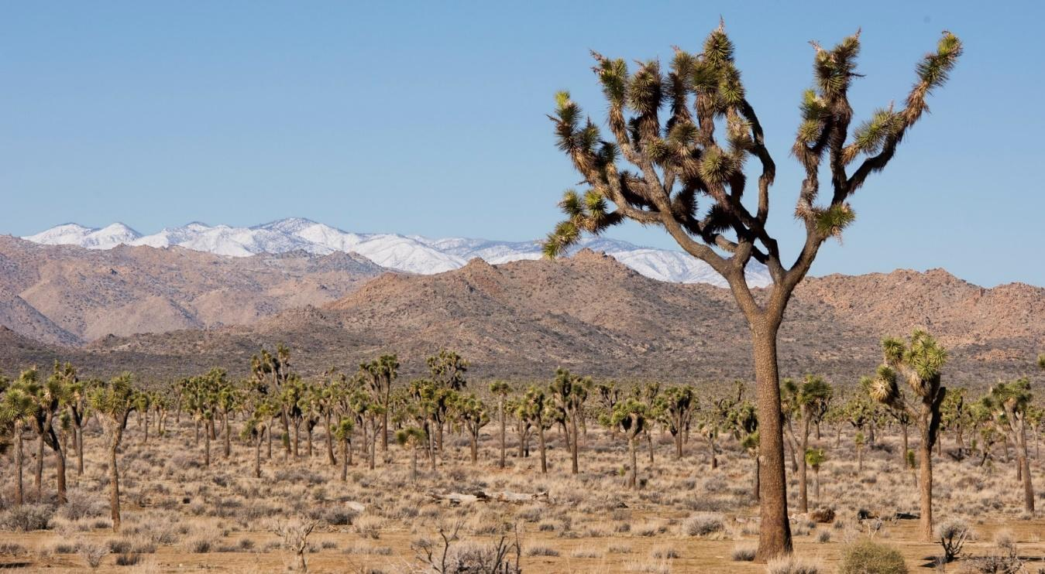

To be completed by field staff:

ID ______ Time ________ Location__________ Date _____
Field staff____________

PRIVACY ACT and PAPERWORK REDUCTION ACT statement:
The Paperwork Reduction Act requires us to tell you why we are collecting this information, how we will use it, and whether or not you have to respond. We are authorized by the National Park Service Protection Interpretation and research in System (54 USC §100702) to collect this information. The routine uses of this information will be for the benefit of NPS Managers and Planning staff in North Cascades National Park in future initiatives related to the visitor use and resource management within the site. The data collected will be summarized to evaluate visitor uses and expectations during their visit at North Cascades National Park. Your responses to this collection are completely voluntary and will remain anonymous. You can end the process at any time and will not be penalized in any way for choosing to do so. All contact information collected for the purpose of the follow-up survey will be destroyed at the end of the collection period and no personal identifiable records will be maintained or stored for any purposes. Data collected will only be reported in aggregates and no individually identifiable responses will be reported. A Federal agency may not conduct or sponsor, and you are not required to respond to, a collection of information unless it displays a currently valid OMB Control Number (1024-0224).
BURDEN ESTIMATE STATEMENT: We estimate that it will take about 10 minutes to complete this questionnaire. You may send comments concerning the burden estimates or any aspect of this information collection to: Megan McBride, National Park Service, megan_mcbride@nps.gov (email).

NOTE: In this questionnaire, “personal group” is defined as anyone that you are visiting the park with, such as spouse, family, friends, etc. This does not include the larger group that you might be traveling with, such as school, church, scouts, or tour group.
TOPIC AREA 3: CVIS3; CVIS2; CVIS1
(Variation: Expanded questions to obtain information about seasonal visitation and site-specific visitation)

- Please tell us about your past visitation to Joshua Tree National Park (referred to as “the park” in the survey).
- Including today, how many days in the last month (30 days) have you visited the park?

________________________________________________

- Including today, how many days in the last year (12 months) have you visited the park?

________________________________________________

- Including today, how many years (total) have you visited the park?

________________________________________________

- In what year did you first visit the park? (YYYY)

________________________________________________

TOPIC AREA 3: DEST17

- On this trip, how long did you and your personal group spend visiting Joshua Tree NP? Please list partial hours / days as ¼, ½, ¾.

________ | Number of hours, if fewer than 24 hours
 | OR
________ | Number of days, if 24 hours or more
TOPIC AREA 2: ITN4
- On this trip…
❑ | Joshua Joshua Tree NP was the primary destination
❑ | Joshua Joshua Tree NP was one of several destinations
❑ | Joshua Joshua Tree NP was not a planned destination

TOPIC AREA 3: CVIS8; DEST26
- On this visit to Joshua Tree NP, please select all the park locations that you and your personal group visited in Joshua Tree NP? Select all white boxes with location names that apply.
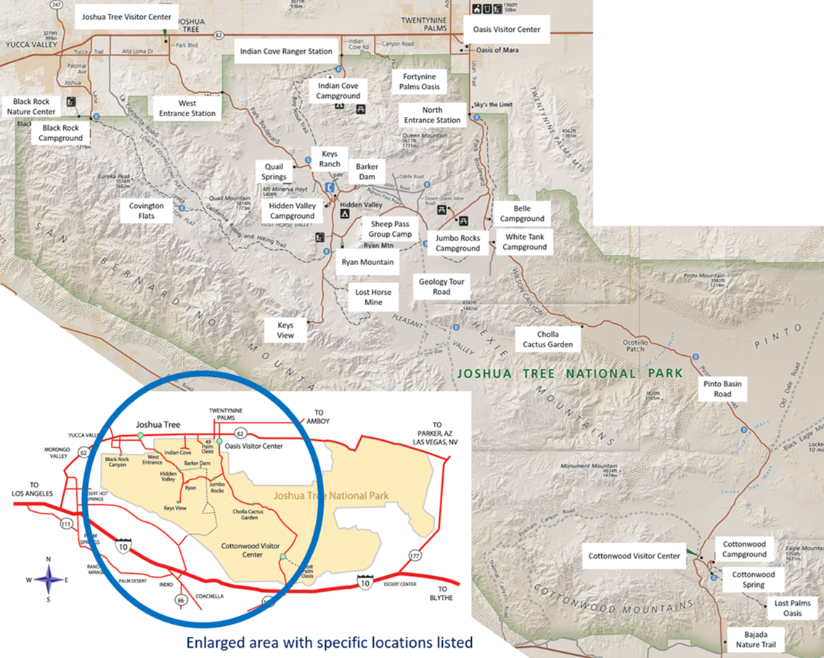

- Please list any other locations visited in the park on this trip.
________________________________________________________________

TOPIC AREA 3: CVIS8, CVIS9
- For this trip, where did you and your personal group spend the longest amount of time? Please select only one location.
- North Entrance Station | - Sheep Pass Group Camp
- West Entrance Station | - Bajada Nature Trail
- Indian Cove Ranger Station | - Barker Dam
- Cottonwood Visitor Center | - Cholla Cactus Garden
- Joshua Tree Visitor Center | - Cottonwood Spring
- Oasis Visitor Center | - Covington Flats
- Black Rock Nature Center | - Fortynine Palms Oasis
- Belle Campground | - Geology Tour Road
- Black Rock Campground | - Keys Ranch
- Cottonwood Campground | - Keys View
- Hidden Valley Campground | - Lost Horse Mine
- Indian Cove Campground | - Lost Palms Oasis
- Jumbo Rocks Campground | - Pinto Basin Road
- White Tank Campground | - Quail Springs
- Ryan Mountain | - Other _____________

TOPIC AREA 3: CVIS7
- On this trip, what was the primary reason that you and your personal group came to the Joshua Tree NP area (Yucca Valley, Joshua Tree, Twentynine Palms)? Please mark one.
❑ | Resident of the area (Yucca Valley, Joshua Tree, Twentynine Palms, Indio)
❑ | Visit Joshua Tree NP
❑ | Visit other attractions in the area
❑ | Visit friends / relatives at the Twentynine Palms U.S. Marine Corps base
❑ | Visit friends / relatives in the area (other than the Marine Corps base)
❑ | Traveling through – unplanned visit
❑ | Business
❑ | Other (Please specify) ________________________________________

TOPIC AREA 5: ACT18c
- On this visit, in which activities did you and your personal group participate within Joshua Tree NP? Mark all that apply.

- Attended field classes or  other guided activities | - Picnicking
- Attended ranger-led programs | - Rock scrambling  (without specialized gear or skills)
- Backpacking overnight | - Seeking spiritual connection
- Bicycling | - Sightseeing
- Bouldering  (using pads and bouldering guides) | - Slacklining
- Camping | - Stargazing / viewing night sky
- Created content for social media / blogs | - Technical climbing  (with specialized gear or skills)
- Day hiking | - Trail running
- Enjoyed nature | - Viewed plants and/or wildlife
- Exercised to promote physical fitness | - Visited historical or archaeological sites
- Family / friend gathering or celebration | - Visited visitor center(s)
- Horseback riding | - Walking self-guided nature trails  (with brochures/signs)
- Photography / videos | - Other (Please specify) ______________________
- Which one of the above activities was the primary activity in which you and your personal group participated at Joshua Tree NP on this visit? Please select one.
[item list will populate based on answers to Question #8]

TOPIC AREA 5: ACT11 (Variation: Focused wording on rock climbing in the park)
- Did anyone in your personal group participate in rock climbing in Joshua Tree NP on this visit or past visit(s)? Please mark one.
❑ | No, have not participated in climbing activities. Go to Question 7C
❑ | Climbed on both this visit and past visit(s)
❑ | This is our first time climbing here
❑ | Have climbed in the past, but not on this visit

TOPIC AREA 3: CVIS8 (Variation: Focused wording on rock climbing in the park)

- Where is your personal group’s preferred area to climb in Joshua Tree NP?
❑ | Don’t have a preferred area
OR | List one area ________________________________________

TOPIC AREA 5: ACT11 (Variation: Focused wording on bouldering in the park)

- Did anyone in your personal group participate in bouldering in Joshua Tree NP on this visit or past visit(s)? Please mark one.
❑ | No, have not participated in bouldering activities. Go to Question 8
❑ | Bouldered on both this visit and past visit(s)
❑ | This is our first time bouldering here
❑ | Have bouldered in the past, but not on this visit

TOPIC AREA 3: CVIS8 (Variation: Focused wording on bouldering in the park)

- Where is your personal group’s preferred area to boulder in Joshua Tree NP?
❑ | Don’t have a preferred area
OR | List one area ________________________________________

TOPIC AREA 2: ITIN8 and ACCOM4 (Variation: split into two questions in order to distinguish between camping inside the park and staying outside (which may or may not include camping)

  - Did you or members of your personal group attempt to make reservations for campsites at Joshua Tree NP for this trip?
❑ Yes ❑ No Go to Question 15

  - Were you able to make campsite reservations for this trip?
❑ Yes ❑ No

  - On this visit, how many nights, if any, did you and your personal group camp overnight within Joshua Tree NP?
________ | Number of nights inside Joshua Tree NP  - Did not stay in Joshua Tree NP

- On this visit, how many nights, if any, did you and your personal group stay overnight away from home in the area surrounding Joshua Tree NP (Yucca Valley, Joshua Tree, Twentynine Palms)?

________ | Number of nights in the surrounding area  - Did not stay in the local area

TOPIC AREA 2: ACCOM6

- In what type of lodging did you and your personal group spend the night(s) inside the park? Please check all that apply in Column A.
- In what type of lodging did you and your personal group spend the night(s) outside the park in the surrounding area (Yucca Valley, Joshua Tree, Twentynine Palms)? Please check all that apply in Column B.

Column A  (inside the park) |  | Lodging type | Column B (outside the park)
 | Lodge, motel, cabin, rented condo/home, or bed & breakfast |  |  | ❑
❑ | RV / trailer camping |  |  | ❑
❑ | Tent camping in developed campground |  |  | ❑
❑ | Backcountry campsite |  |  | ❑
 | Personal seasonal residence |  |  | ❑
 | Residence of friends or relatives |  |  | ❑
❑ | Other (Please specify) _________________________________________________________ |  |  | ❑

TOPIC AREA 2: INFOSOURCE10 (Variation: Added section to get information about future visit preferences.)

- Prior to this visit, how did you and your personal group obtain information about the park? Please mark all that apply in Column A. If you were to visit Joshua Tree NP in the future, how would you and your personal group prefer to obtain information about the park? Please mark all that apply in Column B.

Column A (prior to this visit) |  | Source of information | Column B (preferred for future visits)
❑ | Did not obtain information prior to visit |  |  | ❑
❑ | Joshua Tree NP website: www.nps.gov/jotr |  |  | ❑
❑ | Social media – Which one(s)? |  |  | ❑
 | ❑ Facebook ❑ Twitter ❑ Instagram ❑ Reddit ❑ Flickr ❑ Other
❑ | Other websites (Trip Advisor, Hotels.com, Expedia, etc.) |  |  | ❑
❑ | Friends / relatives / word of mouth |  |  | ❑
❑ | Highway signs |  |  | ❑
❑ | Inquiry to park via phone, mail, or email |  |  | ❑
❑ | Local businesses (hotels, motels, restaurants, etc.) |  |  | ❑
❑ | Maps / brochures |  |  | ❑
❑ | Newspaper / magazine articles |  |  | ❑
❑ | Other National Park Service sites / units |  |  | ❑
❑ | Previous visits |  |  | ❑
❑ | School class / program |  |  | ❑
❑ | State or local welcome center / visitors bureau / chamber of commerce |  |  | ❑
❑ | Television / radio programs / DVDs |  |  | ❑
❑ | Travel guides / tour books (AAA, Fodor’s, Lonely Planet, etc.) |  |  | ❑
❑ | Other (Please specify) ________________________________________ |  |  | ❑

- From the sources marked in Column A, did you and your personal group receive the type of information about the park that you needed?
❑ No ❑ Yes Go to Question 16

- If NO, what type of park information did you and your personal group need that was not available? Please be specific.
________________________________________________________________________

TOPIC AREA 2: ITIN2
- How far in advance, if at all, did you begin planning your most recent visit to Joshua Tree NP? Please select one and fill in the blank.

- Didn't plan in advance
- Days: How many days? ________________________________________________
- Weeks: How many weeks? ________________________________________________
- Months: How many months? _______________________________________________

TOPIC AREA 4: SERVICES11

- Please mark all the information services and facilities that you or your personal group used during this visit to Joshua Tree NP
- Next, for only those services and facilities that you or your personal group used, please rate their importance from 1-5.
- Finally, for only those services and facilities that you or your personal group used, please rate their quality from 1-5.

a) Information services /  facilities used |  | b) If used, how important?  1=Not important  2=Somewhat important  3=Moderately important  4=Very important  5=Extremely important | c) If used, what quality?  1=Very poor  2=Poor  3=Average  4=Good  5=Very good
❑ | No information services / facilities used | n/a | n/a
❑ | Assistance from visitor center staff | ______ | ________
❑ | Assistance from entrance station staff | ________ | ________
❑ | Assistance from roving rangers
❑ | Bulletin boards | ________ | ________
❑ | Joshua Tree NP website: www.nps.gov/jotr  (used before or during visit) | ________ | ________
❑ | Park brochure / map
❑ | Park newspaper | ________ | ________
❑ | Ranger-led programs (walks, talks, etc.) | ________ | ________
❑ | Roadside exhibits
❑ | Sales items in visitor center (selection, price, etc.) | ________ | ________
❑ | Trailside exhibits / signs
❑ | Visitor center exhibits
❑ | Other park publications (plant lists, dog information, camping brochure, etc.) | ________ | ________

Topic Area 1: RES2

- Are you a permanent resident or citizen of the United States?

☐ NO - What is your country of origin? _______________________
☐ YES - What is your zip code and state of your primary residence?
State_____________ Zip code ______________

Topic Area 1: AGE1
- What is your age

Topic Area 1: GEND1
- What is your gender? (select one)
Male
Female
Transgender, non-binary, or another gender
Prefer not to answer

Topic Area 1: EDUC1
- What is the highest level of school you have completed? (select one)
❑ Less than high school | ❑ Some college | ❑ Graduate or professional degree
❑ Some high school | ❑ Two-year college graduate | ❑ Do not wish to answer
❑ High school graduate | ❑ Four-year college graduate
Topic Area 1: ECON9

- Which category best describes your total household income in U.S. dollars during 2024 before taxes? (select one)
❑ Less than $24,999 | ❑ $50,000 to $74,999 | ❑ $150,000 to $199,999
❑ $25,000 to $34,999 | ❑ $75,000 to $99,999 | ❑ $200,000 or more
❑ $35,000 to $49,999 | ❑ $100,000 t $149,999 | ❑ Do not wish to answer

Topic Area 1: RACE/ETH2
- What is your race and/or ethnicity? Select all that apply and enter additional details in the spaces below.
- American Indian or Alaska Native—Enter, for example, Navajo Nation, Blackfeet Tribe of the Blackfeet Indian Reservation of Montana, Native Village of Barrow Inupiat Traditional Government, Nome Eskimo Community, Aztec, Maya, etc.

- Asian—Provide details below.
- Chinese | - Asian Indian | - Filipino
- Vietnamese | - Korean | - Japanese
Enter, for example, Pakistani, Hmong, Afghan, etc.

- Black or African American—Provide details below.
- African American | - Jamaican | - Haitian
- Nigerian | - Ethiopian | - Somali
Enter, for example, Trinidadian and Tobagonian, Ghanaian, Congolese, etc.

- Hispanic or Latino—Provide details below.
- Mexican | - Puerto Rican | - Salvadoran
- Cuban | - Dominican | - Guatemalan
Enter, for example, Colombian, Honduran, Spaniard, etc.

- Middle Eastern or North African—Provide details below.
- Lebanese | - Iranian | - Egyptian
- Syrian | - Iraqi | - Israeli
Enter, for example, Moroccan, Yemeni, Kurdish, etc.

- Native Hawaiian or Pacific Islander—Provide details below.
- Native Hawaiian | - Samoan | - Chamorro
- Tongan | - Fijian | - Marshallese
Enter, for example, Chuukese, Palauan, Tahitian, etc.

- White—Provide details below.
- English | - German | - Irish
- Italian | - Polish | - Scottish
Enter, for example, French, Swedish, Norwegian, etc.

Thank you for your help with this survey!
Please click "next" to finalize your response.

