**Non-substantive Change Request**

**OMB Control Number: #1190-0020**

**TITLE: Civil Rights Reporting Portal**

**Date Submitted: February 19, 2025**

**Summary of request:** AGENCY is requesting a change request to revise questions to align with E.O. 14168 *Defending Women From Gender Ideology Extremism and Restoring Biological Truth to the Federal Government.*

**Description of Changes Requested:** This request updates sex questions used in the form at https://civilrights.justice.gov/report/ to be in accordance with EO 14168. Please check the boxes below if your request includes:

X Revision of an existing question(s)

Deletion of an existing question(s)

|  |  |  |
| --- | --- | --- |
| **Description of Changes to Burden (if applicable):** | **Approved Burden** | **Requested Burden** |
| Remove the ‘gender identity’ choice from the Personal Characteristics question on the form at https://civilrights.justice.gov/report/ (see attachments section below); changed ‘gender’ language to ‘sex’ on ‘educational’ pages | TOTAL TIME: Time may vary based on level of detail from the public.  TIME per response: Time may vary based on level of detail from the public. A single response can take less than a minute.  # respondents: 533,046 since March, 2020 | TOTAL TIME: Time may vary based on level of detail from the public.  TIME per response: Time may vary based on level of detail from the public. A single response can take less than a minute.  # respondents: 533,046 since March, 2020 |
| Total | TOTAL TIME | TOTAL TIME |

**Captures of form before changes were made:**

**1. Removed ‘gender’ question on ‘Personal Characteristics’ question at https://civilrights.justice.gov/report/**

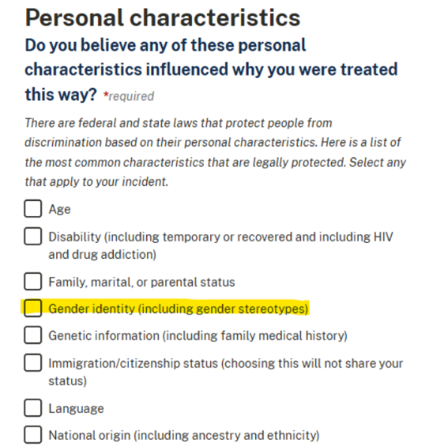

**2. Changed the word ‘gender’ to ‘sex’ in the hate crime section of the Reporting Portal at https://civilrights.justice.gov/**

**3. Changed the word ‘gender’ to ‘sex’ on the ‘Get help for hate crimes and human trafficking’ page at https://civilrights.justice.gov/hate-crime-human-trafficking**

**Captures of form after changes were made:**

**1. Removed ‘gender’ question on ‘Personal Characteristics’ question at https://civilrights.justice.gov/report/**

**2. Changed the word ‘gender’ to ‘sex’ in the hate crime section of the Reporting Portal at https://civilrights.justice.gov/**

**3. Changed the word ‘gender’ to ‘sex’ on the ‘Get help for hate crimes and human trafficking’ page at https://civilrights.justice.gov/hate-crime-human-trafficking**

