**Web Collection Instrument Screens** (English)

Login Screen

Dear Employer Screen

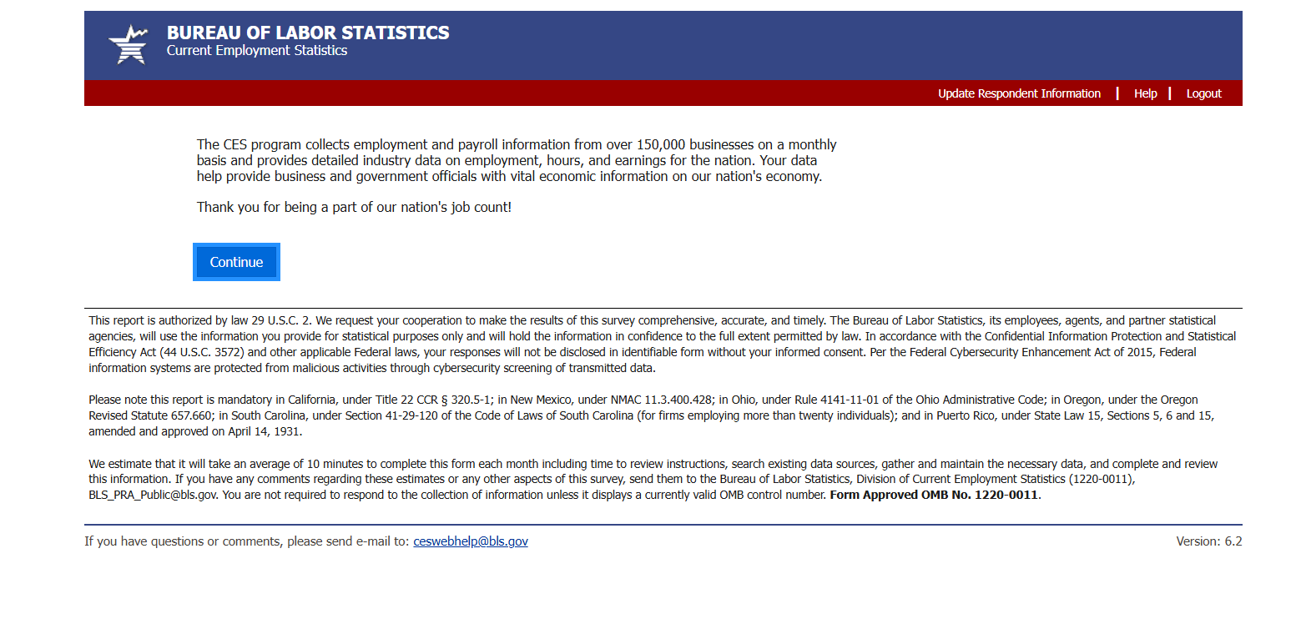

Respondent Information Screen (for first-month Web respondents only)

Set Pay and Commissions Frequency Screen (for first-month Web respondents only, private sector)

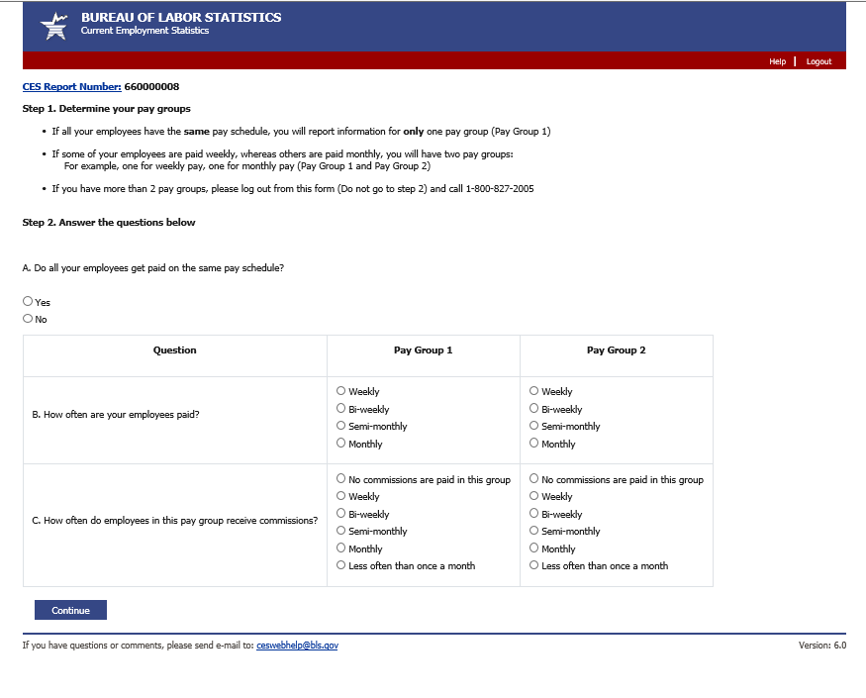

Data Entry Screen (pay group 1)

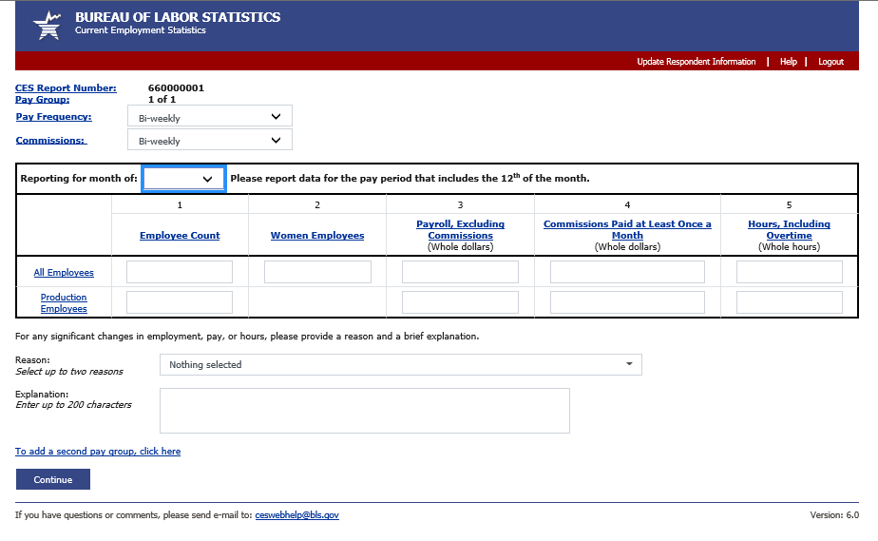

Data Entry Screen (pay group 2, if 2 pay groups)

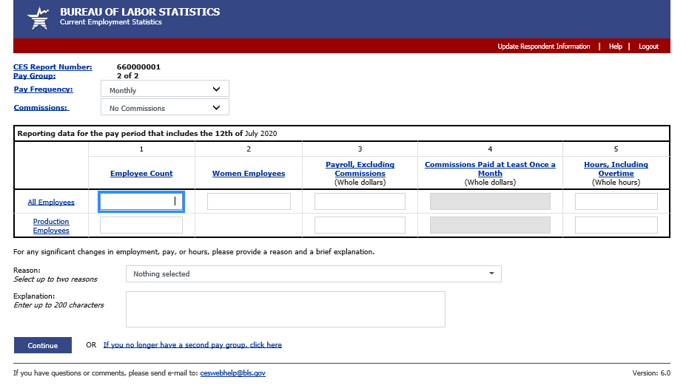

Data Review Screen

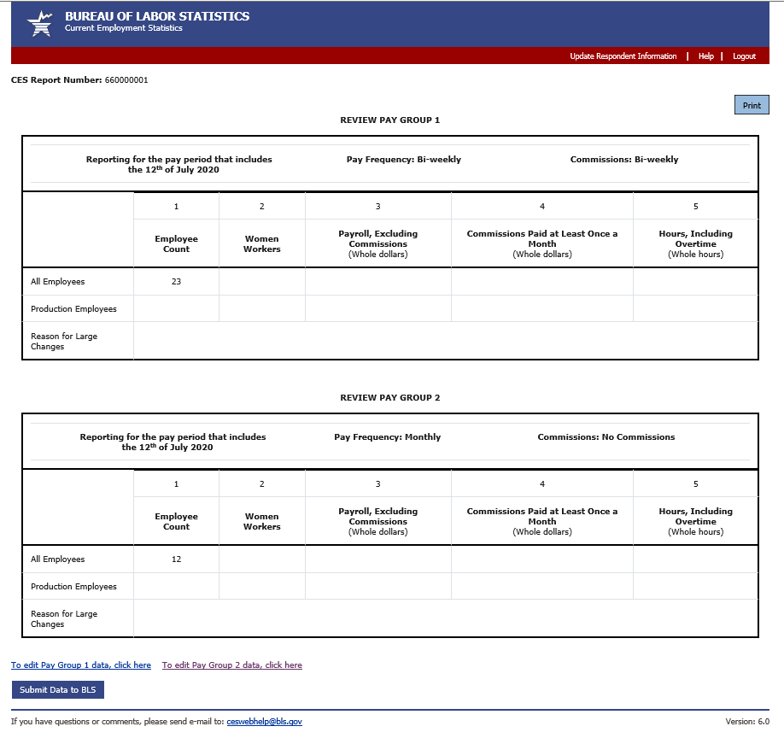

Thank You Screen

**Web Collection Instrument Screens** (Spanish)

Login Screen

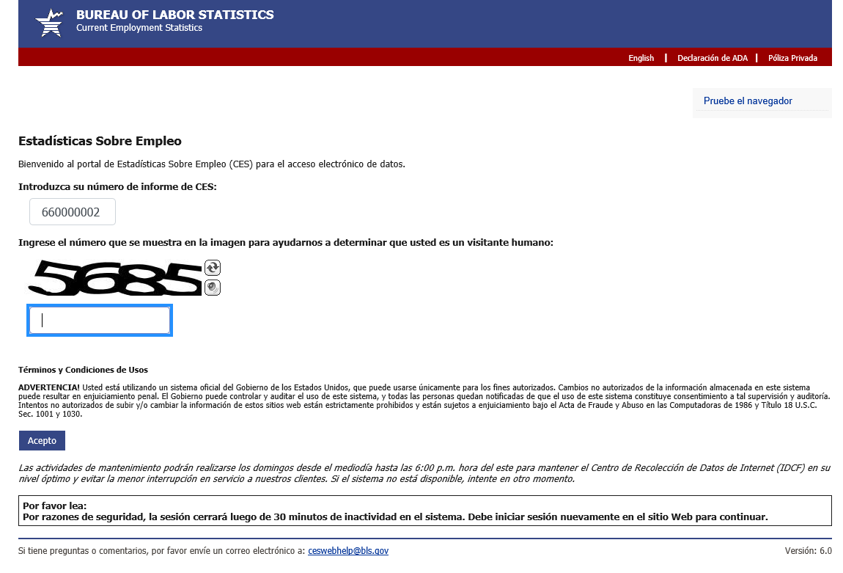

Dear Employer Screen

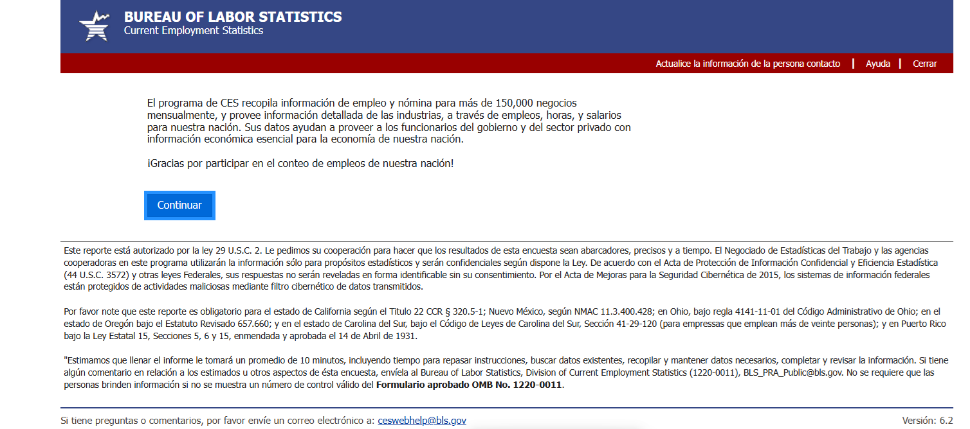

Respondent Information Screen

Set Pay and Commissions Frequency Screen (for first-month Web respondents only, private sector)

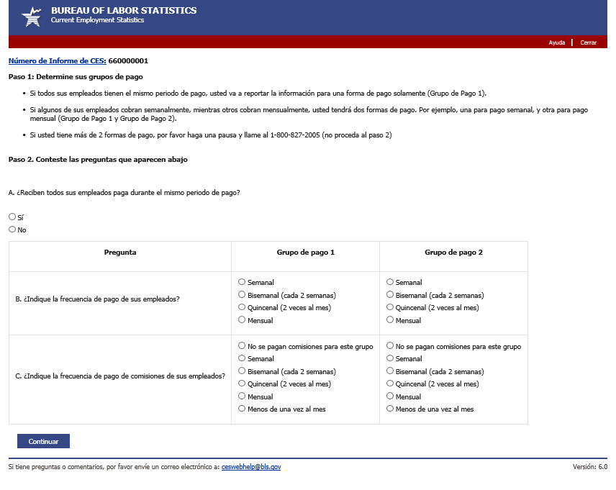

Data Entry Screen (pay group 1)

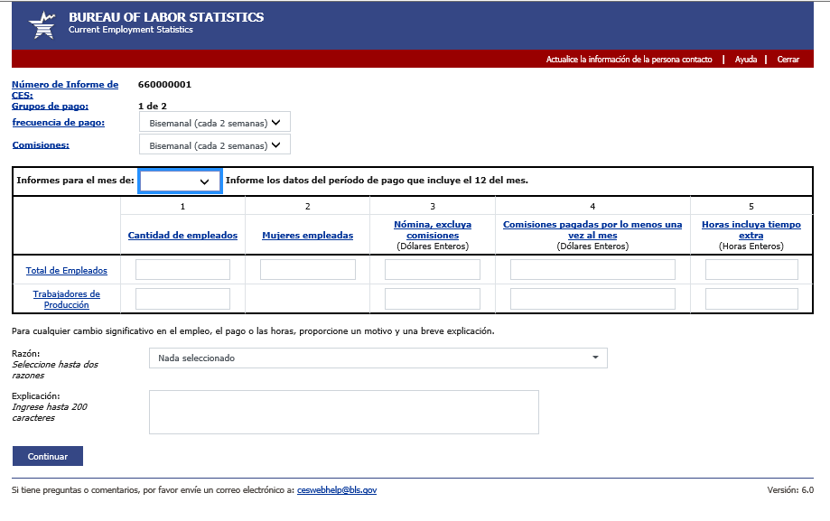

Data Entry Screen (pay group 2, if 2 pay groups)

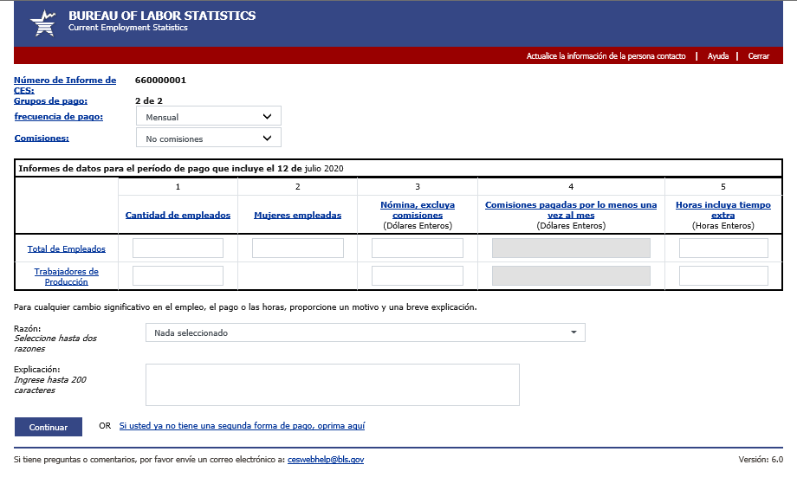

Data Review Screen

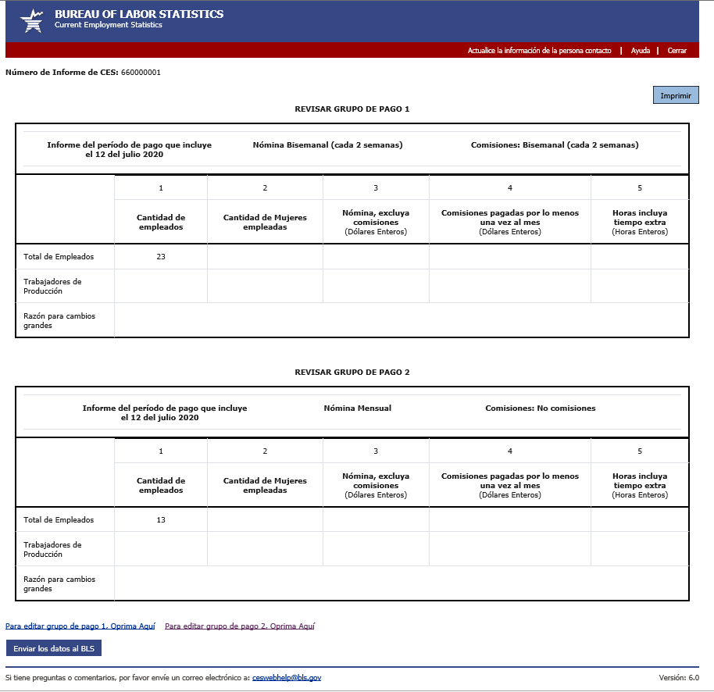

Thank You Screen

