U.S. DEPARTMENT OF LABOR | Office of Workers' Compensation  Division of Coal Mine Workers’ Compensation | 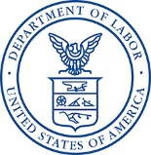

Dear Claimant,

Our records indicate that you have a pending claim with the Federal Black Lung Program. We are very interested in receiving feedback on your experience up to this point in the claim process. Your participation in the enclosed Customer Experience Survey is completely voluntary but your feedback will help us improve the claimant/customer experience. If there are any portions of the survey that you do not wish to complete, you can skip that section/question. We appreciate your assistance in helping us determine what is working and what may be improved. The following survey is confidential.

If you choose to participate in the survey, please return it using the enclosed postage paid envelope within 30 days. Thank you for your participation.

