Non-Substantive Change Request
OMB Control No. 1405-0178
DS-4079

Proposed Changes to Form DS-4079, Questionnaire – Loss of United States Nationality; Attestations to comply with E.O. 14168 - 3.28.2025
On January 20, 2025, President Trump signed Executive Order 14168, “Defending Women From Gender Ideology Extremism and Restoring Biological Truth to the Federal Government.” (E.O. 14168.) To comply with E.O. 14168, which makes it the policy of the United States to recognize two sexes, male and female, and OPM’s January 29, 2025, guidance, the Department of State has reviewed its forms, guidance, websites and other documents to remove anything that promotes gender ideology, such as the use of “they, them, their” when referring to an individual. In reviewing the Form DS-4079, Questionnaire – Loss of United States Nationality; Attestations, the Bureau discovered three instances of the use of plural pronouns “them” and “their” to refer to an individual. The Department seeks permission to change “them” to “him or her” and to change “their” to “his or her.”
Step 6 and 7 of Instructions page 1
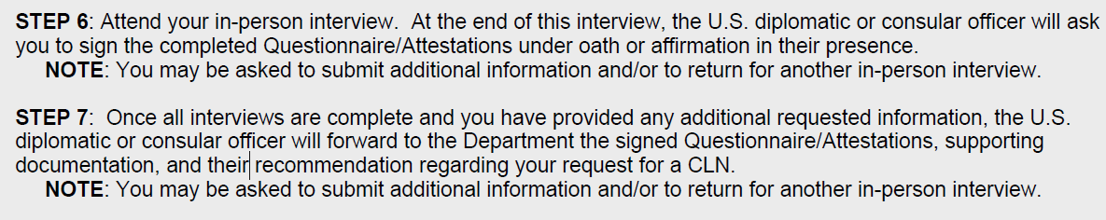
Corrections in Red
Step 6: Attend your in-person interview. At the end of this interview, the U.S. diplomatic or consular officer will ask you to sign the completed Questionnaire/Attestations in their his or her presence.
Step 7: Once all interviews are complete and you have provided any additional requested information, the U.S. diplomatic or consular officer will forward to the Department the signed Questionnaire/Attestations, supporting documentation, and their his or her recommendation regarding your request for a CLN.

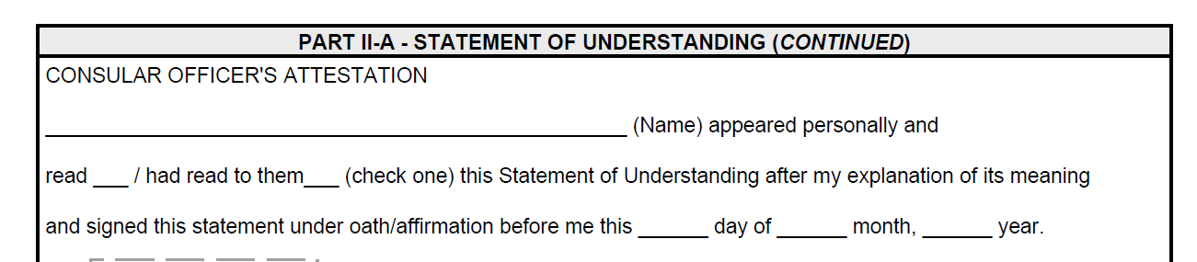

PART II-A, Page 11. _________(Name) appeared personally and read ____/had read to them him or her _____ (check one) this Statement of Understanding ….

