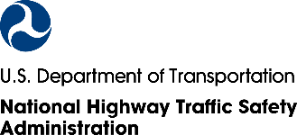

C/O ICF

980 Beaver Creek Drive

Martinsville, VA 24112

*12345678A* 12345678A

Martinsville Resident

980 Beaver Creek Drive Suite 2   
Martinsville, VA 24112  
***************AUTO**MIXED AADC 270  
DDFAAAAATATFFATTDFDATATATTAFAAAFFAFFTTFFFDAFDFTFFFFFDFTFDA  
1 1

We recently invited you to participate in the **National Traffic Safety Survey** run by the National Highway Traffic Safety Administration (NHTSA). **Share your voice on transportation issues important to your community** **and get a $10 Amazon.com gift code** for participating.

If someone in your household has already completed the survey, thank you!

**If not, please follow these simple steps:**

**Step 1**: Give this postcard to the **adult** in your household **with the next birthday**.

*This is a random way to decide who fills out the survey in each household.*

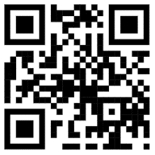

**MERGE**

**QR CODES**

**HERE**

**Step 2:** Go to **www.NTSSurvey.com** andenter **<PINNUM>** to take the survey.

**Scan this QR code**

with your smartphone.

Learning about your experiences and opinions helps NHTSA make better decisions about **policies and programs that affect people like you every day.** Thank you in advance for your help!

Sincerely,

Essie Wagner

Director, Office of Behavioral Safety Research, NHTSA