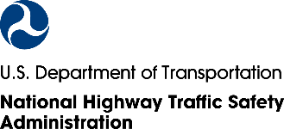

C/O ICF

980 Beaver Creek Drive

Martinsville, VA 24112

*12345678A* 12345678A

Martinsville Resident

980 Beaver Creek Drive Suite 2   
Martinsville, VA 24112  
***************AUTO**MIXED AADC 270  
DDFAAAAATATFFATTDFDATATATTAFAAAFFAFFTTFFFDAFDFTFFFFFDFTFDA  
1 1

We have tried to reach you about our National Traffic Safety Survey (NTSS). **Please help represent your community in this important study.**

As a reminder, **participants receive a $10 Amazon.com gift code** for completing the survey. If someone in your household has already completed the survey, thank you!

If not, we hope you will complete the survey we mailed you or **follow these steps to participate online:**

**Step 1**: Give this postcard to the **adult** in your household **with the next birthday**.



**MERGE**

**QR CODES**

**HERE**

**Step 2:** Go to **www.NTSSurvey.com** andenter **<PINNUM>** to take the survey.

**Scan this QR code**

with your smartphone.

Filling out the survey will **help NHTSA understand the issues that are important to people in your area.** Thank you in advance for your help!

Sincerely,

Essie Wagner

Director, Office of Behavioral Safety Research, NHTSA