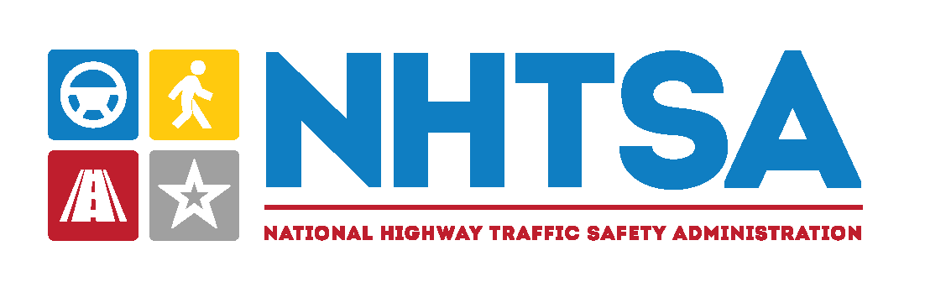
3
It’s our duty to ensure the safety of all road users and vehicles and to empower people with choices that reduce the possibility of traffic crashes.

To do this we:
- Develop public campaigns to model safe decisions by drivers, passengers, bicyclists, and pedestrians.
- Support traffic safety outreach, education, and enforcement programs.
- Research topics in vehicle safety, new technologies, and driver and other road user behavior.
- Share information on vehicle and equipment ratings so consumers can make informed decisions.
- Regulate how far a vehicle must travel on a gallon of fuel.
- Crash-test vehicles and set safety standards for automakers.
- Oversee safety recalls of motor vehicles and equipment.
Read more at www.nhtsa.gov

Our Mission:
To save lives, prevent injuries, and reduce economic costs due to road traffic crashes, through education, research, safety standards, and enforcement.
3
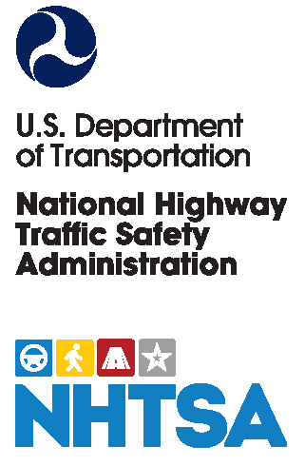
Why are we asking you to do this survey?
The National Traffic Safety Survey focuses on important transportation issues like traffic safety and enforcement, emerging vehicle technologies, and passenger and driver behavior. NHTSA, in collaboration with ICF, an independent research firm, is conducting this survey to understand peoples’ attitudes and behaviors on these topics.

How will my responses be used?
Results from this survey will help inform initiatives, policies, and programs to increase road safety across the country every day.

Why was I invited to this survey?
Your household was randomly selected from a list of residential addresses in the United States.

Who should complete the survey?
The person in your household who is aged 18+ with the next birthday has been selected for this survey, no matter what type of transportation that person uses.

How long will the survey take?
On average this survey should take about 30 minutes to complete.

How is my privacy protected?
Shared survey results are reported in group form and do not identify you. This study has been approved by the Office of Management & Budget.
For more
information:
(888)-123-4567 or
NTSS@icf.com

Frequently Asked Questions

