Help us serve you better.

The VetResources Community Network (VRCN) is the VA’s front door for community and strategic partners collaboration to meet community needs, maximize outreach capabilities, build trusted relationships, increase access to VA health and benefits and provide tools to better serve their Veteran community.
We want to hear about your experience with the VetResources Community Network (VRCN). By responding to this survey, you will directly help us partner more successfully with community partners and collaborators to better serve Veterans, their families, and survivors.

This survey should take approximately 5 minutes to complete.

First Name

Last Name

Phone Number
Email

Name of Organization
I received valuable information at this event.

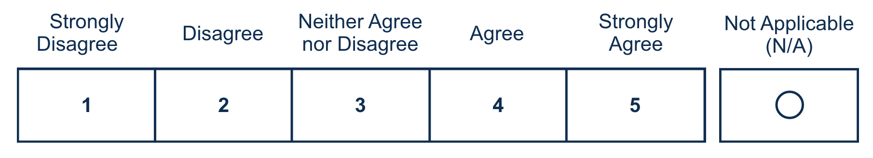

I would recommend other community partners serving Veterans and their families to join the VRCN.

Please explain why you selected this response.

0/400
Logic: if the respondent selects option 1 or 2 comment box appears

I was able to network with other community partners to bridge gaps in services and better meet the needs of the community my organization serves.

What other topics would you recommend for the next VRCN event?
0/400
What does your organization need from VA for outreach and community engagement? (Select all that apply)
□ Regional/Local Communications and Outreach Support
□ State/county focused resources
□ National Communications and Outreach Support (VA Blog post/VetResources Newsletter)
□ Event Posting on VA outreach and event page
□ Connection to local VHA/VBA/NCA leadership
□ VA expertise and engagement for a community event/convening/conference
□ Connection to another partner organization
□ Support to build a coalition or CVEB
□ Consult with overview of Community Tools and Playbook

What does your organization need from community partners and VSOs to best support Veterans, families, caregivers, and survivors? (Select all that Apply)
□ Referral Mechanisms
□ Technology Solutions
□ Funding
□ Outreach Support
□ Data/Research
□ Event Coordination

What are your top focus areas now? (Select all that Apply)
□ Veterans
□ Caregivers/Survivors
□ Minority Veterans (Women, African American, AANHPI, Tribal, LGBTQ+)
□ Homelessness/ Food Security
□ Financial Readiness
□ Education/ Employment
□ Community Partner Support
□ Communication, Outreach, Social Networking
□ Suicide Prevention/ Mental Health
□ Veteran Technology Solutions
□ Other 

How many Veterans and their families, caregivers, and survivors does your organization currently serve or reach in a given year?
Number Free Text Field

I trust VA to provide Veterans and their families with the care and services needed.
Required
Is your organization part of or leading a Community Veteran Engagement Board? (CVEB)
O Yes
O No

Have you accessed the VetResources Community Idea Lab?
O Yes
O No

