Program Participation Survey
V1 DRAFT 01/23/2024
Working Draft, Pre-Decisional, Deliberative document – Internal VA Use Only


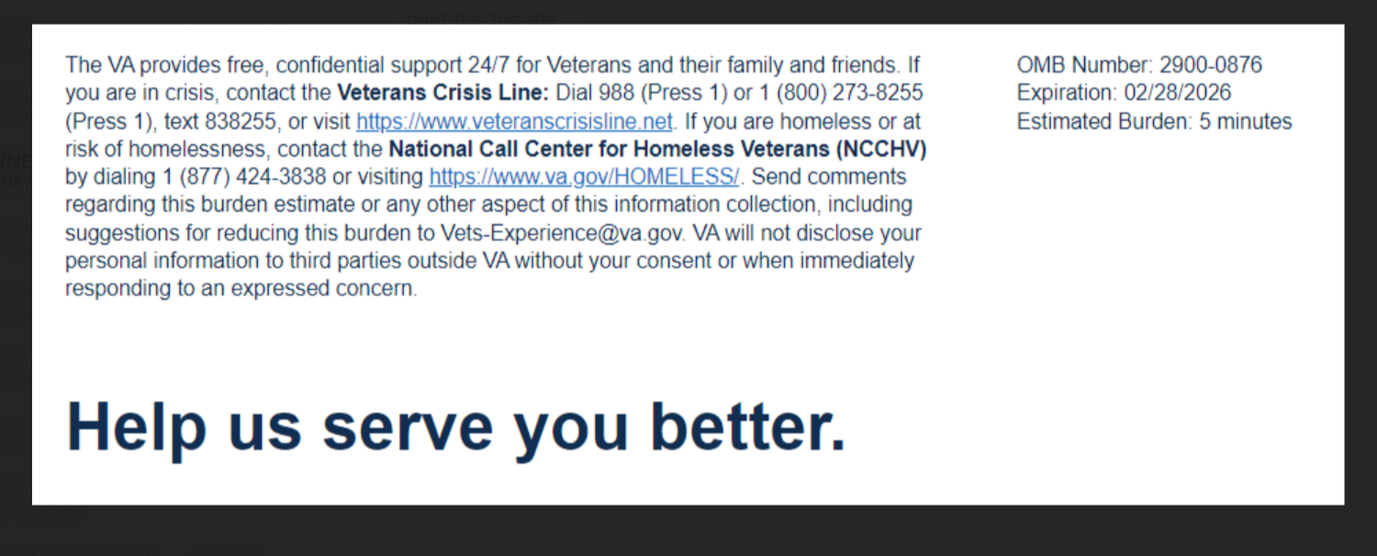
We want to hear about your experience learning about the Veteran Readiness & Employment (VR&E) Program, also known as Chapter 31. By responding to this survey, you will directly help us improve the program and provide better support to Veterans like you. Your ability to become employed and live independently is important to us!
The following questions ask about your most recent experience with your VA Vocational Rehabilitation Counselor.

This survey should take approximately 5 minutes to complete.

Error Message: “You may only select up to 3 selections” if more than 3 responses are selected.
[1] What VR&E services are most important to you? Select up to three
  - How to become employed
  - Choice of training facility
  - Apprenticeships
  - On the job training
  - Choosing my own goals
  - Reaching independent living goals

[2]
My counselor shows empathy and concern for me as a person

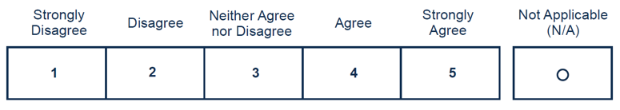
[3]
My counselor made the process and next steps clear
[4]
I found it easy to access VR&E tools and resources

[5] Please indicate your satisfaction with the following:
I was satisfied with the timeliness of my education and subsistence allowance payments
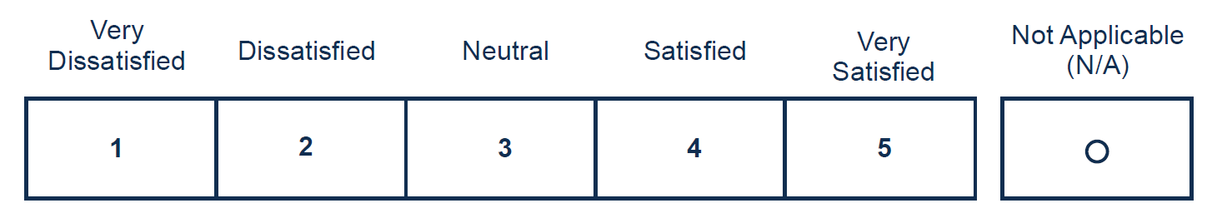
[6] I trust VR&E to help me prepare for, obtain, and maintain suitable employment or achieve
independence in my daily living.
Required

