Request for Approval under the “Generic Clearance for Improving Customer Experience: OMB Circular A-11, Section 280 Implementation”

(OMB Control Number:2900-0876)

TITLE OF INFORMATION COLLECTION: VBA Education Survey

PURPOSE OF COLLECTION:
The VA provides educational benefits to Veterans, servicemembers and qualified family members, to ensure they have a full and fair opportunity to advance their skills. VBA oversees several programs that support active and former Armed Forces personnel with furthering their education and/or receiving approved training.

The Education Service Survey is designed to measure customer experience of beneficiaries. The three key touch points or moments that matter: 1) applying for benefits, 2) enrolling in school, and 3) receiving education benefits. These three moments that matter will constitute the three Survey Types.

Veterans experience data will be collected using an online transactional survey disseminated via an invitation email sent to selected beneficiary. The data collection will occur every two weeks for most Benefit Types and Survey Types. For the Montgomery GI Bill (Chapter 30 and Chapter 1606), enrollment data will only be available for extract once a month. Therefore, enrollment Beneficiaries for these Benefit Types and Survey Type will only be surveyed once a month.

These surveys replace the current VBA Education surveys.

TYPE OF ACTIVITY: (Check one)

[ ] Customer Research (Interview, Focus Groups, Surveys)
[ X ] Customer Feedback Survey
[ ] Usability Testing of Products or Services

ACTIVITY DETAILS

- If this is a survey, will the results of this survey be reported to Touchpoints as part of quarterly reporting obligations specified in OMB Circular A-11 Section 280?
[ ] Yes
[ X] No
[ ] Not a survey

- How will you collect the information? (Check all that apply)
[ ] Web-based or other forms of Social Media
[ ] Telephone
[ ] In-person
[ ] Mail
[ X] Other, Email Based survey

- Who will you collect the information from?
The target population of the Education Service survey will include all beneficiaries that reach one of the touch points. The sample will exclude beneficiaries without a valid email address, those that have been invited to take another VEO survey in the past 30 days, and those with incomplete information.

- How will you ask a respondent to provide this information?
Randomly sampled customers will be contacted through an invitation email. A link will be enclosed so the survey may be completed using an online interface, with customized customer information. The survey itself will consist of a handful of questions revolving around a human-centered design, focusing on such elements as trust, emotion, effective, and ease of the interaction. SORN: Veterans, Dependents of Veterans, and VA Beneficiary Survey Records (43VA008)

- What will the activity look like?
Randomly sampled customers will be contacted through an invitation email. A link will be enclosed so the surveys may be completed using an online interface, with customized customer information. The surveys itself will consist of a handful of questions revolving around a human-centered design, focusing on such elements as trust, emotion, effective, and ease of the interaction.

- Please provide your question list.
Applying for Benefits Survey

[1] I learned about VA education benefits from the following source(s). Select all that apply.
Required
  - Friends, Family and/or Peers
  - Military Education Office
  - Transition Assistance Program (TAP)
  - VA Web Sites
  - Social media (LinkedIn, Facebook, etc.)
  - Veteran Service Organization (VSO), State or Federal Agency
  - Other [Logic: When selected, a text box appears]


[2] It was easy to find information about applying for education benefits.
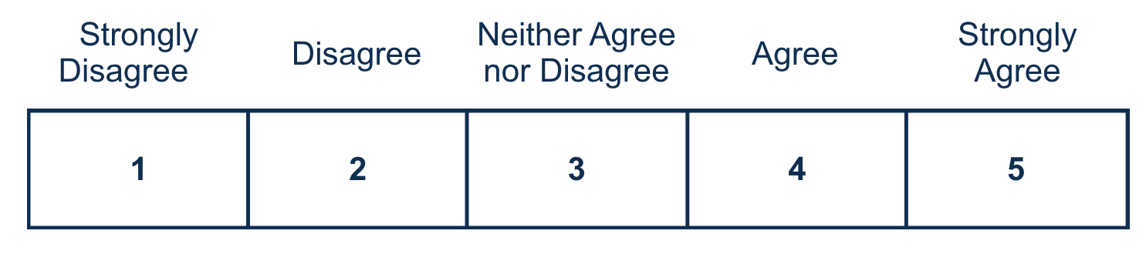

[3] The information provided helped me understand how to apply for education benefits.
[4] The GI Bill Comparison Tool helped me to make decisions about my education and training options.
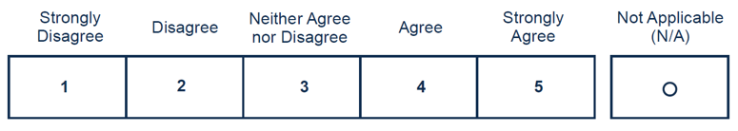
[5] The Certificate of Eligibility (COE) letter clearly explained my education benefits.
[6] For GI Bill benefits, I trust Education Service to fulfill its commitment to Veterans, families, caregivers, and survivors.
Required

[7] Is there anything else you would like to share about your experience applying for education benefits?

0/400

Enrolling in School Survey

[1] It was easy to obtain a copy of my certificate of eligibility.

[2] It was easy to share my certificate of eligibility with my school to use my GI bill benefit.

[3] It was easy to find information about my educational benefits when needed.
[4] After enrolling in school I had a clear understanding of when I would receive my benefits.

[5] For GI Bill benefits, I trust Education Service to fulfill its commitment to Veterans, families, caregivers, and survivors.
Required

[6] Is there anything else you would like to share about your experience of enrolling with your educational benefits?

0/400

Receiving Education Benefits

[1] VA provides my educational benefits without difficulty.

[2] I understood my education benefit may change based on my enrollment status.

[3] It was easy to find information about my educational benefits when needed.
[4] I sought assistance from the VA regarding my education benefits (Y/N) – if yes:
If response is ‘‘N” skip to Q5

[4a] VA provided effective assistance.
[5] The VA properly informed me of what to expect in regard to my issued payments.

[6] For GI Bill benefits, I trust Education Service to fulfill its commitment to Veterans, families, caregivers, and survivors.
Required

[7] Is there anything else you would like to share about your experience of receiving your educational benefits?

0/400

- When will the activity happen?
The population for the survey will be extracted every week. Any record with a valid email address will be included in the sample. Email invitations are delivered to all selected participants. They will have 14 days to complete the survey. Data will be accessible to users instantly on the VSignals platform.
- Is an incentive (e.g., money or reimbursement of expenses, token of appreciation) provided to participants?
[ ] Yes [ X ] No
If Yes, describe:

BURDEN HOURS

Category of Respondent | No. of Respondents | Participation Time | Burden  Hours
Applying for Benefits | 14,340 | 5 | 1,195
Enrolling in School | 13,524 | 5 | 1,127
Receiving Educational Benefits | 15,780 | 5 | 1,315
Totals | 43,644 |  | 3,637

CERTIFICATION:

I certify the following to be true:
- The collections are voluntary;
- The collections are low-burden for respondents (based on considerations of total burden hours or burden-hours per respondent) and are low-cost for both the respondents and the Federal Government;
- The collections are non-controversial;
- Any collection is targeted to the solicitation of opinions from respondents who have experience with the program or may have experience with the program in the near future;
- Personally identifiable information (PII) is collected only to the extent necessary and is not retained;
- Information gathered is intended to be used for general service improvement and program management purposes
- Upon agreement between OMB and the agency aggregated data may be released as part of A-11, Section 280 requirements only on performance.gov. Summaries of customer research and user testing activities may be included in public-facing customer journey maps.
- Additional release of data will be coordinated with OMB.

Name and email address of person who developed this survey/focus group/interview:

Name: Juan Jackson

Email address: juanrjackson@yahoo.com

All instruments used to collect information must include:
OMB Control No. 2900-0876
Expiration Date: 02/28/2026

HELP SHEET

(OMB Control Number: XXXX-XXXX)

TITLE OF INFORMATION COLLECTION: Provide the name of the collection that is the subject of the request. (e.g. Comment card for soliciting feedback on xxxx)

PURPOSE: Provide a brief description of the purpose of this collection and how it will be used. If this is part of a larger study or effort, please include this in your explanation.

TYPE OF COLLECTION: Check one box. If you are requesting approval of other instruments under the generic, you must complete a form for each instrument.

CERTIFICATION: Please read the certification carefully. If you incorrectly certify, the collection will be returned as improperly submitted or it will be disapproved.

Personally Identifiable Information: Agencies should only collect PII to the extent necessary, and they should only retain PII for the period of time that is necessary to achieve a specific objective.

BURDEN HOURS:
Category of Respondents: Identify who you expect the respondents to be in terms of the following categories: (1) Individuals or Households;(2) Private Sector; (3) State, local, or tribal governments; or (4) Federal Government. Only one type of respondent can be selected per row.
No. of Respondents: Provide an estimate of the Number of respondents.
Participation Time: Provide an estimate of the amount of time required for a respondent to participate (e.g. fill out a survey or participate in a focus group)
Burden: Provide the Annual burden hours: Multiply the Number of responses and the participation time and divide by 60.

