Applying for Benefits Survey
V4 DRAFT 1/24/2024
Working Draft, Pre-Decisional, Deliberative document – Internal VA Use Only


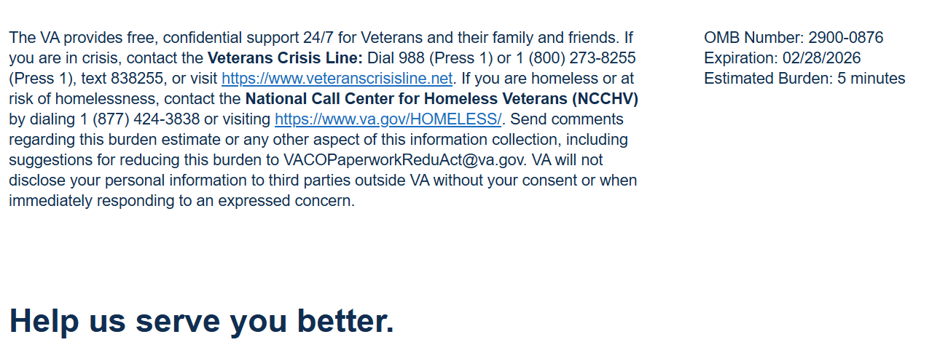

We want to hear about your experience with applying for benefits from VA Education Service. By responding to this survey, you will directly help us improve, and provide better support to beneficiaries like you.

This voluntary survey should take approximately 5 minutes to complete.

[1] I learned about VA education benefits from the following source(s). Select all that apply.
Required
  - Friends, Family and/or Peers
  - Military Education Office
  - Transition Assistance Program (TAP)
  - VA Web Sites
  - Social media (LinkedIn, Facebook, etc.)
  - Veteran Service Organization (VSO), State or Federal Agency
  - Other [Logic: When selected, a text box appears]


[2] It was easy to find information about applying for education benefits.
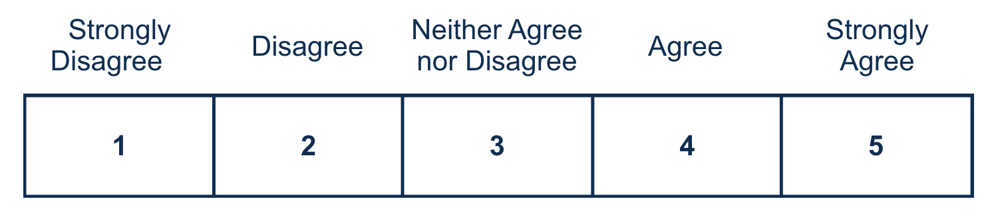

[3] The information provided helped me understand how to apply for education benefits.
[4] The GI Bill Comparison Tool helped me to make decisions about my education and training options.
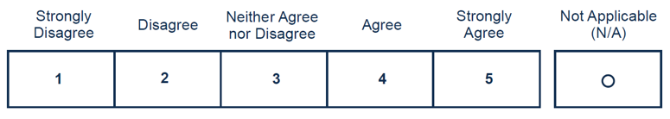
[5] The Certificate of Eligibility (COE) letter clearly explained my education benefits.
[6] For GI Bill benefits, I trust Education Service to fulfill its commitment to Veterans, families, caregivers, and survivors.
Required

[7] Is there anything else you would like to share about your experience applying for education benefits?

0/400



Privacy Notice: By filling out this survey, you are authorizing VA database access to retrieve Veteran contact information to follow up with you accordingly for purposes of service recovery, potential crisis, or to learn more about feedback you have shared regarding your experience with VA. Your contact information and response may be referred to the Veterans Crisis Line if an automated review indicates your response may be concerning. The Veterans Crisis Line may contact you for follow up as a result of that referral. VA may utilize individual Veteran survey data from this survey or other sources to ensure the final scores truly and accurately represent the experiences of Veterans. This collection of information is authorized by 38 U.S.C. Section 301. The Systems of Records Notice can be found here: https://www.federalregister.gov/d/2021-01526.

Respondent Burden: An agency may not conduct or sponsor, and a person is not required to respond to, a collection of information unless it displays a currently valid OMB control number. The OMB control number for this project is 2900-0876, and it expires 02/28/2026. Public reporting burden for this collection of information is estimated to average 5 minutes per respondent, per year, including the time for reviewing instructions, searching existing data sources, gathering, and maintaining the data needed, and completing and reviewing the collection of information. Send comments regarding this burden estimate and any other aspect of this collection of information, including suggestions for reducing the burden, to VA Reports Clearance Officer at VACOPaperworkReduAct@va.gov. Please refer to OMB Control No. 2900-0876 in any correspondence. Do not send your completed VA Form to this email address.

