VBA Finance Center Survey
V3 DRAFT 04/10/2025
Working Draft, Pre-Decisional, Deliberative document – Internal VA Use Only



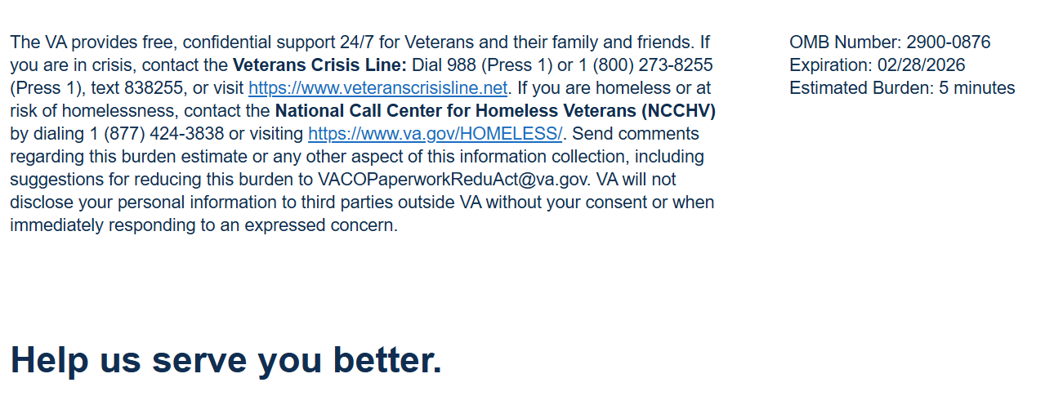

We want to hear about your experience with the VBA Finance Center. By responding to this survey, you will directly help us improve, and provide better support to beneficiaries like you.

This voluntary survey should take approximately 5 minutes to complete.

[1] How did you report your non-receipt of payment claim?
  - In person (visited a local VA office)
  - By phone (called the 800-827-1000)
  - By mail (sent a letter to the VA)

[2] I am satisfied with the service I received from the VBA Finance Center regarding my non-receipt claim.
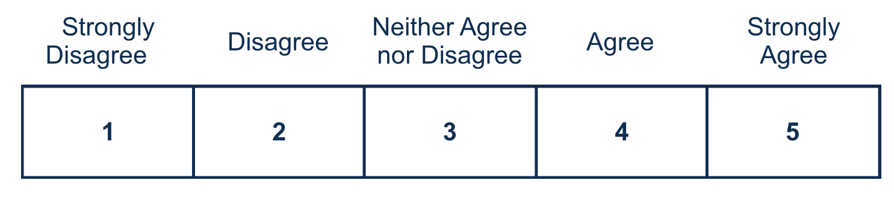
[3] The VBA Finance Center resolved my non-receipt claim in a reasonable amount of time.
[4] My non-receipt claim was resolved to my satisfaction.
[5] My non-receipt claim resulted in a reissuance of funds.
  - Yes
  - No

[5a] The amount received is what I expected. [If “yes” to Q5]
[5b] I received a letter explaining why my non-receipt claim did not result in reissuance of funds. [If “no” to Q5]
  - Yes
  - No
  - Not Applicable

[5c] The letter was professional and accurate. [If “yes” to Q5b]
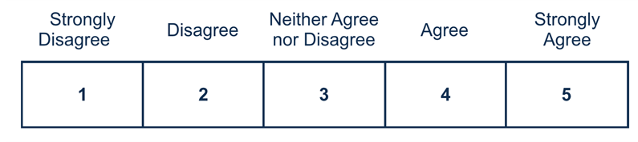

[6] I trust the VBA Finance Center to make a fair and accurate decision on my non-receipt of payment claim.


Respondent Burden: An agency may not conduct or sponsor, and a person is not required to respond to, a collection of information unless it displays a currently valid OMB control number. The OMB control number for this project is 2900-0876, and it expires 02/28/2026. Public reporting burden for this collection of information is estimated to average 5 minutes per respondent, per year, including the time for reviewing instructions, searching existing data sources, gathering, and maintaining the data needed, and completing and reviewing the collection of information. Send comments regarding this burden estimate and any other aspect of this collection of information, including suggestions for reducing the burden, to VA Reports Clearance Officer at VACOPaperworkReduAct@va.gov. Please refer to OMB Control No. 2900-0876 in any correspondence. Do not send your completed VA Form to this email address.

