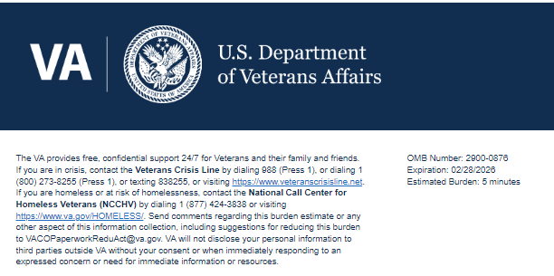
TITLE: PACT Act Toxic Exposure Screening Navigator Customer Service Ad Hoc Survey

Help us serve you better.

We want to hear about your experience with the Atlanta VA PACT Act & Toxic Exposure Screening Navigator Program. By responding to this voluntary survey, you will help us improve the program and provide better support to community care facilities like yours. Getting Veterans the help they need is essential to us!

This survey should take you approximately 5 minutes to complete.

- I am likely to recommend [the Toxic Exposure Screening Navigator(s)] to another veteran. (req)
  - Strongly Disagree
  - Disagree
  - Neither Agree nor Disagree
  - Agree
  - Strongly Agree
- [The Navigator] took my health concerns seriously.
  - Strongly Disagree
  - Disagree
  - Neither Agree nor Disagree
  - Agree
  - Strongly Agree
- [The Navigator(s)] treated me with courtesy and respect.
  - Strongly Disagree
  - Disagree
  - Neither Agree nor Disagree
  - Agree
  - Strongly Agree
- [The Navigator] was familiar with my exposure type and addressed my questions/concerns.
  - Strongly Disagree
  - Disagree
  - Neither Agree nor Disagree
  - Agree
  - Strongly Agree
- [The Navigator(s)] understood my exposure informed healthcare needs.
  - Strongly Disagree
  - Disagree
  - Neither Agree nor Disagree
  - Agree
  - Strongly Agree
- [The Navigator(s)] was knowledgeable [about resources and the VA healthcare system].
  - Strongly Disagree
  - Disagree
  - Neither Agree nor Disagree
  - Agree
  - Strongly Agree
- [The Navigator(s)] was helpful when explaining my exposure informed healthcare options.
  - Strongly Disagree
  - Disagree
  - Neither Agree nor Disagree
  - Agree
  - Strongly Agree
- It was easy to connect with [the Navigator(s)].
  - Strongly Disagree
  - Disagree
  - Neither Agree nor Disagree
  - Agree
  - Strongly Agree
- [The Navigator(s)] responded in a timely manner when I needed help.
  - Strongly Disagree
  - Disagree
  - Neither Agree nor Disagree
  - Agree
  - Strongly Agree
- My interactions with [the Toxic Exposure Screening Navigator(s)] have increased my trust in VA. (req)
  - Strongly Disagree
  - Disagree
  - Neither Agree nor Disagree
  - Agree
  - Strongly Agree

Thank you for choosing VA.

Privacy Notice: By filling out this survey, you are authorizing VA database access to retrieve Veteran contact information to follow up with you accordingly for purposes of service recovery, potential crisis, or to learn more about feedback you have shared regarding your experience with VA. Your contact information and response may be referred to the Veterans Crisis Line if an automated review indicates your response may be concerning. The Veterans Crisis Line may contact you for follow up as a result of that referral. VA may utilize individual Veteran survey data from this survey or other sources to ensure the final scores truly and accurately represent the experiences of Veterans. This collection of information is authorized by 38 U.S.C. Section 301 (https://www.federalregister.gov/d/2021-01526).

Respondent Burden: An agency may not conduct or sponsor, and a person is not required to respond to, a collection of information unless it displays a currently valid OMB control number. The OMB control number for this project is 2900-0876, and it expires 02/28/2026. Public reporting burden for this collection of information is estimated to average 5 minutes per respondent, per year, including the time for reviewing instructions, searching existing data sources, gathering, and maintaining the data needed, and completing and reviewing the collection of information. Send comments regarding this burden estimate and any other aspect of this collection of information, including suggestions for reducing the burden, to VA Reports Clearance Officer at VACOPaperworkReduAct@va.gov. Please refer to OMB Control No. 2900-0876 in any correspondence. Do not send your completed VA Form to this email address.

