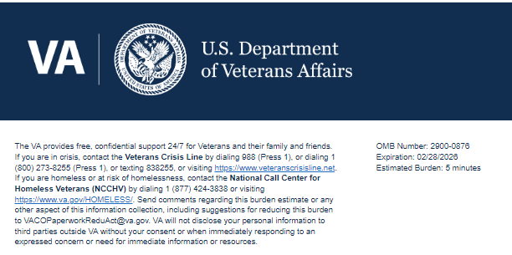
TITLE: VA Call Center Experience & Expectations Survey

Help us serve you better.

Your opinion matters. We care about your time with VA. Please take this survey to let us know about your experience. The more information you share with us, the better we can serve you.

This voluntary survey should take you approximately 5 minutes to complete.

Note: All text in blue are notes and will not appear on the live survey.
Section 1: Screening
1. Have you ever called VA to get help or information in the past 12 months?
[ ] Yes
[ ] No → (Logic: Skip to Question 11)

Section 2: Recent Call Experience (for Callers Only)
Thinking about your most recent call to the VA…
2. What was the reason for your call? (Check all that apply)
[ ] Benefits (e.g., disability, education)
[ ] Health care services or appointments
[ ] Billing or payment
[ ] VA login or account access
[ ] Crisis or urgent help
[ ] Other (please describe): __________
3. Before calling, did you try any of the following methods to get help or information? (Check all that apply)
[ ] VA.gov
[ ] My HealtheVet
[ ] Mobile app
[ ] Chatbot or online chat
[ ] None of the above

Please rate each of the following according to how strongly you agree or disagree with the statement.

4. I was able to quickly reach someone to address my issue.
[ ] Strongly Agree
[ ] Agree
[ ] Neither Agree or Disagree
[ ] Disagree
[ ] Strongly Disagree

5. The person I spoke with was able to effectively address my issue.
[ ] Strongly Agree
[ ] Agree
[ ] Neither Agree or Disagree
[ ] Disagree
[ ] Strongly Disagree

6. I felt I had to repeat information or provide details I had already given (e.g., name, SSN, reason for calling).
[ ] Strongly Agree
[ ] Agree
[ ] Neither Agree or Disagree
[ ] Disagree
[ ] Strongly Disagree

7. After calling VA, I knew what to do next.
[ ] Strongly Agree
[ ] Agree
[ ] Neither Agree or Disagree
[ ] Disagree
[ ] Strongly Disagree

8. I am satisfied with the service I received during the call.
[ ] Strongly Agree
[ ] Agree
[ ] Neither Agree or Disagree
[ ] Disagree
[ ] Strongly Disagree

Section 3: Improvements
9. Please describe any changes or improvements that would have made your experience more positive. (Open text)
__________________________________________________________________________

10. Which of the following items would be most important to you when improving the overall VA call experience? (Rank top 3)
[ ] Speak to a live person quickly
[ ] Not having to repeat information
[ ] Clearer menu options
[ ] Better self-service tools
[ ] Call-back option instead of holding
[ ] Faster resolution
[ ] Wait time announcement at the start of the call
[ ] Other: __________

Section 4: Expectations
11. Why have you never called VA? (Check all that apply) (Logic: Only appears if Question 1 = No)
[ ] I found what I needed online
[ ] I didn’t think I’d get help
[ ] I didn’t know which number to call
[ ] I prefer to use other methods
[ ] Other: __________

12. If you were to call VA in the future, which of the following would be most important to you? (Check all that apply)
[ ] Short wait times
[ ] Ability to speak to someone knowledgeable
[ ] Quick Follow-up or confirmation
[ ] Secure and private handling of my info
[ ] Other: __________

Section 5: Demographics (Optional)
13. Please select all that apply. Are you a:
[ ] Veteran
[ ] Family member
[ ] Dependent
[ ] Caregiver
[ ] Survivor
[ ] VA employee
[ ] Other: __________

14. What is your age group?
[ ] Under 25
[ ] 25–44
[ ] 45–64
[ ] 65+

Thank you for choosing VA.

Privacy Notice: By filling out this survey, you are authorizing VA database access to retrieve Veteran contact information to follow up with you accordingly for purposes of service recovery, potential crisis, or to learn more about feedback you have shared regarding your experience with VA. Your contact information and response may be referred to the Veterans Crisis Line if an automated review indicates your response may be concerning. The Veterans Crisis Line may contact you for follow up as a result of that referral. VA may utilize individual Veteran survey data from this survey or other sources to ensure the final scores truly and accurately represent the experiences of Veterans. This collection of information is authorized by 38 U.S.C. Section 301 (https://www.federalregister.gov/d/2021-01526).

Respondent Burden:
An agency may not conduct or sponsor, and a person is not required to respond to, a collection of information unless it displays a currently valid OMB control number. The OMB control number for this project is 2900-0876, and it expires 02/28/2026. Public reporting burden for this collection of information is estimated to average 5 minutes per respondent, per year, including the time for reviewing instructions, searching existing data sources, gathering and maintaining the data needed, and completing and reviewing the collection of information. Send comments regarding this burden estimate and any other aspect of this collection of information, including suggestions for reducing the burden, to VA Reports Clearance Officer at PRAVA@va.gov. Please refer to OMB Control No. 2900-0876 in any correspondence. Do not send your completed VA Form to this email address.

