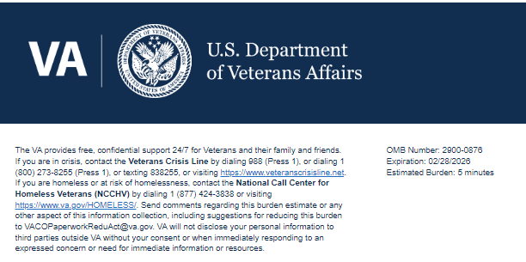
TITLE: Getting Started with VA Pilot Support

Help us serve you better.

Your opinion matters. We care about your time with VA. Please take this survey to let us know about your experience. The more information you share with us, the better we can serve you.

This voluntary survey should take you approximately 5 minutes to complete.

1. What is your current military status?
- Active Duty
- Reserve
- National Guard
- Veteran (Separated)
- Veteran (Retired)
2. What is your branch of service?
- Army
- Navy
- Marine Corps
- Coast Guard
- Air Force
- Space Force
3. What is your most recent rank?
- E1 – E4
- E5 – E6
- E7 – E9
- WO1 – WO5
- O1 – O3
- O4 – O5
- O6+
4. In total, how long have you served in the military?
- 0 to 1 year
- 1 to 3 years
- 3 to 5 years
- 5 to 10 years
- 10 to 15 years
- 15 to 20 years
- 20+ years
5. Where are you in your military transition process?
- I've already started the separation/retirement process and I'm separating/retiring within the next 6 months.
- I've already started the separation/retirement process and I'm separating/retiring in 6-12 months.
- I've already started the separation/retirement process and I'm separating/retiring more than 12 months from now.
- I plan to start the separation/retirement process within the next 6 months.
- I plan to start the separation/retirement process more than 6 months from now.
- I don't have plans to start the separation/retirement process.
- I already separated or retired within the last year.
- I already separated or retired more than a year ago.
6. Which benefits or services will you apply for as a result of using the discover-your-benefits tool? (Select all that apply)
- VA Disability Benefits
- VA Healthcare
- VA Home Loan
- GI Bill/Education Benefits
- Career/Employment Assistance
- Mental Health/Wellness Resources
- Financial Planning Services
- The tool has not recommended any benefits that match my needs
7. The discover-your-benefits tool helped me identify benefits and resources I may be eligible for.
- Strongly Disagree
- Disagree
- Neither Agree nor Disagree
- Agree
- Strongly Agree
8. The discover-your-benefits tool made it easier to plan my military transition.
- Strongly Disagree
- Disagree
- Neither Agree nor Disagree
- Agree
- Strongly Agree
9. The discover-your-benefits tool helped me prepare for civilian life.
- Strongly Disagree
- Disagree
- Neither Agree nor Disagree
- Agree
- Strongly Agree
10. The discover-your-benefits tool included the goal(s) I want to achieve.
- Strongly Disagree
- Disagree
- Neither Agree nor Disagree
- Agree
- Strongly Agree
11. I would recommend the discover-your-benefits tool to my friends.
- Strongly Disagree
- Disagree
- Neither Agree nor Disagree
- Agree
- Strongly Agree
12. I trust that the discover-your-benefits tool is designed to support Veterans.
- Strongly Disagree
- Disagree
- Neither Agree nor Disagree
- Agree
- Strongly Agree
13. Do you have any additional feedback on the discover-your-benefits tool? Note: Please do not include any personal-identifiable information (PII) or personal health information (PHI)
[Text Box]

Thank you for choosing VA.

Privacy Notice: By filling out this survey, you are authorizing VA database access to retrieve Veteran contact information to follow up with you accordingly for purposes of service recovery, potential crisis, or to learn more about feedback you have shared regarding your experience with VA. Your contact information and response may be referred to the Veterans Crisis Line if an automated review indicates your response may be concerning. The Veterans Crisis Line may contact you for follow up as a result of that referral. VA may utilize individual Veteran survey data from this survey or other sources to ensure the final scores truly and accurately represent the experiences of Veterans. This collection of information is authorized by 38 U.S.C. Section 301 (https://www.federalregister.gov/d/2021-01526).

Respondent Burden: An agency may not conduct or sponsor, and a person is not required to respond to, a collection of information unless it displays a currently valid OMB control number. The OMB control number for this project is 2900-0876, and it expires 02/28/2026. Public reporting burden for this collection of information is estimated to average 5 minutes per respondent, per year, including the time for reviewing instructions, searching existing data sources, gathering, and maintaining the data needed, and completing and reviewing the collection of information. Send comments regarding this burden estimate and any other aspect of this collection of information, including suggestions for reducing the burden, to VA Reports Clearance Officer at VACOPaperworkReduAct@va.gov. Please refer to OMB Control No. 2900-0876 in any correspondence. Do not send your completed VA Form to this email address.

