Request for Approval under the “Generic Clearance for Improving Customer Experience: OMB Circular A-11, Section 280 Implementation”

(OMB Control Number:2900-0876)

TITLE OF INFORMATION COLLECTION: Medical Disability Examination Office (MDEO)Survey

PURPOSE OF COLLECTION:
Through the Veterans Benefits Administration (VBA), the Department of Veterans Affairs administers Compensation & Pension (C&P) examinations to veterans. A medical examination is a critical piece of evidence for determining the extent of disability, and thus the disability rating that is warranted. As such, the examination and accompanying report must provide the required detailed findings sufficient for VA adjudicators to arrive at an appropriate determination. The survey will support VA in understanding the experiences of Veterans going through the Disability Compensation contract exam process. The feedback received from these surveys will support making short- and long-term process and program improvements.

TYPE OF ACTIVITY: (Check one)

[ ] Customer Research (Interview, Focus Groups, Surveys)
[ X] Customer Feedback Survey
[ ] Usability Testing of Products or Services

ACTIVITY DETAILS

- If this is a survey, will the results of this survey be reported to Touchpoints as part of quarterly reporting obligations specified in OMB Circular A-11 Section 280?
[ ] Yes
[X ] No
[ ] Not a survey

- How will you collect the information? (Check all that apply)
[ ] Web-based or other forms of Social Media
[ ] Telephone
[ ] In-person
[ ] Mail
[X ] Other, Email Based survey

- Who will you collect the information from?
The target population of the survey are all Veterans that have completed a MDEO exam. The population for the survey will be drawn from MDEO data. Any record with a valid email address will be included in the survey.

- How will you ask a respondent to provide this information?
The respondents will be contacted by email within 30 days of their interaction. The email will contain a link to the survey. After responding to the survey questions the respondent can click submit to provide their feedback.

- What will the activity look like?
Respondents will be contacted by email within 30 days of their exam. They will have 14 days to complete the survey. A link will be enclosed so the survey may be completed using an online interface, with customized customer information. The survey itself will consist of a handful of questions revolving around a human-centered design, focusing on such elements as trust, emotion, effective, and ease of the interaction.

- Please provide your question list.

[1] Overall, I am satisfied with the service I received from the Examination Provider.
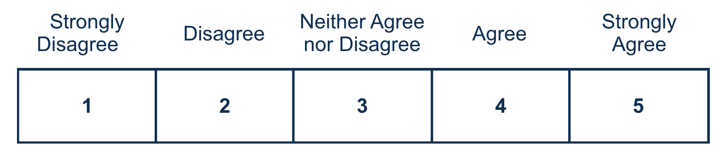
[2] How long from your scheduled appointment time did you wait to see the examiner?
  - No wait – I was seen on time or ahead of my scheduled appointment time.
  - Less than 30 minutes
  - 30 – 45 minutes
  - 46 minutes – 1 hour
  - Greater than 1 hour
[3] My appointment was at a reasonable date and time.
[4] My appointment was at an accessible location that was easy to find.
[5] The Examination Provider’s office was clean.
[6] The Examination Provider’s staff treated me with respect.
Required
[7] The Examination Provider treated me with respect.

[8] I trust VA to fulfill our country’s commitment to Veterans.
Required
[9] Is there anything else you would like to share regarding your experience with the Examination Provider? Please do not include any personally identifiable information such as Social Security Number, Veteran ID, or medical information.

- When will the activity happen?
Respondents will be contacted by email within 30 days of their exam. They will have 14 days to complete the survey. This will be an ongoing continuous survey.

- Is an incentive (e.g., money or reimbursement of expenses, token of appreciation) provided to participants?
[ ] Yes [ X ] No
If Yes, describe:

BURDEN HOURS

Category of Respondent | No. of Respondents | Participation Time | Burden  Hours
MDEO Survey | 360,000 | 5 | 30,000
Totals | 360,000 | 5 | 30,000

CERTIFICATION:

I certify the following to be true:
- The collections are voluntary;
- The collections are low-burden for respondents (based on considerations of total burden hours or burden-hours per respondent) and are low-cost for both the respondents and the Federal Government;
- The collections are non-controversial;
- Any collection is targeted to the solicitation of opinions from respondents who have experience with the program or may have experience with the program in the near future;
- Personally identifiable information (PII) is collected only to the extent necessary and is not retained;
- Information gathered is intended to be used for general service improvement and program management purposes
- Upon agreement between OMB and the agency aggregated data may be released as part of A-11, Section 280 requirements only on performance.gov. Summaries of customer research and user testing activities may be included in public-facing customer journey maps.
- Additional release of data will be coordinated with OMB.

Name and email address of person who developed this survey/focus group/interview:

Name: Juan Jackson

Email address: juan.jackson@va.gov

All instruments used to collect information must include:
OMB Control No. 2900-0876
Expiration Date: 02/28/2026

HELP SHEET

(OMB Control Number: XXXX-XXXX)

TITLE OF INFORMATION COLLECTION: Provide the name of the collection that is the subject of the request. (e.g. Comment card for soliciting feedback on xxxx)

PURPOSE: Provide a brief description of the purpose of this collection and how it will be used. If this is part of a larger study or effort, please include this in your explanation.

TYPE OF COLLECTION: Check one box. If you are requesting approval of other instruments under the generic, you must complete a form for each instrument.

CERTIFICATION: Please read the certification carefully. If you incorrectly certify, the collection will be returned as improperly submitted or it will be disapproved.

Personally Identifiable Information: Agencies should only collect PII to the extent necessary, and they should only retain PII for the period of time that is necessary to achieve a specific objective.

BURDEN HOURS:
Category of Respondents: Identify who you expect the respondents to be in terms of the following categories: (1) Individuals or Households;(2) Private Sector; (3) State, local, or tribal governments; or (4) Federal Government. Only one type of respondent can be selected per row.
No. of Respondents: Provide an estimate of the Number of respondents.
Participation Time: Provide an estimate of the amount of time required for a respondent to participate (e.g. fill out a survey or participate in a focus group)
Burden: Provide the Annual burden hours: Multiply the Number of responses and the participation time and divide by 60.

