Medical Disability Examination Office – Getting the Exam Survey
V10 DRAFT 05/22/2025
Working Draft, Pre-Decisional, Deliberative document – Internal VA Use Only

EMAIL SUBJECT LINE: Tell Us About Your VA Medical Disability Exam Experience (5 minutes)

EMAIL PREHEADER: Tell us about your recently completed medical disability examination appointment.


OMB Number: 2900-0876
Expiration: 2/28/2026
Estimated Burden: 5 minutes

Your opinion matters.

Dear <First Name Last Name>,
We care about your experience with VA. Please take this 5 minute survey to let us know about your recent medical disability examination with <Examiner Name> on <Date>. The Department of Veterans Affairs will use the information gathered to identify areas where we excel and areas where we may need to make improvements. The more information you share with us, the better we can serve you.



Thank you,

Veterans Experience Office
Department of Veterans Affairs

Whether you’re just getting out of the service or you’ve been a civilian for years, the VA Welcome Kit
can help guide you to the benefits and services you’ve earned.

The Veterans Crisis Line provides free, confidential support for Veterans and their families and
friends in crisis. Dial 988 (Press 1) or 1 (800) 273-8255 (Press 1), or text 838255 to receive
confidential support 24/7 (System of Records Notice VA158VA10NC5). Visit https://
www.veteranscrisisline.net for more information.

Additionally, the National Call Center for Homeless Veterans (NCCHV) provides free, confidential
support for Veterans and their family members and friends who are homeless or at risk of
homelessness. Veterans can either call or chat online with the National Call Center for Homeless
Veterans where trained counselors are ready to talk confidentially 24 hours a day, 7 days a week.
Dial 1 (877) 424-3838 or visit https://www.va.gov/HOMELESS/ to receive confidential support.
Please do not reply to this email - it is unmonitored.

If you wish to share your feedback, please do so by <Month DD, YYYY at TT:TT>.

You received this email because you provided your email address to VA. If you would like to opt out
from receiving future surveys, please click below.

Unsubscribe from this VA Survey | Privacy Policy

By filling out this survey, you are authorizing VA database access to retrieve Veteran contact information to follow up with you accordingly for purposes of service recovery, potential crisis, or to learn more about feedback you have shared regarding your experience with VA. Your contact information and response may be referred to the Veterans Crisis Line if an automated review indicates your response may be concerning. The Veterans Crisis Line may contact you for follow up as a result of that referral. VA may utilize individual Veteran survey data from this survey or other sources to ensure the final scores truly and accurately represent the experiences of Veterans. This information is collected in accordance with section 3507 of the Paperwork Reduction Act of 1995. Title 38, United States Code, allows us to ask for this information. We estimate that you will need an average of 5 minutes to review the instructions and complete this survey. The results of this survey will be used to inform opportunities for program improvement in the quality of VA services. Participation in this survey is voluntary, and your decision not to respond will have no impact on VA benefits or services which you may currently be receiving. VA cannot conduct or sponsor a collection of information unless a valid OMB control number is displayed. You are not required to respond to a collection of information if this number is not displayed. Valid OMB control numbers can be located on the OMB Internet Page at https://www.reginfo.gov/public/do/PRAMain. Information gathered will be kept private to the extent provided by law.

Medical Disability Examination Office - Getting the Exam Survey
V10 DRAFT 05/22/2025
Working Draft, Pre-Decisional, Deliberative document – Internal VA Use Only

EMAIL SUBJECT LINE: We still want to hear about your recent Medical Disability Examination Experience (5 minutes)

EMAIL PREHEADER: Tell us about your recently completed medical disability examination appointment.

OMB Number: 2900-0876
Expiration: 2/28/2026
Estimated Burden: 5 minutes

Your feedback is important to us.

Dear <First Name Last Name>,
VA still wants to hear about your most recent medical disability examination with <Examiner Name> on <Date>. Please let us know how we are doing by taking a 5 minute survey regarding your experience.

Thank you,

Veterans Experience Office
Department of Veterans Affairs

Whether you’re just getting out of the service or you’ve been a civilian for years, the VA Welcome Kit
can help guide you to the benefits and services you’ve earned.

The Veterans Crisis Line provides free, confidential support for Veterans and their families and
friends in crisis. Dial 988 (Press 1) or 1 (800) 273-8255 (Press 1), or text 838255 to receive
confidential support 24/7 (System of Records Notice VA158VA10NC5). Visit https://
www.veteranscrisisline.net for more information.

Additionally, the National Call Center for Homeless Veterans (NCCHV) provides free, confidential
support for Veterans and their family members and friends who are homeless or at risk of
homelessness. Veterans can either call or chat online with the National Call Center for Homeless
Veterans where trained counselors are ready to talk confidentially 24 hours a day, 7 days a week.
Dial 1 (877) 424-3838 or visit https://www.va.gov/HOMELESS/ to receive confidential support.
Please do not reply to this email - it is unmonitored.

If you wish to share your feedback, please do so by <Month DD, YYYY at TT:TT>.

You received this email because you provided your email address to VA. If you would like to opt out
from receiving future surveys, please click below.

Unsubscribe from this VA Survey | Privacy Policy

By filling out this survey, you are authorizing VA database access to retrieve Veteran contact information to follow up with you accordingly for purposes of service recovery, potential crisis, or to learn more about feedback you have shared regarding your experience with VA. Your contact information and response may be referred to the Veterans Crisis Line if an automated review indicates your response may be concerning. The Veterans Crisis Line may contact you for follow up as a result of that referral. VA may utilize individual Veteran survey data from this survey or other sources to ensure the final scores truly and accurately represent the experiences of Veterans. This information is collected in accordance with section 3507 of the Paperwork Reduction Act of 1995. Title 38, United States Code, allows us to ask for this information. We estimate that you will need an average of 5 minutes to review the instructions and complete this survey. The results of this survey will be used to inform opportunities for program improvement in the quality of VA services. Participation in this survey is voluntary, and your decision not to respond will have no impact on VA benefits or services which you may currently be receiving. VA cannot conduct or sponsor a collection of information unless a valid OMB control number is displayed. You are not required to respond to a collection of information if this number is not displayed. Valid OMB control numbers can be located on the OMB Internet Page at https://www.reginfo.gov/public/do/PRAMain. Information gathered will be kept private to the extent provided by law.

Medical Disability Examination Office - Getting the Exam Survey
V10 DRAFT 05/22/2025
Working Draft, Pre-Decisional, Deliberative document – Internal VA Use Only

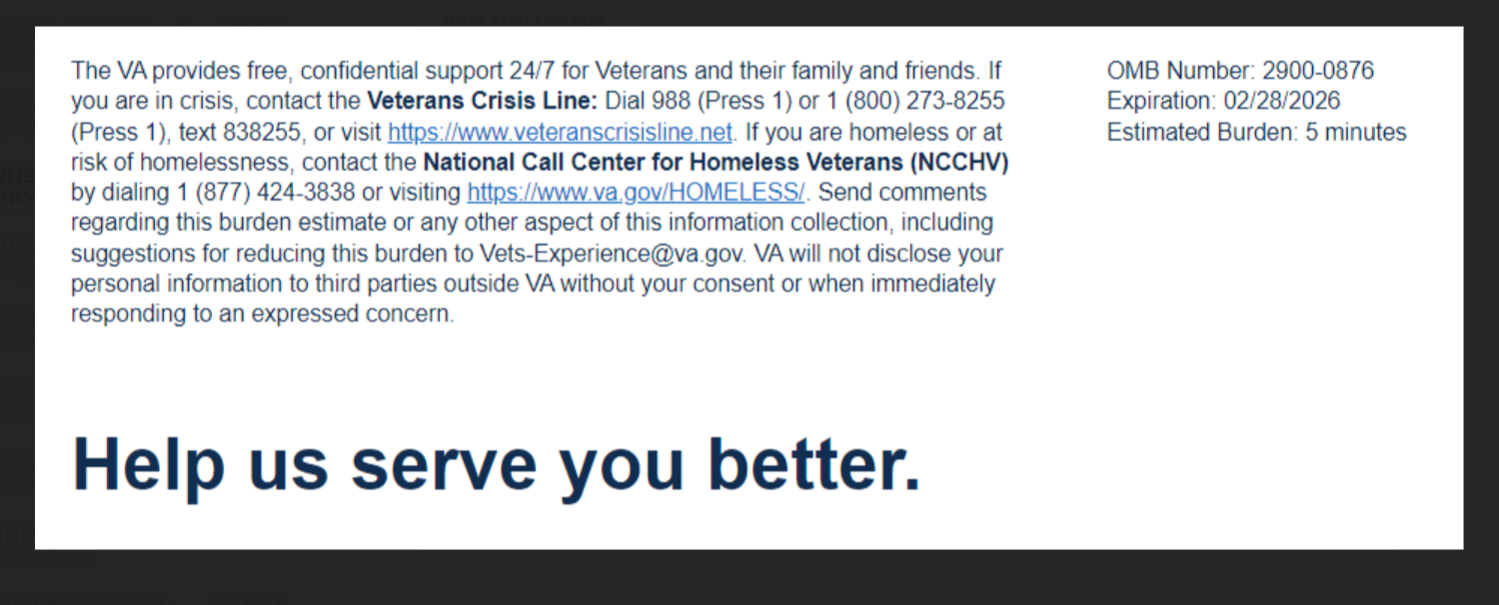
Our records show that you recently completed a medical disability examination with <Examiner Name>. We want to hear about your experience. By responding to this survey, you directly help us improve VA services.
This voluntary survey should take approximately 5 minutes to complete.
Required
[1] Overall, I am satisfied with the service I received from the Examination Provider.
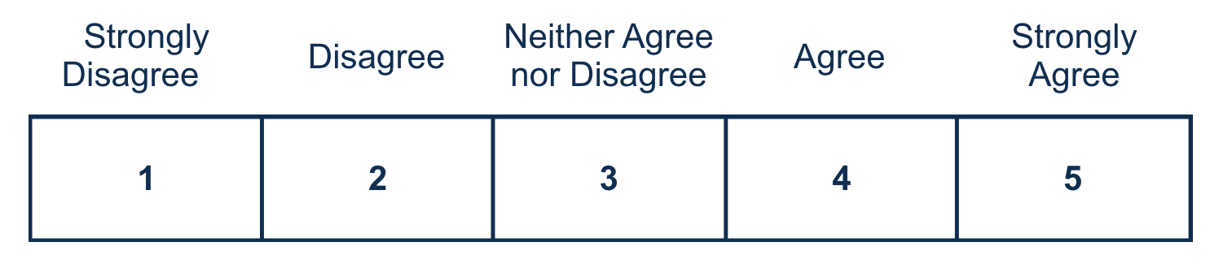
[2] How long from your scheduled appointment time did you wait to see the examiner?
  - No wait – I was seen on time or ahead of my scheduled appointment time.
  - Less than 30 minutes
  - 30 – 45 minutes
  - 46 minutes – 1 hour
  - Greater than 1 hour
[3] My appointment was at a reasonable date and time.
[4] My appointment was at an accessible location that was easy to find.
[5] The Examination Provider’s office was clean.
[6] The Examination Provider’s staff treated me with respect.
Required
[7] The Examination Provider treated me with respect.

[8] I trust VA to fulfill our country’s commitment to Veterans.
Required
[9] Is there anything else you would like to share regarding your experience with the Examination Provider? Please do not include any personally identifiable information such as Social Security Number, Veteran ID, or medical information.



Privacy Notice: By filling out this survey, you are authorizing VA database access to retrieve Veteran contact information to follow up with you accordingly for purposes of service recovery, potential crisis, or to learn more about feedback you have shared regarding your experience with VA. Your contact information and response may be referred to the Veterans Crisis Line if an automated review indicates your response may be concerning. The Veterans Crisis Line may contact you for follow up as a result of that referral. VA may utilize individual Veteran survey data from this survey or other sources to ensure the final scores truly and accurately represent the experiences of Veterans. This collection of information is authorized by 38 U.S.C. Section 301. The Systems of Records Notice can be found here: https://www.federalregister.gov/d/2021-01526.
Respondent Burden: An agency may not conduct or sponsor, and a person is not required to respond to, a collection of information unless it displays a currently valid OMB control number. The OMB control number for this project is 2900-0876 and it expires 02/28/2026. Public reporting burden for this collection of information is estimated to average 5 minutes per respondent, per year, including the time for reviewing instructions, searching existing data sources, gathering and maintaining the data needed, and completing and reviewing the collection of information. Send comments regarding this burden estimate and any other aspect of this collection of information, including suggestions for reducing the burden, to VA Reports Clearance Officer at vapra@va.gov. Please refer to OMB Control No. 2900-0876 in any correspondence. Do not send your completed VA Form to this email address.

Medical Disability Examination Office - Getting the Exam Survey
V10 DRAFT 05/22/2025
Working Draft, Pre-Decisional, Deliberative document – Internal VA Use Only

